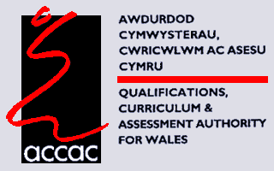
Index

Page

Introduction 3

Thinking skills principles 4

Thinking skills principles to pilot 5

Planning for opportunities to develop thinking skills 5

Assessment for learning principles 6

Assessment for learning principles to pilot 8

Planning for opportunities to develop assessment for 8
learning

Overview of principles to pilot 9

Appendix 1 10
Draft progression of thinking skills development

Appendix 2 14
Thinking skills strategies

Appendix 3 50
Assessment for learning strategies
Introduction

This document attempts to draw together successful and popular teaching strategies that have been used in the classroom to develop better quality thinking and assessment for learning. In the document ‘Why develop thinking skills and assessment for learning?’ a number of parallels were drawn between both initiatives. In essence, the two are inextricably linked. It follows, therefore, that similar teaching strategies may be used to stimulate better thinking and assessment for learning. However, as both thinking skills and assessment for learning also retain several specific characteristics as shown in the earlier document, then it is clear that different teaching strategies may be required to enhance better quality thinking or encouraging learners to use assessment for learning. For these reasons, and to aid teachers in identifying suitable strategies to adopt in the classroom, the remainder of this document has been split into separate sections dealing with thinking and assessment for learning (although as mentioned, the overlap between the two should always be borne in mind).

Teachers are asked to select three principles (see page 8) to pilot in the classroom. The principles selected could all be from thinking skills or all from assessment for learning or a mixture of both. Teachers could try and develop these principles with one or more of their classes. However, ACCAC will need to be informed of the classes to be used by 25 November 2005 in the first instance.

Thinking Skills Principles

There has been much research in the area of developing thinking. Many thinking skills have been identified and labelled. In an attempt to combine the wide range of research, ACCAC has developed a draft progression in Developing Thinking with three broad processes in mind: Planning, Developing and Reflecting. Several principles/types of thinking in each of these three areas have then been classified. The draft progression can be found at Appendix 1. Please note that the progression is an attempt to give a comprehensive overview. It is not expected that any teacher/subject will use all of the progression but that teachers can dip into the progression to suit the learners’ and the subjects’ needs.

The whole process of developing quality thinking can be viewed as cyclical/spiral so that learning from reflection can be fed back into the next task.

Diagram: Developing Thinking Skills – learner’s spiral

METACOGNITION

It should be noted that metacognition (thinking about thinking) is at the heart of all learning; learners need to ‘unpack their thinking’ in order to appreciate the strategies they have used to learn, to assimilate the learning that has taken place and to link the learning to a new context.
Thinking Skills Principles to pilot

Ten principles of the thinking skills progression have been selected for pilot in this development programme. They have been selected to allow for continuity in thinking and subject-specific differences.

Plan | Develop | Reflect
Thinking principles
Activating prior knowledge, skills and understanding | Thinking about cause and effect and predicting | Drawing conclusions on own learning and thinking
Determining the approach/method | Forming opinions and making decisions
Determining success criteria | Thinking logically and seeking patterns | Determining success
 | Thinking critically | Linking and lateral thinking

Associated with each thinking principle are suggested teaching strategies, at Appendix 2. This is by no means an exhaustive list, but more an introduction to the types of strategies that may be initially experimented with in the classroom and the list will consequently grow as teachers develop confidence and experience. Obviously, questioning strategies play a major role in this initiative; these are dealt with in the section on Assessment for Learning.

Planning for Opportunities to develop Thinking Skills

It is vital that teachers give as much consideration on how to teach as what to teach. The function of the teacher should not be just to control the delivery of knowledge, but to plan and manage a challenging learning experience for every learner, every lesson.

From the medium-term planning (i.e. Scheme of Work), teachers could choose a learning objective that would appear to be rich in opportunities to develop a particular thinking principle. They could then creatively work on a related classroom activity, bearing in mind the thinking skill principle and the underlying practices to develop thinking in lessons.

Assessment for Learning Principles

The focus will be on three main areas for developing classroom principles for Assessment for Learning:

- Questioning technique
- Providing feedback to learners
- Peer and self-assessment.

Evidence from assessment for learning practice can indicate to the teacher where more time is needed and where it can be saved so that teachers do not become slaves to schemes of work. Summative tests should be seen to be a positive part of the learning process, if used formatively.

Questioning technique

It is important that we ask questions that are worth asking and answering! We need to be clear about the purpose of our question and ensure that learners understand what type of thinking is being promoted. We can think of a ‘good’ question as being one: that promotes discussion; in which everyone can have an answer; which makes learners think, and has a purpose (i.e. is focused towards a learning objective). As Black and Wiliam (1998) stated:

‘What is essential is that any dialogue should evoke thoughtful reflection in which all learners can be encouraged to take part.’

The average wait-time of British teachers is 0.9 seconds. If we haven’t accepted an answer by then, we tend to modify the question or simply answer it ourselves! If we want learners to think about a question, we must provide time for this to happen, and develop an atmosphere in which everyone is expected to think. If the wait-time is increased to a mere 3 seconds, there is a huge increase in the number of learners responding, and in the depth of the answers given and the range of language used in their answers.

Research has shown that using some of the strategies from Appendix 3 in the classroom have led to learners becoming more active participants in their own learning and teachers changing their role from presenters of information to mediators of exploration and the development of ideas.

Providing feedback to learners

Research has shown that feedback as grades or marks has a negative effect on learning. However, comments only become useful if they are used to guide further work or ‘close the learning gap’, and the teacher checks that past targets have been met. It is the quality of the dialogue rather than the quantity that is critical when giving feedback on both written and oral work. Written or oral comments to learners also help learners to focus on the learning issues rather on trying to interpret a mark or a grade. To be effective, feedback should be as immediate as possible, should be clear and should make the learner think. Opportunities for learners to follow up comments should be planned as part of the overall process. Written tasks, and/or oral questioning, should encourage learners to develop and show understanding of the key features of what they have learned.

Peer and self-assessment

Learners can only achieve a learning intention if they understand that intention and can assess what they need to do. The criteria must be transparent to learners and concrete examples of success should be provided.

Peer assessment is uniquely valuable because learners may accept from one another criticisms of their work which they would not take seriously if made by the teacher. Interchange will take place in a language that learners themselves would naturally use. If learners do not understand an explanation, they are more likely to interrupt a peer when they would not interrupt a teacher. Peer assessment places the work in the hands of the learners. The teachers can then be free to observe and reflect on what is happening and to frame helpful interventions. However, for peer assessment to work effectively, learners must be trained in the good practices of group work (see Why develop booklet), and this is not something that will happen overnight.

Self-assessment will only happen if teachers help learners, particularly the low attainers, to develop the skill. Like effective group work, this will take time and practice.

Engaging in peer- and self-assessment is much more than just checking for errors or weaknesses. It involves making explicit what is normally implicit, and thus requires the learner to be active in their learning. When learners reflect on their levels of understanding it can be used in informing future teaching. By actively involving learners in writing and marking assessments, they can see that they are beneficiaries rather than victims of testing, because tests can help them improve their own learning.

Assessment for Learning Skills Principles to pilot

Questioning | Feedback | Peer and self-assessment
Assessment for learning principles
Improving quality of answers | Target setting | On-going lesson assessment
Peer discussion | Immediacy of feedback | Uses of summative assessment
Active involvement of all learners

Associated with each assessment for learning principle are suggested teaching strategies, at Appendix 3. This is by no means an exhaustive list, but more an introduction to the types of strategies that may be initially experimented with in the classroom and the list will consequently grow as teachers develop confidence and experience.

Planning for Opportunities to use Assessment for Learning

Assessment for learning strategies can be used to find the learner’s current position, move the learner on towards his/her targets, act as checks on the path to reaching the targets, and to discover if the targets have been reached. The types of strategies used will depend on the learner’s current position, the learner’s misconceptions, the learner’s targets, subject area, age and whether the learner is experienced in using these strategies. Planning for these opportunities is an essential part of lesson preparation and can reduce the burden of teaching all pupils exactly to the school scheme of work. Therefore it can reduce the time required by a scheme of work, and free up time to develop ideas and overcome misconceptions.

Overview of principles for pilot

Teachers should select three principles from the list below:

Thinking skills Assessment for learning

Plan | Develop | Reflect | Questioning | Feedback | Peer and self-assessment
Activating prior knowledge, skills and understanding | Thinking about cause and effect and predicting | Drawing conclusions on own learning and thinking | Improving quality of answers | Target setting | On-going lesson assessment
Determining the approach /method | Forming opinions and making decisions |  | Peer discussion | Immediacy of feedback | Uses of summative assessment
Determining success criteria | Thinking logically and seeking patterns | Determining success | Active involvement of all pupils | Immediacy of feedback | Uses of summative assessment
 | Thinking critically | Linking and lateral thinking

Appendix 1: Draft Thinking Skills Progression
Developing thinking skills across the curriculum
process | Type of thinking/  principle | concrete more abstract  supported progression independent  simple complex  personal bigger picture  familiar in task and level of independence unfamiliar
Plan | Asking questions (to understand the problem)  Activating prior knowledge, skills and understanding  Determining the approach/  method  Gathering information  Determining success criteria | Ask why, what, how, where, when etc.  Show awareness of personal needs and skills.  Choose from given options what to do and how to do it.  Choose from given options where to find information and ideas.  Identify, in response to questions, some basic success criteria for what is going to be done. | Ask questions related to context and listen before asking further questions, in expectation of concrete answers.  Identify own prior knowledge and skills related to context.  Plan, with support, the approach/method to be used.  Suggest where to find relevant information and ideas.  Determine some basic success criteria. | Ask relevant questions and begin to link questions into sequences; give reasons for choice of questions.  Begin to identify gaps in required knowledge, skills and understanding.  Plan the approach/ method to be used.  Suggest how to find relevant information and ideas.  Determine success criteria. | Ask questions that build on responses to earlier questions; give some considered reasons for choice of questions.  Identify gaps in required knowledge, skills and understanding.  Suggest alternative approaches/methods; identify the strategy to be used.  Suggest a range of options as to where and how to find relevant information and ideas.  Determine success criteria for the strategy. | Ask more probing questions; give considered reasons for choice of questions.  Describe gaps in knowledge, skills and understanding.  Explain why the approach/method/  strategy has been selected and identify possible problems.  Analyse independently suggested options.  Determine a range of success criteria for the strategy(ies). | Identify the problem and set the questions to resolve it; justify choice of questions.  Prioritise gaps in knowledge, skills and understanding.  Take account of possible problems when justifying why the strategy(ies) is to be used.  Evaluate options.  Determine and justify a range of success criteria for the strategy(ies).

Develop | Thinking creatively  Taking risks  Valuing errors and unexpected outcomes  Thinking about cause and effect and predicting  Thinking logically and seeking patterns  Thinking critically  Forming opinions and making decisions  Monitoring progress | Observe events and show curiosity.  Begin to be aware of risk and start to take chances.  Realise when something works and when it doesn’t.  See simple links between cause and effect in concrete situations and routines; make and try out simple predictions.  Identify obvious observed differences.  Begin to distinguish ‘fact’ from opinion.  Begin to express own opinions and make decisions in concrete situations.  With support, follow the ‘plan’. | Generate imaginative ideas and possibilities.  Take chances and begin to be aware of risk, and to take responsibility for actions.  Describe errors and unexpected outcomes.  Identify links in concrete situations; give reasons for predictions.  Identify and describe similarities and differences by making simple comparisons.  Review information and ideas to begin to distinguish ‘fact’ from opinion.  Form opinions and make decisions by weighing up some pros and cons.  Follow the plan. | Develop a variety of imaginative ideas, possibilities and alternatives, including those of others.  Begin to understand risk and how to take responsibility for actions.  Begin to make use of errors and unexpected outcomes.  Describe links at a concrete level; use some prior knowledge to explain predictions.  Identify, describe and begin to explain patterns and relationships.  Distinguish between ‘fact’ and opinion, giving some evidence/knowledge-based reasons.  Form considered opinions and make informed decisions by weighing up pros and cons.  Follow the plan, make some amendments at times. | Develop a variety of imaginative ideas, possibilities and alternatives and assess their quality.  Identify risk and take responsibility for actions and decisions.  Make use of errors and unexpected outcomes.  Begin to explain links; apply prior knowledge to explain predictions.  Explain patterns and relationships and identify uncertainties.  Identify and begin to assess bias and reliability.  Consider other views to inform opinions and decisions.  Follow the plan, making amendments where necessary. | Develop innovative ideas that challenge perceptions.  Manage risk and take responsibility for actions and decisions.  Value errors and unexpected outcomes and see the opportunities they present.  Explain links; apply detailed prior knowledge to explain predictions.  Analyse uncertainties in more abstract situations.  Analyse information and ideas in order to assess bias, reliability and validity.  Take different perspectives in more complex situations, to inform opinions and decisions.  Revise plan effectively when necessary. | Critically appraise and develop connections that move ideas forwards.  Evaluate how to effectively manage risk and take responsibility in a complex situation.  Build on unexpected outcomes as well as successes to re-evaluate.  Evaluate an increasing range of links and variables.  Evaluate uncertainties, making suggestions as to how they may be explained.  Evaluate information and ideas in order to gauge bias, reliability and validity.  Take multiple perspectives in more abstract situations to inform opinions and decisions.  Regularly check progress and revise plan as necessary.

Reflect | Describing the approach/  method/strategy(ies)  Determining success  Reviewing the approach/ method/strategy(ies)  Drawing conclusions on own learning and thinking  Linking and lateral thinking | Show what has been done.  Identify, in response to questions, what worked and what didn’t; begin to link to set success criteria.  Show, in response to questions, some of what has been learned/found out.  Make links between concrete or practical events. | Describe some of what has been done.  Identify what worked and what didn’t; link to set success criteria.  Begin to suggest how the approach/method could be improved.  Describe what has been learned/found out.  Link the learning, with support, to other situations. | Recount the approach/method used.  Decide whether the approach/method was successful; link to set success criteria.  Identify and consider other approaches/ methods.  State simple conclusions; begin to recognize that some conclusions can be misleading  Link the learning to similar situations, within and outside school. | Describe any amendments made to the planned approach/method; identify and describe the strategy used.  Decide whether a particular strategy was successful; link to set success criteria.  Identify other strategies that might have been effective.  Explain conclusions using some evidence; recognize that some conclusions can be misleading.  Link the learning to dissimilar but familiar situations, within and outside school. | Explain why amendments were made to the planned approach/method; explain why the strategy(ies) was used.  Analyse the strategy(ies) used.  Analyse alternative strategies.  Explain evidenced conclusions; suggest reasons for misleading conclusions.  Link the learning to unfamiliar or more abstract situations. | Justify amendments made to the strategy(ies) used.  Evaluate the strategy(ies) used.  Evaluate alternative strategies.  Develop evidenced and justified conclusions and judgements.  Integrate the learning and link it to more abstract situations.

Glossary:

Process – the part of the thinking skills cycle, i.e. plan, develop, reflect.
Concrete – relating to a material/actual situation/context
Abstract – relating to theory rather than actual/material situation/context
Supported – with teacher’s help.
Independent – without help from a teacher.
Personal – directly relating to the learner.
Bigger picture – relating to a wide range of circumstances some of which will be far away from the day-to-day life of the learner.
Familiar – well-known to the learner
Unfamiliar – novel to the learner.
Justify – demonstrate the correctness of the outcome taking into account a variety of reasoning.
Method / Approach – the procedure for the task – the ‘what to do’ and the ‘how to do it’.
Strategy – the mental process/system that learners can deliberately recruit to help themselves learn or understand something new (such as using a mnemonic, looking for links to prior knowledge and skills, scanning) that is generic to other contexts/tasks.
Analyse – examine in detail
Evaluate – make an assessment of the outcome taking into account a variety of reasoning
Success criteria – a list of criteria that could demonstrate success or otherwise in a task.
‘Fact’ – something that could be taken as fact.
Learning – the knowledge, understanding and skills gained from carrying out the task. This should relate to the strategies used and the metacognitive elements as well as the subject-centred learning.
Appendix 2

Using these strategies

We will concentrate on developing better quality thinking across the three broad processes: Plan, Develop, Reflect. Ten thinking principles have been identified from the thinking skills progression. Associated with each principle are suggested teaching strategies. Teachers and advisory colleagues may have their own ideas as to strategies that would work better in their classrooms and could choose to use these instead. It is hoped that teachers will add their own ideas to this list as the programme goes on. For this reason this section is printed on separate pages so that examples of these strategies that have worked in the classroom can be easily added. Obviously questioning strategies play a major role in this initiative; these are dealt with in the section on Assessment for Learning.

Plan
Thinking principle | Suggested teaching strategy
Activating prior knowledge, skills and understanding | Concept maps  Concept Cartoons  KWL/QuADS grids  Mind Mapping  Odd One Out
Determining the approach/method | Brainstorming including placemat activities  Mind Mapping  Snowball Challenge/Post it Challenge  Sequencing activities
Determining success criteria | KWL/QuADS grids  Traffic Lighting  Think-pair-share

Develop
Thinking principle | Suggested teaching strategy
Thinking about cause and effect and predicting | Concept Cartoons  Fortune lines  KWL/QuADS grids  Living Graphs  Odd One Out  Predicting from the video
Forming opinions and making decisions | Brainstorming  Diamond Ranking  Mind Mapping  Most likely to….  Multi-layered mystery  Snowball Challenge
Thinking logically and seeking patterns | Memory Diagram  Mysteries  Whole and Part  Who-what-when-where
Thinking critically | Jigsawing  Venn diagrams

Reflect
Thinking principle | Suggested teaching strategy
Drawing conclusions on own learning and thinking | Concept Map  PMI diagram  Questionnaire  Reflection triangles
Determining success | Hot Seating  PMI diagram  Splat  Taboo  Traffic Lighting
Linking and lateral thinking | Concept Cartoons  Just a minute

Please note: The allocation of strategies to principles is at times arbitrary as many strategies fulfill key roles for more than one principle. In addition, there is much overlap between principles.
Index to Useful Thinking Skills Strategies
Strategy Page

- Concept Cartoons 18
- Concept Map 19
- Diamond Ranking 20
- Fortune Lines 22
- Hot Seating 24
- Jigsawing 25
- Just a minute 26
- KWL grids 27
- Living Graphs 28
- Memory Diagram 30
- Mind Mapping© 31
- Most likely to 32
- Mysteries/Multi layer mysteries 33
- Odd One Out 35
- Placemat activities 36
- PMI diagram (Edward de Bono) 37
- Post-it challenge 38
- Questionnaire 39
- QuADS grids 40
- Reflection Triangles 41
- Sequencing 42
- Snowball Challenge 43
- Splat! 44
- Taboo 45
- Traffic Lighting 46
- Venn Diagrams 47
- Whole and Part 48
- Who-what-when-where 49

1. Concept Cartoons

What is it? - explores learners’ misconceptions in science; commercially available; written by Stuart Naylor and Brenda Keogh. Explores alternative viewpoints using a more interactive version of simple discussion. Learners choose a character from the cartoon who they most agree with and so takes away the ‘fear of failure’ for many reluctant learners. The teacher and class can then discuss and explore alternative opinions. A teacher-designed example used with a Year 7 science class is shown below:

What factors affect how quickly a rotor motor will fall?
The heavier the
rotor motor
the faster it will
fall
Gravity pulls
everything down
with the same force
so its weight
won’t matter
The longer the
wings are the
slower it will fall
Small wings have
big air resistance –
It’ll be faster then
Air resistance
slows things
down
I think…….
Sarah
Gethin
Jenny
Bethan
Alun
2. Concept Map

What is it? A diagrammatic representation showing the relationships between ideas in a topic. An extremely valuable technique since learners do not easily make such connections of their own volition. Concept mapping stimulates learners to consider possible links between objects and thus enhances their grasp of whole topics. There are two simple instructions:
1. Any objects which are related should be linked with a line with an arrow showing the direction of the link
2. The reason for any links must be written on the link line.

Example:

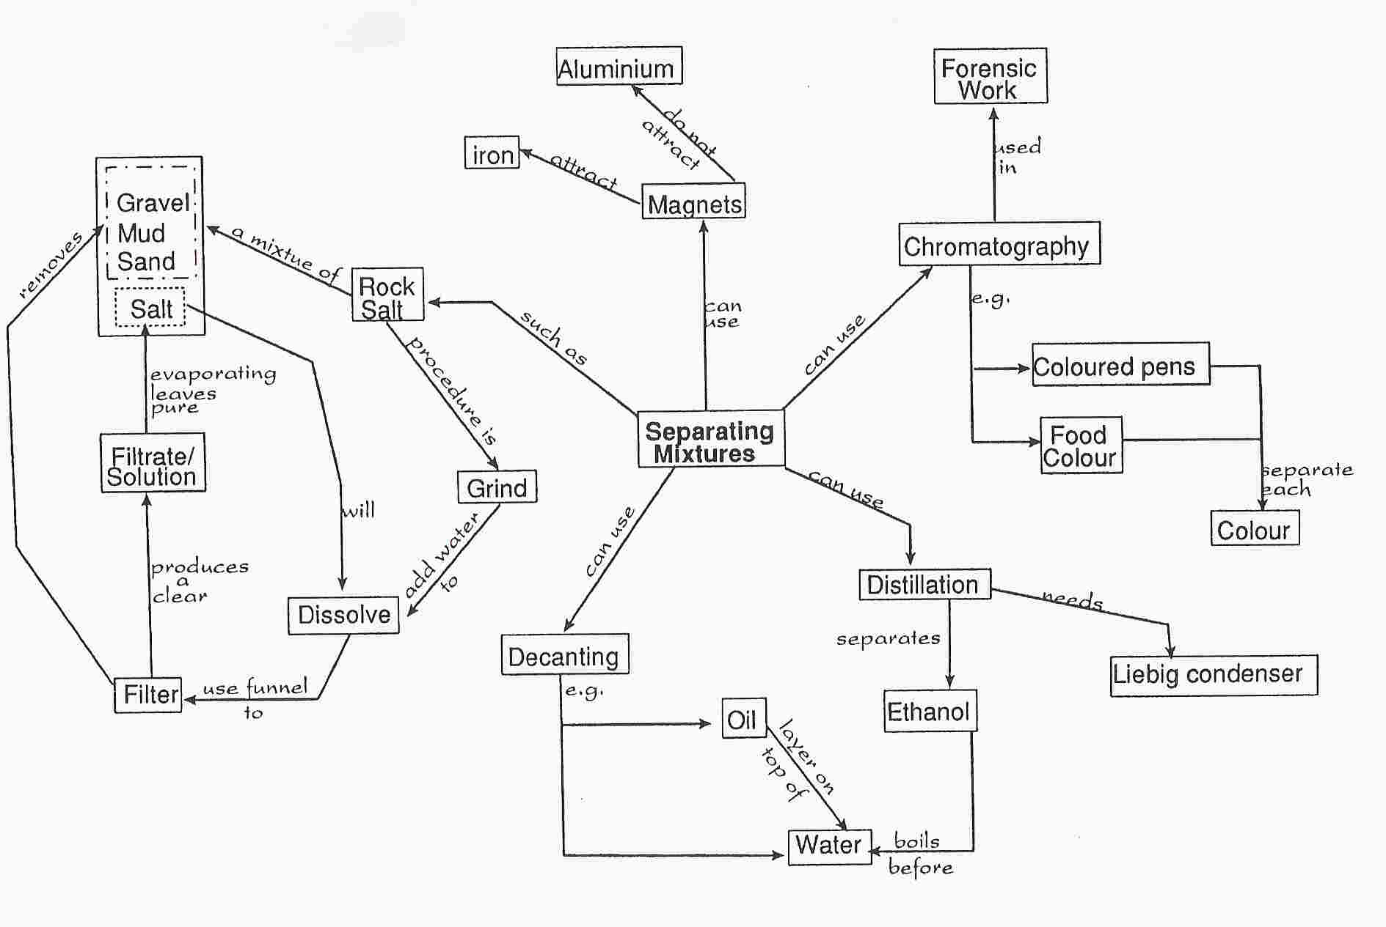

taken from ‘Mappers’ Handbook’, Learners’ Co-operative Ltd

3. Diamond Ranking

What is it? A strategy that promotes discussion or reflection about the relative importance of a range of factors. Diamond ranking, as opposed to simple ranking, encourages a focus on the single most important – or one you agree with most strongly – then the next two, next three, next two, the last one. Learners place them in a diamond shape as shown and then justify their decisions. Typical grids are shown below along with an example:

16 Grid Diamond 9 Grid Diamond

Most Important

Least Important

Example

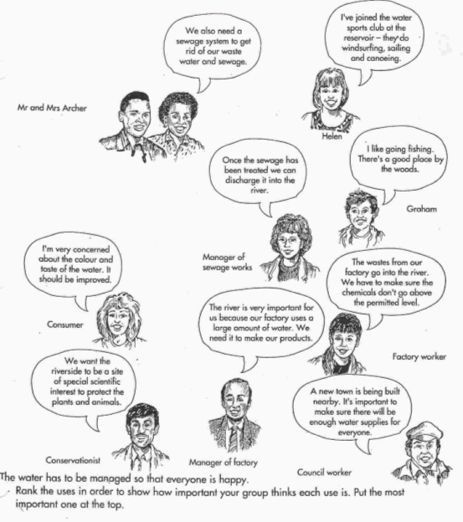
taken from ‘Science Kaleidoscope’, Heinemann
4. Fortune Lines

What is it? For complete explanation, see Living Graphs/Living Maps.
The main skills addressed in this strategy are sequencing, which usually provides one of the organising features of the Fortune Line, and interpreting information, where learners have to interpret statements and place them on the graph. Fortune lines are particularly powerful for supporting humanities subjects such as history, geography and RE, as well as appropriate for developing essential literacy and numeracy skills. A Fortune Line is usually focused on the experiences or fortunes of a central character or characters. This character can be real or fictional, the only requirement being that they undergo changes in their fortune over time.

Example: Goldilocks and the 3 Bears

For further discussion on using this resource, see Sequencing also.

Sentences and story pictures

The Three Bears went for a walk in the wood.

Baby bear saw his chair was broken.

Baby bear chased Goldilocks out of the house.

Goldilocks ate up all the porridge.

Goldilocks was very pleased to see her Mum.

Goldilocks saw Daddy Bear’s chair.

‘extras’ to generate conflict

“What big eyes you’ve got Granny”, said Little Red Riding Hood



Fortune Graph – Learners complete with sentence level work or story pictures/both.
How did they feel?

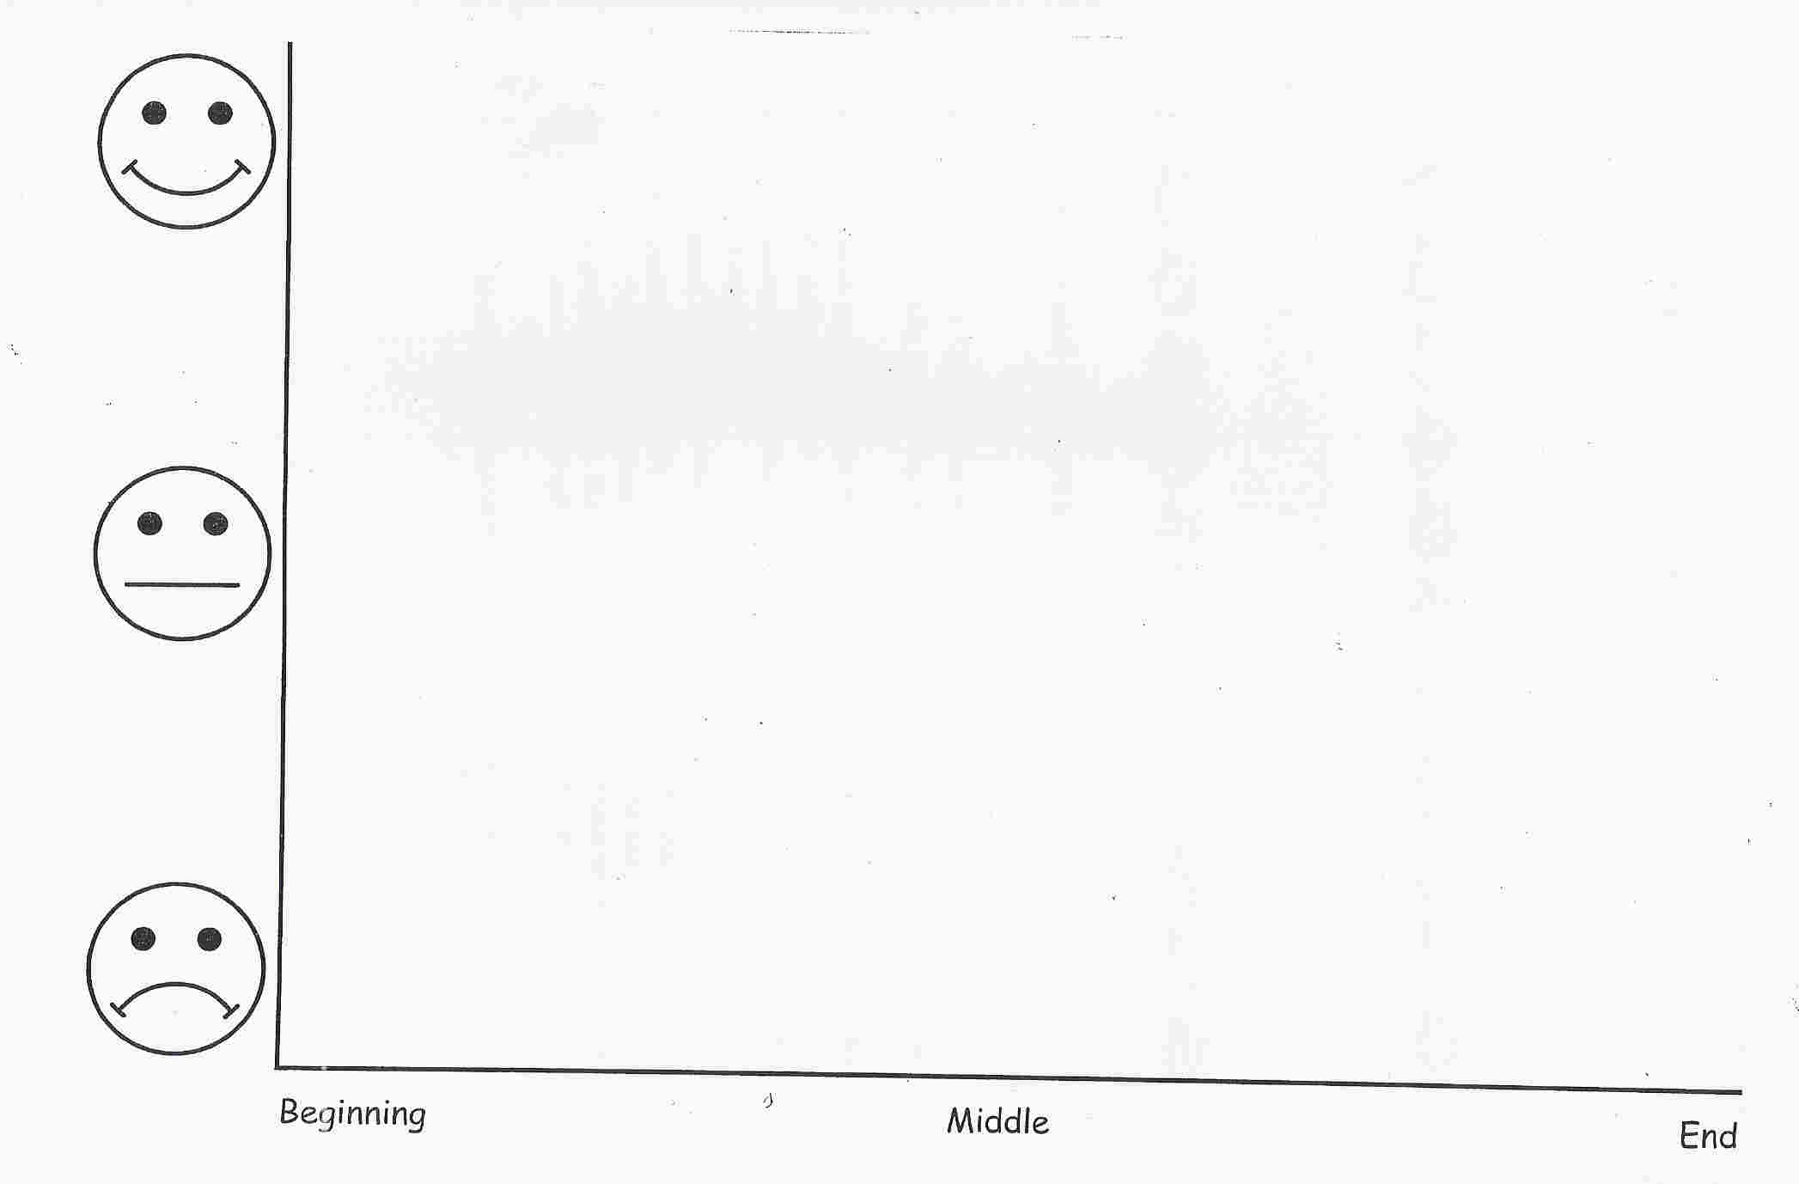
Idea taken from ‘Thinking Through Primary Teaching’, Chris Kington Publishing.

5. Hot Seating

What is it? This strategy has a number of variations. In the first of these, a learner is selected to act as an ‘expert witness’ or to assume the role of a character. They may either be given information beforehand or be required to solve queries using knowledge of the subject as a result of a sequence of lessons. The rest of the class are put into groups and they must devise a list of questions to put to the ‘expert witness’. A small panel of ‘enquirers’ are chosen from these groups. The teacher may act as ‘judge’ to rule out any inappropriate questions! Dressing up for role play is optional but some learners prefer it to be more in character! Works extremely well for emotive ideas when linked with prior research.

Example: Carrie’s War
Learners had been studying the above text and were exploring how emotions can be conveyed in creative writing. Questions put to ‘Carrie’ included how she felt about being evacuated, was she lonely, what belongings did she choose to take with her to Wales etc…

6. Jigsawing

What is it? The class is divided into groups and each group presented with a different task. The findings of the groups, once amalgamated, is required by the whole class to solve a problem. During a set time-limit, the groups must fully research their task and devise a way of clearly communicating this information to another group/the class. Groups share their findings and further discussion is promoted on how best to use this collective information to solve the original problem (links well on a large-scale to ‘Placemat Activities’).

Example: Problem: How did the lives of the poor and rich compare in the Middle Ages in Britain?

Group tasks
Group 1: Schooling for the rich
Group 2: Schooling for the poor
Group 3: Clothing of the rich
Group 4: Clothing of the poor etc..

Groups share information, discuss what it means and the best way to present their information. From here, learners may be encouraged to use another Thinking Skills strategy e.g. Venn Diagrams.

7. Just a minute

What is it? Group work exercise. Learners are asked to talk for one minute on a particular topic such as ‘light’; if they say anything incorrect the opposing team can step in and take over, winning the point.
8. KWL/KWHL grids

What is it? Often used as a ‘learning log’ as it allows learners and teachers to explore prior learning. Learners can prioritise or select their method of enquiry, success is obvious, monitoring of the learning is easy as is evaluation of learning that has taken place.

Example:

What do I Know? | What do I Want to know? | What have I Learnt?
Teachers may choose to fill in the ‘W’ column with a few questions linked to the learning intention and allow learners to select further questions also.

An example of a KWHL grid is given below. This promotes a more metacognitive intention.

What do I Know | What do I Want to know? | How did I learn it? | What have I Learnt?

9. Living Graphs/Maps

What is it? Closely related to Fortune Lines. These activities encourage learners to interpret information from segmented text and organise it using a visual graphical structure. They promote effective listening and negotiating skills as well as inference and reasoning. Learners must make decisions about the relevance and weight they give to different pieces of information; they have to manage at least two aspects of the data at the same time, one of which is usually chronological and the other dependent on the context chosen for the activity.

In a Living graph, learners must justify the position of statements on the graph, as ambiguous statements are also included; the nature of the graph can vary as a line graph or bar chart depending on the data. What is important is that learners need to be able to interpret the numerical information or the overall shape of the graph.

Example: Busy Road

Statements for ‘Busy Road’

Mrs Nixon, the headteacher, drives her car into the school car park.

Mr Jordan drops Lee, David and Ellie at the school gate.

PC Smith drives home from nightshift.

A bus drives past the school. It is full of people going to work.

At 2 o’clock, a van driver delivers some paper to the school.

Caspar the caretaker’s cat crosses the road.

Mr Garner the lollipop man puts on his coat and collects his stick.

Mrs Scott the teaching assistant leaves the car park to go home.

Mrs Al-Asadi collects Jamal and Jemma from school.

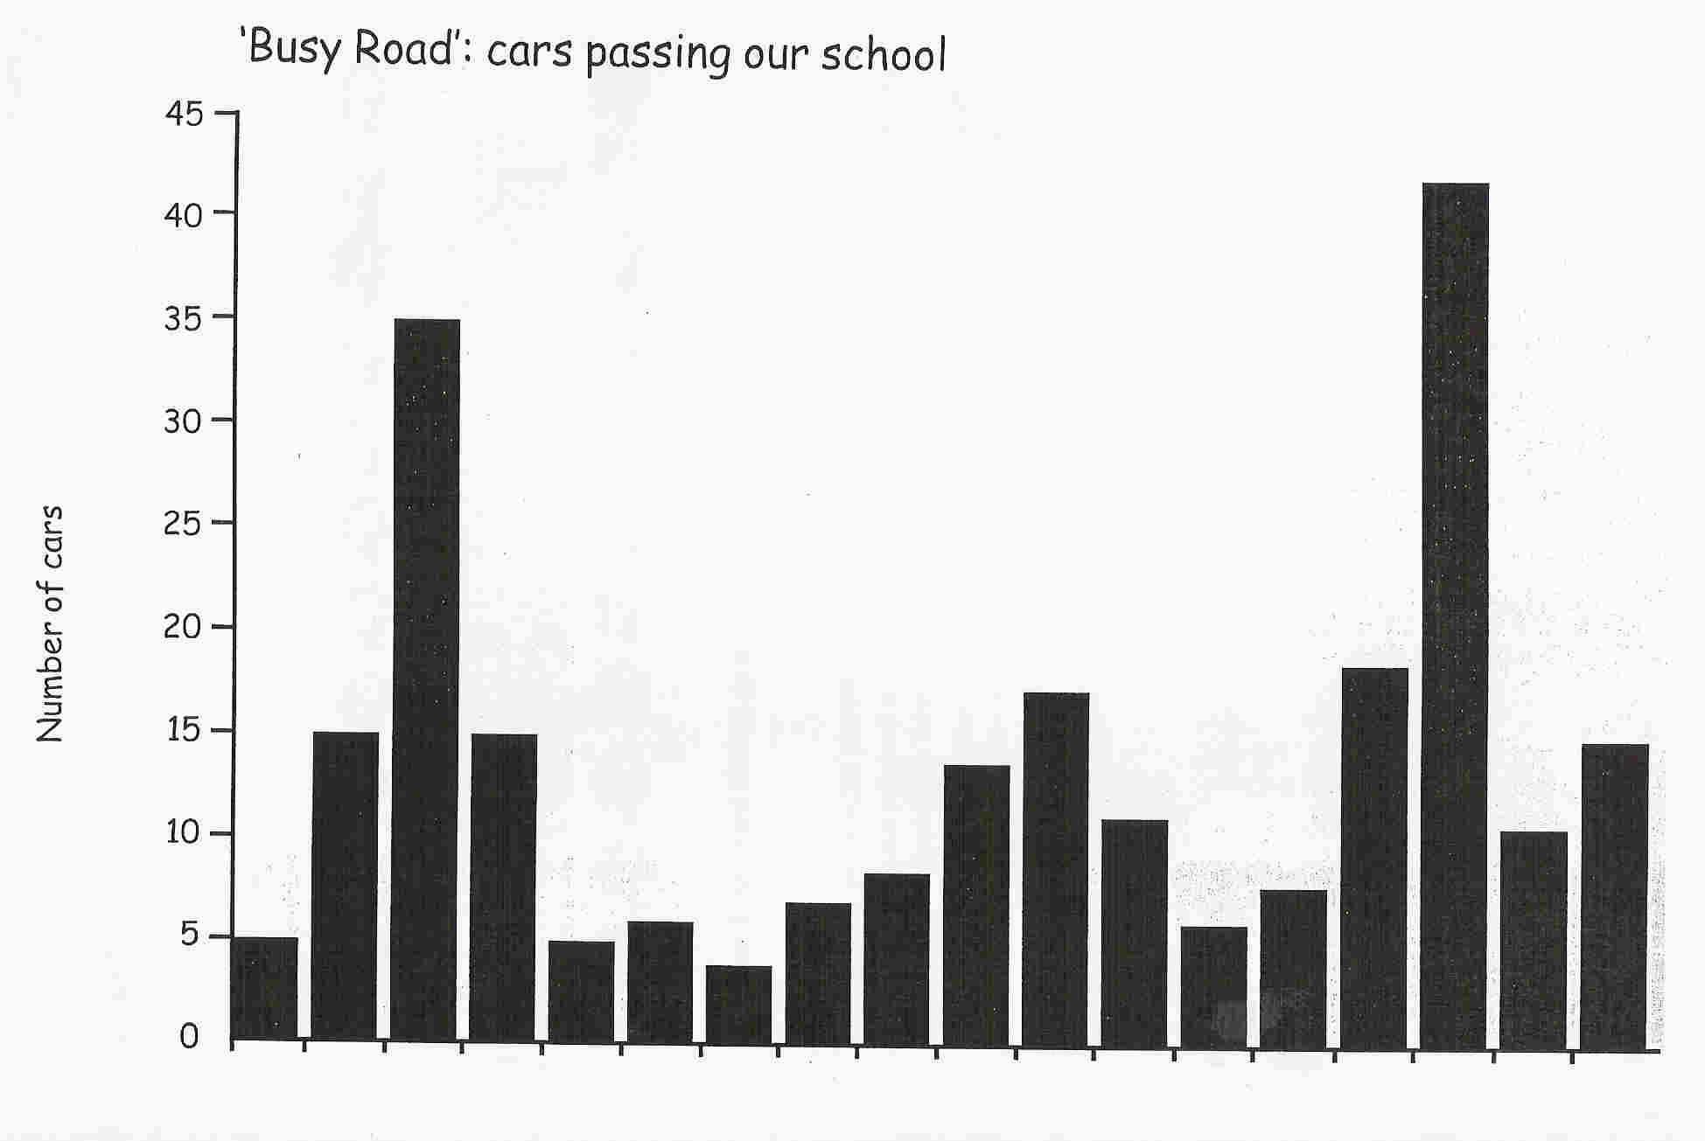
taken from ‘Thinking Through Primary Teaching’, Chris Kington Publishing.
10. Memory Diagram

What is it? Learners work in groups. Each group either has an unlabelled diagram/map or a blank sheet of paper. Hidden around the room are copies of the labelled diagram/map. One member of the group is given 10 seconds to look at the completed version and then must return to their group, draw what they remember and instruct the next group member in what they should look for. The whole group is involved in developing a strategy that will allow them to complete the task accurately and in the shortest amount of time. Questions may be given after completion to test understanding of the construction of the diagram.

Example: Rock Cycle

The Rock Cycle
Sediment
Sedimentary rock
Metamorphic
rock
Magma
Igneous
rock
Cemented together
Weathering
And
erosion
Weathering
And
erosion
Rising, cooling
And solidifying
Heat and increased pressure
Partial melting
Heat and
Increased
pressure
Weathering
And erosion

A variation on this strategy is to Text-to-Picture/Picture-to-text.
In these cases, groups are required to study a short piece of text and represent this as a diagram or vice versa (this activity tends to work best with very specific text).

11. Mind Mapping

What is it? Invented by Tony Buzan, Mind Mapping © is a system for recording information in a way which is more compatible with the way the brain works than linear text. The main concept is positioned centrally with lines radiating outwards with a single word on them to represent each connected main idea. Smaller branches radiate out from the main branches with subsidiary ideas and examples. Learners can use colours, pictures, text and lines to link related ideas on different branches. A simple example is shown below:

number
help
guests
time

Plan
Make
Meal Design
likes

time?
recipe
allergies
tools

menu
ingredients

shopping

12. Most likely to (closely related to ‘Who-what-when-where’)

What is it? Learners work in groups and are usually presented with some visual/audio evidence (possibly pictures/video/music). They use this evidence to justify ideas of questions posed by the teacher e.g. Who is likely to live there/personality of people/feelings evoked etc.

Example 1
Learners are shown video clip with soundtrack removed – groups are asked to describe the mood of the place, who is most likely to live there etc. A selection of three pieces of music is played. The groups have to justify which piece of music they would use as the soundtrack. A comparison with the actual soundtrack can lead to valuable discussion and exploration of initial ideas.

Example 2
Learners are shown a selection of photographs (e.g. Urban, City, Coastal etc…). They are asked to discuss a series of questions in groups and justify their answers e.g. “Where would you be most likely to see a fox?” “Which area would be most likely to benefit from tourism?” ….etc

Example 3
Learners are given photographs of a number of places of worship and asked to identify with justification a series of answers e.g. “Which is most likely to be a Roman Catholic Church?”, “How do you know?”, “Which is most likely to be found in Asia?” …etc.

13. Mysteries/Multi layer mysteries

What is it? This is a problem-solving activity based around (a) central question(s), which learners must investigate and attempt to answer. The information or ‘clues’ are presented on separate slips of card which learners must sift through in order to reach their conclusions. Mysteries are very versatile teaching and assessment aids that can be used to promote a wide range of cognitive skills. Mysteries tend to have a strong narrative thread – they are about people to whom things happen or who initiate events. This helps to engage the attention of learners of all levels. These people, places and circumstances do not have to be real, they can be an amalgam that represent important relationships and generalisations, but closeness to reality is preferred! Good sources of material for developing mysteries are newspaper articles. Most mysteries lend themselves to sequencing activities, which can help learners develop their own narrative for the event.

Example: What was the cause of the start of the Great Fire of London?

There are a number of variations as to how to run this activity. Some teachers present a ‘big question’, others ask learners to develop a series of questions to solve after studying the cards. Learners and teachers can discuss effective sorting methods, timelines, strength of evidence etc. Follow up work may involve learners to present their evidence in a number of different ways.
Statement cards

Thomas Farrinor was Baker to King Charles II. | The Baker’s maid was the first victim of the Great Fire.
The Baker said that he thought he had put out his oven, but embers from the fire set light to nearby firewood. | Most of the houses and buildings were made of wood and many had thatched roofs.
The people tried to put the fire out with buckets of water. | Hundreds of rats lived in Pudding Lane.
Lots of people spent time saving their things instead of trying to stop the fire spreading. | On Wednesday night the wind hushed and the fire burned gently.
The buckets were made of wood and leather. | The fire destroyed about four-fifths of the city, or more than 430 acres.
The Baker forgot to turn off his oven. | The Baker lived in Pudding Lane.
The fire started in Pudding Lane. | The buildings caught fire very easily.
Sparks from the Baker’s burning house fell on hay and straw at the Star Inn. | Riverfront warehouses were bursting full of oil, tallow and other combustible goods.
The strong easterly wind kept the fire burning. | The fire began at night when everybody was asleep.
About 13,200 houses, nearly 90 parish churches, and nearly 50 livery company halls were burned down. | Houses were pulled down to stop the fire spreading, but wood and rubbish were left lying in the street.
taken from ‘Thinking Through Primary Teaching’, Chris Kington Publishing.

14. Odd One Out

What is it? This is a versatile strategy and can easily be applied and developed in different subjects and with different ages of learners. It helps learners to develop an understanding of key concepts and vocabulary. This supports skills such as classification, and defining attributes. It also helps learners to understand properties of things. Learners could be asked to identify a similarity that distinguishes two items from a third and can be a basis for whole class work as well as paired or group work.

Example 1
amphibian
Webbed feet/
lives on water
?

?

?

farm
animal
?

Has feathers

Has feathers.
Is a bird

Example 2
3 569
6 is the odd one out

Kylie
5 is the odd one out
5 is the odd one out
But for a different reason
To Romeo
Romeo
Mark
What are their reasons?
taken from ‘Thinking Through Primary Teaching’, Chris Kington Publishing.

15. Placemat activities

What is it? This strategy encourages all members of a group of four to share ideas in a constructive and visual manner. Learners are given a large A3 laminated ‘placemat’, as shown below, along with some post-it notes. Each group member individually compiles their own ideas on a particular problem and writes them on post-it notes. He/she then sticks the post-it notes on their section of their group’s placemat. This provides a more concrete basis for learners to question other members of their group about ideas. Each group then compiles a collaborative answer by moving selective post-it notes to the middle section. The group’s ideas are then shared with other groups. This is a very powerful strategy in ‘training’ learners in managing metacognition and devising strategies as they can physically follow the path of their decision making.

Example:

More jobs = more money for locals

More money for public
Increased house prices
What are the effects of increasing industry in South Wales valleys?

More people visit area

Increased pollution
Less tourists visit

16. PMI diagram (Edward de Bono)

What is it? Learners categorise their learning or ideas into: P plus (i.e. worked); M minus (i.e. may not work) and I interesting. Encourages learners to identify what has worked and not worked for their learning. A grid can be used like the one below.

Plus (worked)

+

_
Minus (not worked)
Interesting

17. Post-it challenge

What is it? A combination of placemat activities and snowball challenge! Learners are given a two-minute time limit to write on a post-it note three things they remember (or believe) about a topic/idea/issue. These are collated on the board at the front of the class. Learners and the teachers discuss their relevance and could summarise in chart form or concept map etc.

18. Questionnaire

What is it? A useful strategy that allows learners to reflect on their own learning both individually or collaboratively. Groups could devise a questionnaire for other groups to develop feedback techniques.

19. QuADS grids

What is it? Similar to KWL grids, QuADS grids allow more focus research of a particular question to be undertaken. An example is shown below:

Question | Answer | Details | Source

A question, or series of questions may be posed to learners (or they may be invited to write some of their own). An activity is then used that allows learners to research possible answers. Learners must summarise any information discovered and produce a clear and succinct answer. Any details that they think support their answer, or that they feel are of interest to the discussion, can be recorded in the Details column. Finally, learners must provide accurate details of their research sources for use by other learners.

20. Reflection Triangle

What is it? These are popular and valuable visual prompt for structuring metacognition and linking strategies to other curriculum areas. They can be used from the Foundation Phase to Key Stage 5 (with obvious modifications!). They are also a useful tool as they encourage learners to assess and monitor their individual progress and track types of thinking.

How did
you recognise
these strategies would be
useful?

Reading? Diagrams?
Classifying? Discussing?
Listening? Using models?

- How did they help you solve the problem?

Individually? Groups?
- Which was better? Why?

21. Sequencing

What is it? This strategy is frequently used at KS1 although its merits extend through all key stages. Learners may be asked, on the simplest scale, to sequence numbers, letters or pictures according to pre-set criteria or learner-led criteria. In later key stages, the criteria for sequencing are most likely to be learner-led. In both cases, however, the key issue is that learners must justify to others their reasons for selecting their chosen sequence. A number of examples are shown below.

Example 1: KS1 from ‘Let’s Think!’.
Learners work in groups of six and are each given a card from the story ‘The Cat and the Snail’. They must work together to sequence the pictures to tell the story – but avoid the ‘Red Herring’ picture, which does not fit the sequence!

Example 2: KS1/2 Goldilocks and the Three Bears

Learners read the story of Goldilocks and the Three Bears, and then work in groups to reconstruct the story: firstly using pictures alone, then using sentence strips and finally matching the two together. Resources are outlined under the section for ‘Fortune Lines’. For further challenge, pictures that do not fit the story may be added – this stretches learners to decide whether to include or exclude the information, with justification.

22. Snowball Challenge

What is it? Learners are arranged in teams of five and are asked to remember ONE thing about a topic and write it down in 10 seconds. On bell/whistle, they cover their answer and pass to next team member who records their idea etc. The ‘snowball’ is passed to the next person so that the ‘facts’ grow in size. Once all learners have been involved, they open their ‘snowball’ and share their results with the rest of the class, comparing and contrasting the nature of their results. Learners may reflect on what the frequency of specific ideas emerging might tell them. They may discuss if there appears to be specific emphasis on any particular area or quality of idea.

23. Splat!

What is it? This is a Thinking Skills group-version of bingo. Teams of up to seven learners each are selected and they each elect a ‘splatter’. The ‘splatters’ are sent out of the room for 5 minutes while the remaining team write definitions for the keywords contained on the grid. To play the game, one group is selected to read a definition of their choice – ‘splatters’ must listen to the definitions and quickly ‘splat’ their hand across the word on the grid. Two points are awarded for the fastest ‘splat’ (providing the answer is correct) BUT the splatter must justify their reason citing evidence in the definition. For a correct ‘splat’ but insufficient/incorrect justification a mark is taken off. The teams alternate to give another definition and the process repeats. The first team to amass 10 points is the winner.

Example: Glaciation

erosion | freeze-thaw | deposition | Corrie
transportation | fjord | tarn | Moraines
pyramidal peak | drumlin | hanging valley | Striation

Idea taken from ‘Framework Science’, Oxford University Press.

24. Taboo

A person is given a word and he/she has to describe the word using single words only for their team to guess. However, they must not use the word itself or a selection of other words (also given to the learner) as part of the description! Works well for all subjects – MFL especially! An example is shown below:

Example: Anifeiliaid yn Gymraeg

- Ci 2. Ceffyl 3. Mochyn
Taboo Taboo Taboo
Dog Horse Pig
Woof! Neigh! Oink!

25. Traffic Lighting
What is it? Traditionally a well used and successful strategy for both developing skillful thinking and Assessment for Learning. Before or after a section of work, before or after a test, or as part of a major revision programme, learners traffic-light key words, key concepts or even parts of exam papers. This allows them to prioritise their future efforts towards the things they don’t yet understand or cannot yet do. They need help in sub-dividing the content or skills before they can use the colours but can then focus on trying to turn reds to amber and ambers to green.
Red: can’t do it yet Amber: not sure Green: can do this
An extension of this exercise would then be to pair up ‘Amber’ and ‘Green’ learners to share ideas, whilst the teacher may group the ‘Reds’ together and work with them as a discreet group. Alternatively, this interdependence may be fostered through whole-class discussion and ‘Red answers’ may form the basis of future learning intentions.
Younger learners may find it easier to use thumbs up / thumbs down / thumbs sideways.

26. Venn Diagrams

What is it? This is a useful tool for helping learners to classify factors relating to a particular topic and to see relationships between these factors. Teachers may present the categories to the learners when working at very simple levels and progress to learners categorising with justification as experience increases. Another variation is to identify each ‘circle’ and present an overarching problem and allow learners to research ideas and present their results using Venn diagrams as discussed earlier. Also to increase the level of cognitive challenge and promote further discussion, ambiguous statements or items may be included.

Example: Machines

saw
hammer
scissors
screwdriver
nail
bolt
pliers
clamp
plane
drill
spanner
nut

27. Whole and Part

What is it? This strategy uses a visual framework (or graphical organiser) to guide the learner’s thinking. It encourages learners to identify functional and systemic relationships between objects or systems. They can be used as an individual or small group activity as they provide excellent discussion material.

Example: Eagle
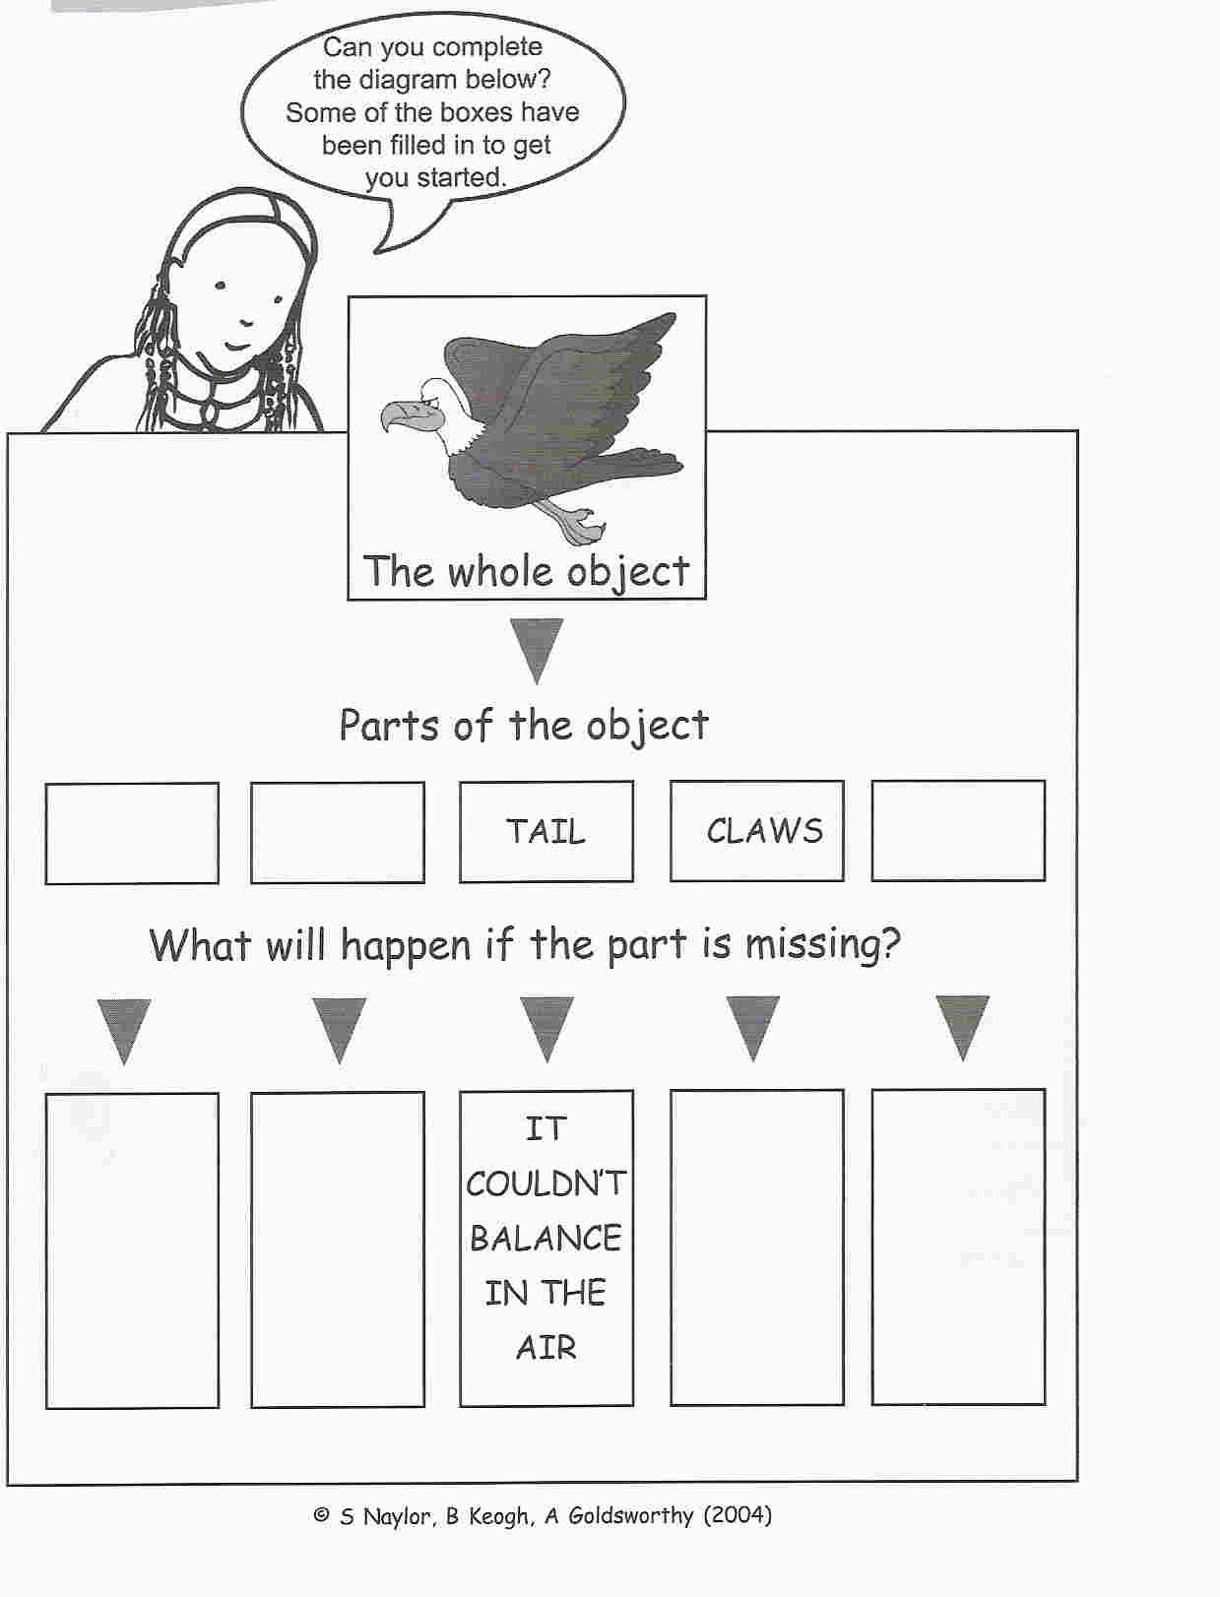
taken from ‘Active Assessment’, S. Naylor, B. Keogh, A. Goldsworthy.

28. Who-what-when-where

What is it? This strategy has been used extensively in the Humanities and Arts; typically it uses a visual or auditory stimulus (possibly a selection of photographs or diagrams or different pieces of music) and learners are asked to identify with justification which resource best fits the answer to a series of questions.

Example: Year 9 Geography
Learners were shown various photographs of a city centre, taken at different times of the year, times of day, decades etc. Learners were asked a series of questions such as:
- Which photograph was taken in mid-summer?
- Which photograph was taken in 1950s? etc

Can be extended into ‘Most likely to’ situations as outlined earlier.

Appendix 3

Using these strategies

We will concentrate on developing assessment for learning across the three broad areas: Questioning, Feedback, Peer and self-assessment. In the table below, we have been identified some principles that enhance the learning experiences. Associated with each principle are suggested teaching strategies. Teachers and advisory colleagues may have their own ideas as to strategies that would work better in their classrooms and could choose to use these instead. It is hoped that teachers will add their own ideas to this list as the programme goes on. For this reason this section is printed on separate pages so that examples of these strategies that have worked in the classroom can be easily added.

Questioning
Assessment for learning principle | Suggested teaching strategy
Improving quality of answers | Increasing thinking/wait time  Big questions  Collaboration on formulating questions  Finding questions learners get wrong
Peer discussion | Think-pair-share  Group responses  Phone a friend
Active involvement of all pupils | Whiteboards  Choice of answers  No hands up  Setting ground rules

Feedback
Assessment for learning principle | Suggested teaching strategy
Target setting | Comments only  How to improve  Closing the gap comments  Temporary comments  Two stars and a wish
Immediacy of feedback | Allow time  Self-assessment  Learner-to-learner dialogue

Peer and self-assessment
Assessment for learning principle | Suggested teaching strategy
Ongoing assessment in lessons | Traffic lighting  Thumbs up/thumbs down  Talk partners  Post-it challenge  KWL/KWHL grids  QuADS grids  Triangles  Self-marking  Peer-marking
Using summative assessments formatively | Reviewing tests  Big copies of exam questions  Learners set questions  Exam question analysis  Coursework

Please note: The allocation of strategies to principles is at times arbitrary as many strategies fulfill key roles for more than one principle. In addition, there is much overlap between principles.
Index to Useful Assessment for Learning Strategies
Strategy Page
- Increase thinking/wait time 54
- Big questions 54
- Collaboration on formulating questions 55
- Finding questions learners get wrong 58
- Think-pair-share 58
- Group responses 58
- Phone a friend 58
- Whiteboards 58
- Choice of answers 59
- No hands up 60
- Setting ground rules 60
- Feedback using comments only 60
- How to improve 60
- Closing the gap comments 61
- Two stars and a wish 61
- Instant feedback 61
- Allow time 61
- Self-assessment 62
- Learner to learner dialogue 62
- Temporary comments 62
- Traffic Lighting 62
- Thumbs up/Thumbs down 63
- Talk partners 63
- Post-it challenge 63
- KWL/KWHL grids 64
- QuADS grids 65
- Triangles 66
- Self marking 66
- Peer marking 66
- Review of summative tests 67
- Group work on big copies of exam questions 67
- Learners set questions 67
- Exam question analysis 68
- Coursework assessment 68

1. Increase Wait time/Thinking time

What is it? Increase ‘wait time/thinking time’ for learner response to at least 5 seconds. This allows learners to answer open questions and not those simply based on recalled facts. Another technique involves learners recording their ideas on mini-whiteboards or paper before displaying their answers.

2. Big questions

What is it? Posing ‘big’, open questions and problem-solving tasks, allowing plenty of time for thinking or researching either as individuals or as groups can lead to a greater depth of understanding and therefore a higher level response. For example “How can we separate salt from water?”, “Why do you think George Orwell wrote Animal Farm?”, “How many ways can you think of to make ten?”

3. Collaboration on formulating questions

What is it? Thinking of ‘good’ questions that elicit thinking and how to word them is not always easy. ‘Good’ questions need to be an integral part of a lesson plan. Collaboration between teachers, either in the same subject area or across subject areas, saves everybody time and effort. A bank of ‘effective’ questions can be built up over time. It’s important that both learners and teachers understand the type of question being asked and a suitable response structure.

Examples of useful questions stems are given in the following table. The questions are classified into types. (Robert Fisher, Brunel University, 1999).

(a) Questions that seek clarification

Question frame | Type of question
Can you explain that…..? | Explaining
What do you mean by…..? | Defining
Can you give an example of….? | Giving examples
How does that help…..? | supporting
Does anyone have a question to ask…..? | Enquiring

(b) Questions that probe reason and evidence

Question frame | Type of question
Why do you think that…..? | Forming an argument
How do we know that…..? | Assumptions
What are your reasons….? | Reason
Do you have evidence…..? | Evidence
Can you give me an example/counter example….? | Counter example

(c) Questions that explore alternative views

Question frame | Type of question
Can you put it another way….? | Re-stating view
Is there a different point of view..? | Speculation
What if someone were to suggest that….? | Alternative views
What would someone who disagreed with you say….? | Counter argument
What is the difference between those views/ideas…..? | Distinctions

(d) Questions that test implications and consequences

Question frame | Type of question
From your ideas, can we work out if….? | Implications
Does it agree with what was said earlier….? | Consistency
What would be the consequences of that…? | Consequences
Is there a general rule for that…? | Generalising
How could you test to see if…? | Testing for truth

(e) Questions about the question/discussion

Question frame | Type of question
Do you have a question about…? | Questioning
What kind of question is this…? | Analysing
How does what was said help us to…? | Connecting
So where have we got to with this problem…? | Summarising
Are we any closer to answering the problem..? | Drawing conclusions

The following box gives some more general questioning strategies, which have been found to be very successful in promoting assessment for learning and extending learner thinking.

Ask ‘follow ups’ Why? Do you agree? Can you elaborate? Tell me more? Can you give an example?

Withhold judgement Respond to learners in a non-evaluative fashion.

Ask for a summary to promote active listening “Could you please summarise John’s point?”

Survey the class “How many people agree with the author’s point of view?”

Allow for learner calling “Sarah, will you please call on someone else to respond?”

Play devil’s advocate Push learners to define their reasoning against different points of view.

Ask learners to ‘unpack their thinking’ “Describe how you arrived at your answer.”

Call on learners randomly Avoid the pattern of only calling on those learners with raised hands.

Encourage learner questioning Allow learners to develop their own questions.

Cue learner responses “There is not a single correct answer for this question. I’d like you to consider alternatives.”

4. Finding questions learners get wrong
What is it? Wrong answers are interesting in that they allow us to identify and challenge a learner’s misconceptions. In a lesson where every learner gets every question right, is anyone learning? We need to develop an atmosphere in which wrong answers are valued as a significant contribution to the learning of the class.

5. Think-pair-share

What is it? Learners are posed a question, given time to think individually, then time to discuss ideas with a partner and finally the pair share their ideas with the rest of the class (or a larger group).

6. Group responses

What is it? Ask learners to make group responses to answers. This strategy can be combined with many others and reduces learners’ fear of failure.

7. Phone a friend

What is it? Ask learners to generate questions. For example learners are arranged in groups and asked to write five questions they do not know the answers to about a particular topic being taught. Each group selects one question from their list. This is read out and given to the next group. The next group reads out their question, which is given to another group until all groups have a question. The groups are then given a set amount of time to find out, discuss and then present their answer to the whole class. The teacher leads discussion where and when appropriate.

8. Whiteboards

What is it? The use of mini write on/wipe off whiteboards – either as individuals or as groups so that learners can display their answers; allows all learners to make a contribution. The teacher can select a few to read aloud.

9. Choice of answers

What is it? Give learners a choice between different possible answers and ask them to vote on the options. This is a very powerful strategy as the fear of failure is removed because learners are agreeing with another person’s ideas therefore they do not have to formulate their own idea and risk fear of rejection by peers. This works especially well in the form of a ‘concept cartoon’ where learners can select a cartoon character that they most agree with. An example of this is shown below:

What factors affect how quickly sugar will dissolve?
The hotter the water,
the faster the sugar
will dissolve
The colder the water but
with granulated sugar
will dissolve faster
than the lumps
Granulated sugar
will always
dissolve faster
Sugar lumps
will dissolve
faster than
granulated
sugar
Temperature
will have no
effect
I think…….
Sarah
Gethin
Jenny
Bethan
Alun
An extension to this form of questioning is then to allow learners to
formulate their own thinking in a character ‘think bubble’ – this
may be a direct agreement with one of the other cartoon characters
or original thought by the learner.
10. No hands up

What is it? Some teachers have used ‘no hands up’ strategies to good success. All learners are expected to contribute, and all answers valued. The teacher may select anyone in the class to answer questions. Therefore all pupils need to frame an answer to the question in their head.

11. Setting ground rules

What is it? Setting ground rules for questions and answers often promotes animated and frank discussions; learners appreciate that they will all be expected to contribute; that half-right answers are good for learning; that it is ok to ‘pass’ until they feel they have clarified their thinking by discussing with peers.

12. Feedback using comments only
What is it? The only type of marking that has any effect on learning is ‘comment only’ as discussed earlier. The addition of a grade destroys any benefit from the comment. Learning happens when the learner has strengths and weaknesses identified, and is given clear advice on how to improve. This technique could be combined with peer assessment so that learners feed back to peers about how improvements could be made.

13. Targets of how to improve

What is it? Learners are given targets but more importantly are shown how to reach those targets. Teachers then check that targets have been reached.

14. Closing the gap comments

What is it? Whatever the task, feedback should first focus on the learning objective of the task. The emphasis when marking should be on both success against the learning objective and improvement needs against the learning objective. Use focused comments to help the learner in ‘closing the gap’ between what they have achieved and what they could have achieved. Useful ‘closing the gap’ comments are:
- Reminder prompt (“What else could you say here?”)
- Scaffolded prompt (“What was the boy doing?, “The boy was so angry he….”, “Describe the expression on the boy’s face.”)
- Example prompt (“Choose one of these or your own: He ran around in circles looking for the rabbit/The dog couldn’t believe his eyes.
(taken from Unlocking Formative Assessment, Shirley Clarke)

15. Two stars and a wish

What is it? A strategy to make sure that there are always positive comments on work with a target. Use ‘two stars and a wish’ when feedback is two positive comments (the stars!) on the work and one specific improvement to make as soon as the comment is received (the wish!).

16. Instant feedback

What is it? Feedback should be as immediate to the task as possible. It should also be related to the learning intention, otherwise learners’ expectations will be that the learning intention is of secondary importance to other issues, e.g. spelling, presentation etc. The use of peer and self-assessment can help to make feedback immediate.

17. Allow time

What is it? When work has been distance-marked, allow learners time to read and then make one focused improvement based on the improvement suggestion. In order for the marking to be formative, the information must be used and acted on by the learners.

18. Self-assessment

What is it? Where possible, allow learners to self-assess work. This involves sharing learning intentions with learners and agreeing on success criteria. Learners will also benefit from looking at work of good quality before they start their task.

19. Learner to learner dialogue

What is it? Encourage a dialogue between learners rather than between teacher and learner. The learners can take it in turns to be the ‘teacher’ when pair marking; they could discuss each other’s work together (e.g. “I think this bit really shows how that character feels, what do you think?”)

20. Temporary comments

What is it? Ensure that corrections to work and comments about the work are temporary. Use pencil or post-it notes for learners to remove once they have acted upon the comments.

21. Traffic Lighting
What is it? Traditionally a well used and successful strategy. Useful at various stages in a lesson (or sequence of lessons), after a section of work, before or after a test, or as part of a major revision programme, learners traffic-light key words, key concepts, learning intentions, or even parts of summative exam papers. This allows them to prioritise their future efforts towards the things they don’t yet understand or cannot yet do. They need help in sub-dividing the content or skills before they can use the colours but can then focus on trying to turn reds to amber and ambers to green.
Red: can’t do it yet Amber: not sure Green: can do this
An extension of this exercise would then be to pair up ‘Amber’ and ‘Green’ learners to share ideas, whilst the teacher may group the ‘Reds’ together and work with them as a discreet group. Alternatively, this interdependence may be fostered through whole-class discussion and ‘Red answers’ may form the basis of future learning intentions. This strategy gives an immediate indication of learners’ understanding and allows the teacher to tailor support accordingly.

22. Thumbs up/Thumbs down

What is it? Similar principles to traffic lighting and avoids the trials of writing self-assessments. Is very useful for younger learners who may struggle with the concept of ‘amber’; instead they hold their thumb to the side.

23. Talk partners

What is it? Learners share with a partner three new things they have learned, what they found easy or difficult, what they need to improve, something they would like to learn next, etc. This strategy allows an overview of the learning that has taken place and allows the teacher to change the teaching focus if necessary.

24. Post-it challenge

What is it? Groups, pairs, individuals evaluate their learning. For example “What have I learned?”, “How did I learn this?”, “What I found easy/difficult?”, “What I need to do next?” on post-it notes and then share with another group or the rest of the class. This technique focuses on thinking about learning and encourages learners to think towards their next steps.

25. KWL/KWHL grids

What is it? Often used as a ‘learning log’ as it allows learners and teachers to explore prior learning. Learners can prioritise or select their method of enquiry, success is obvious, monitoring of the learning is easy as is evaluation of learning that has taken place.

Example:

What do I Know? | What do I Want to know? | What have I Learnt?

Teachers may choose to fill in the ‘W’ column with a few questions linked to the learning intention and allow learners to select further questions also.

An example of a KWHL grid is given below. This promotes a more metacognitive intention.

What do I Know | What do I Want to know? | How did I learn it? | What have I Learnt?

26. QuADS grids

What is it? Similar to KWL grids, QuADS grids allow more focus research of a particular question to be undertaken. An example is shown below:

Question | Answer | Details | Source

Learners may be posed a question or series of questions (or may be invited to write some of their own). An activity is then used that allows learners to research possible answers. Learners must summarise any information discovered and produce a clear and succinct answer. Any details that they think support their answer, or that they feel are of interest to the discussion, can be recorded in the Details column. Finally, learners must provide accurate details of their research sources for use by other learners.

27. Triangles

What is it? Learners place knowledge and feelings in different areas as shown. They allow the learner to interconnect senses and emotions.

28. Self Marking
What is it? Learners mark their own work using mark schemes or assessment criteria. It is most effective if learners understand the assessment procedure and look for ways to improve future work. (Additionally, self assessment of ‘effort’ can be done by learners before they hand work in).

29. Peer Marking

What is it? Learners mark or comment on others’ work. Can be very effective after group or individual presentations, especially if the assessment criteria are clear and have been discussed before the work begins.

30. Review of summative tests (high and middle attainers), (middle and low attainer groupings)

What is it? When a test has been marked by the teacher, learner or peers, the teacher then puts the learners into groups of four or five to look for ways to improve. Tasks could be “Find ten more marks” or “Find enough improvements to move up a grade”. The group can much more easily seek real help when they don’t understand and they can provide solutions for each other. Practice suggests that this approach works best grouping high and mid attainers, and mid and lower attainers, as all can then contribute.

31. Group work on big copies of exam questions
What is it? Each group of three or four gets a super-size laminated exam question. They have to discuss their suggested answer before writing it on in felt-tip pen. They are more prepared to take risks knowing that they can rub it out and work collaboratively. After this they can mark their joint effort using a mark scheme, and then traffic light the appropriate section of their notes.

32. Learners set questions
What is it? Setting questions is a high level skill. It involves learners in deciding the task but also highlights misconceptions quickly. Learners often set impossible questions or do not provide sufficient information for the task to be done. Their own mark schemes are often not directly related to the question they set. By practicing this skill, they learn how to interpret questions and work out what sort of answer is being sought by the questioner. This exercise takes time as they find it hard. It can be done by asking pairs to write three questions, with a mark scheme on the back of each one. When they’ve finished, they pass their questions on to another pair. Finding faults with each others’ questions generates good discussion between pairs.

33. Exam Question analysis

What is it? Many learners don’t know what exam questions are asking for. There are clue words that we know and try to teach them to respond to but ‘explain’ often gets a description as an answer! Some learners don’t realise the number of marks or the size of the space gives them information about their response. Discussion about these issues before and after doing practice questions can really help learners to understand the way that their work will be marked.

34. Coursework – understanding the assessment system including peer and self assessment
What is it? Do learners know what a good piece of coursework (or any work) looks like before they start? Make the assessment criteria explicit and get groups of learners to mark exemplar pieces from last year. Make sure that they see a range so that they can tell the difference between an average piece of work and an excellent one. When their coursework has been marked, using only comments, get them to read the comments and then set targets for their next piece of coursework. Then, they can interpret your comments to decide on their mark. This can be collaborative and involve peer as well as self assessment. Again it takes longer but has a dramatic effect on the quality of the work.

