
Adding a New Kid to KidDesk

When you load the program by double clicking the KidDesk icon
hold down the Shift key and the Alt key simultaneously then tap the A key.
The program will shrink to the Teacher Mode Window.
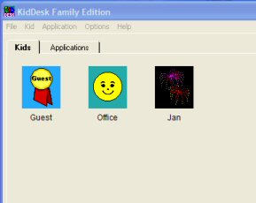

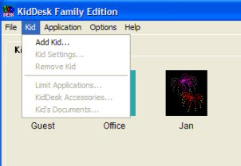
Click on the Kid pull down menu and click on Add kid

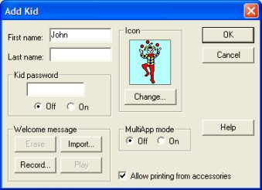
Type in the name and select a picture to
represent that child by clicking on the Change button and selecting the required image. Click OK. The new user should now be created.
