
Add/Remove Applications

When you load the program by double clicking the KidDesk icon
hold down the Shift key and the Alt key simultaneously then tap the A key.
The program will shrink to the Teacher Mode Window.
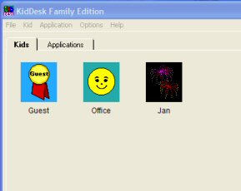

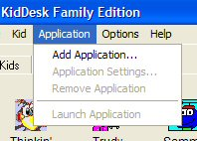
Click on the Application pull down menu and
click on Add Application.

Click Continue.

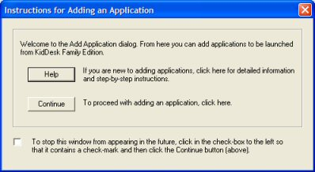

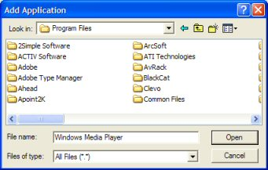

Navigate to the required application in Program Files.

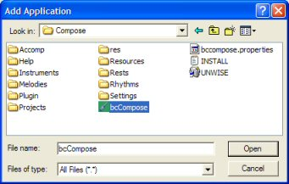
Click once to highlight the required program file and click open.

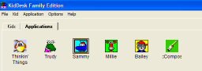
The new program should now be added to the KidDesk desktop.

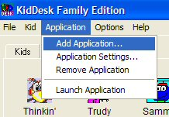
To Remove an Application
Click to select the Application, click on the Application pull down menu then click on Remove Application. You will get a dialogue box asking you if you are sure. Click Yes.

To Limit Applications.
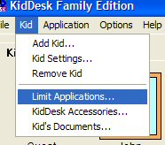
This is useful if you want to set up an office role play area where you only want the KidDesk with no other applications available.

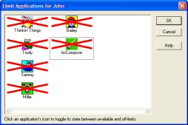
Click on Kid then click on Limit Applications. Click on the applications you wish to limit access to and a red cross appears. Click OK.

