Installing the Kiddesk Application

Place the CD in the CDROM drive.
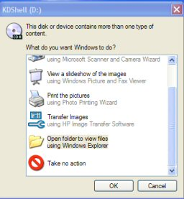
Open the contents by right clicking on the CDROM drive (usually D:) in My Computer or if using Windows XP selecting Open folder to view files.

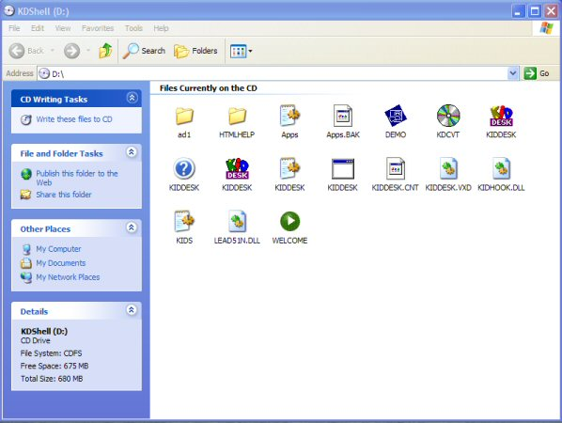

You should now see the contents.

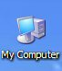
Leaving that window open, double click on My Computer

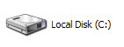
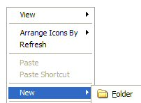
Double click on C Drive

Right mouse click in the window and make a New Folder

Name it Kiddesk and press the Enter key.

Click to shrink the window using the icon on the Title bar.

You should now see two windows open.

In the KDShell (D:) window, click on the Edit pull down menu and click Select All.
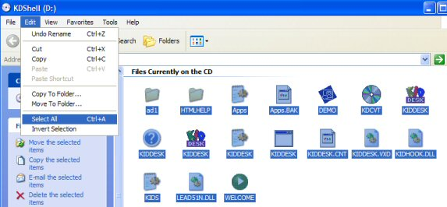
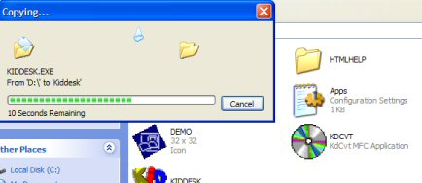
...Place the mouse pointer over one of the highlighted files and drag onto the open Kiddesk window. You should see the files copy across.

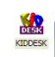
Once the files have copied, close the KidShell (D:) window.

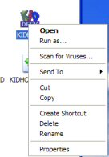
In the open window, right mouse click the first Kiddesk symbol and check it is the Application by clicking on Properties.

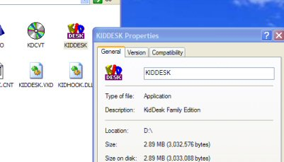

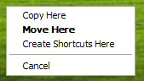
Once you are certain that you have identified the Application not the Icon, right mouse drag it onto the Desktop. A menu will open.

Click Create Shortcuts Here.

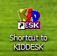
You should now have a Shortcut to the program on your Desktop. Double Click to run Kiddesk.

NB. Kiddesk takes over the whole screen. To exit Kiddesk hold down the Shift and Alt keys and press A.

From this window you can close the program by clicking the cross or Add/Remove Applications or Add/Remove Kids if required.
