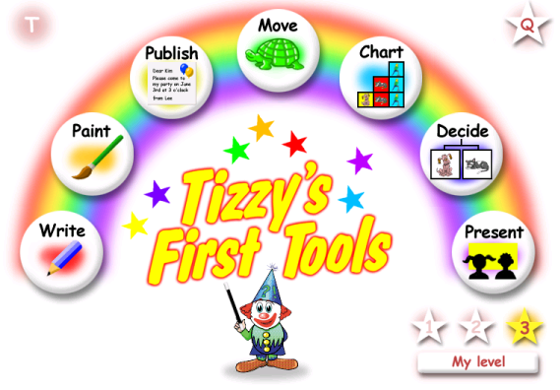
Tizzy’s First Tools

Tizzy’s First Tools – 7 Applications in one program

Teacher Settings
Accessed from Opening screen through CTRL and T

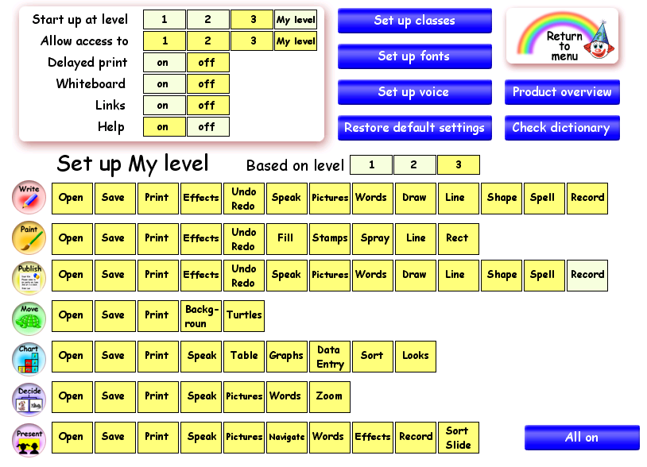

First Level – The Word Processing Screen
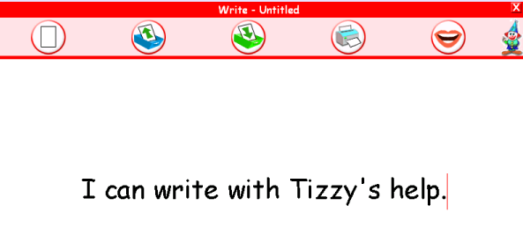




Help button Speech button

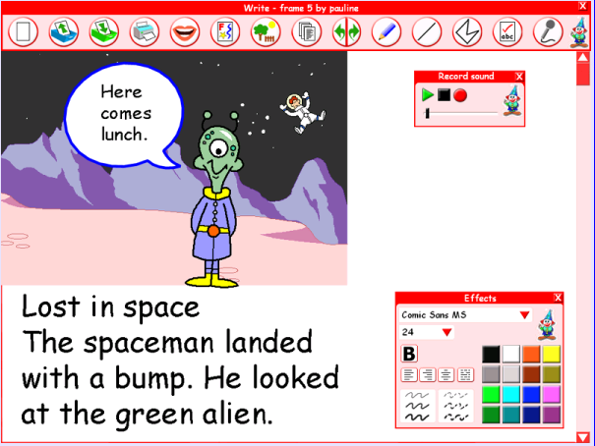
Third Level - The Word Processing Screen

All the features are available at level 3. These include adding pictures, sounds and talking word banks.

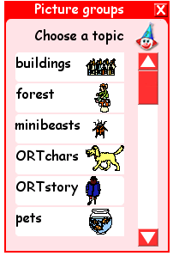
The effects button Picture button
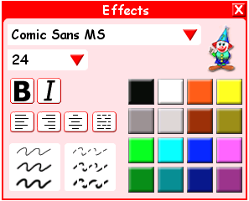



Clip Art

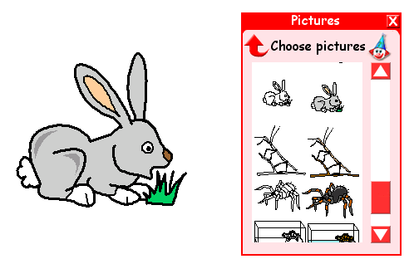
Select a category and then click and drag the
image onto the page.
Click on the image and resize from a corner. Move the image by clicking and moving the mouse.

Word List button

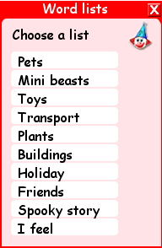
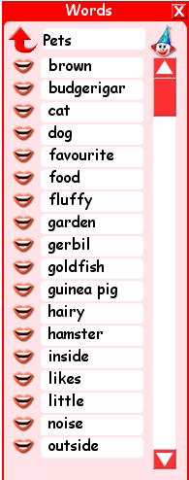

The words in the list can be spoken when the lips are selected.


Words on the screen can be checked for spelling. They can also be spoken once selected.
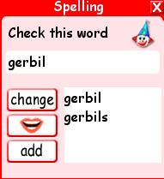

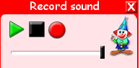
Children can also record their own voices or sounds from the microphone button if a microphone is available.


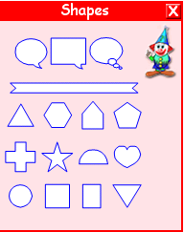

The Shapes button
Click here to reveal a range of shapes which can be selected and dragged on to the page. They can then be resized from a corner or moved by clicking and dragging.
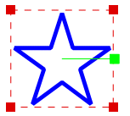
Shapes can also be rotated by turning the green handle.

Shapes can be duplicated also. Hold the control key down and drag the shape.


Pencil Tool and Line Tool

Draw with a pencil or straight line. Select the drawing and use the effects button the change colour, line thickness or style.

The undo and redo button can always be used if things go wrong.


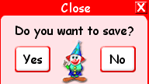

New Open Save Print Close

Painting

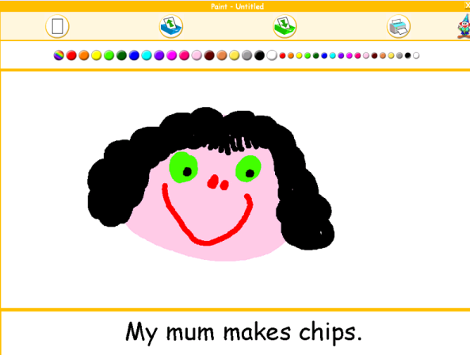
First Level - Paint Screen

Children can select different thicknesses of brush from a range of colours. There’s even a rainbow paint brush.

At the bottom of the screen phrases can be typed.
Work can be saved and printed from the icons in the task bar.

Third Level - Paint Screen
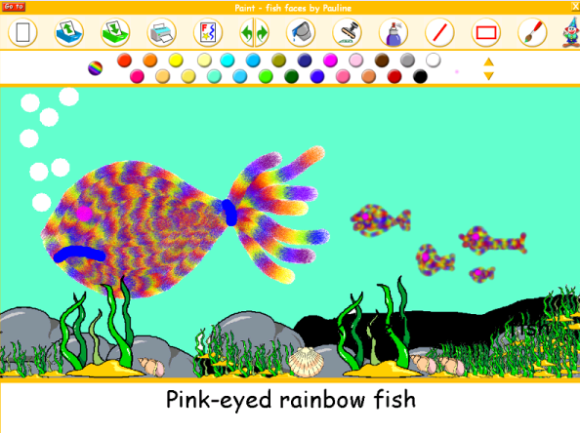
Level 3 settings enable children to experiment with a greater range of tools. These include shapes and lines together with a spray can, fill bucket special effects and stamps.

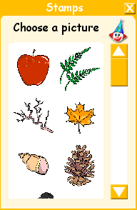


Select the stamp icon on the tool bar and then click on your page to produce the stamp. To stop the stamp appearing, select the painting tool.

First Level - Charts Screen

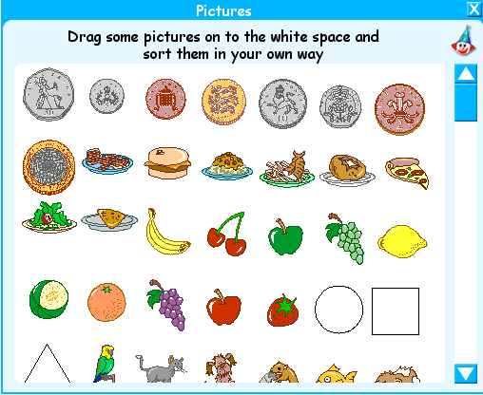
The first stage of charting at level 1 allows children to select items from a menu and group them according to simple criteria.

How many people like strawberries?
How many people like apples?
Select the pictures icon and then

Arrange the pictures to illustrate the results of the survey.

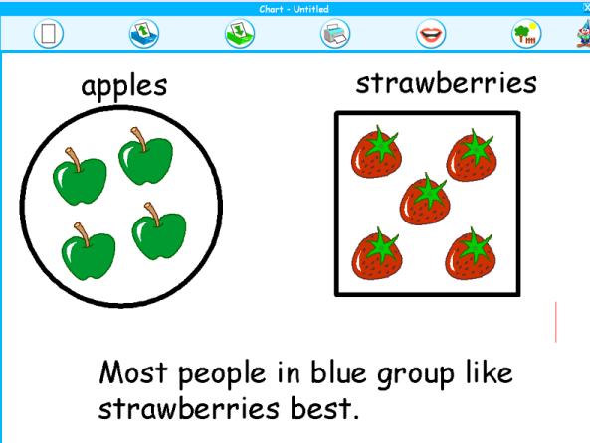

Children can also write a sentence to explain what they have found.

Third Level - Charts Screen

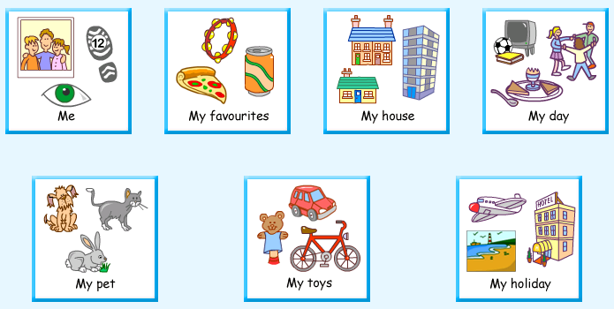
From this screen, children can select a topic from which they can produce graphs and tables.

Enter data and then select this button to display the information in a tabular format as shown below

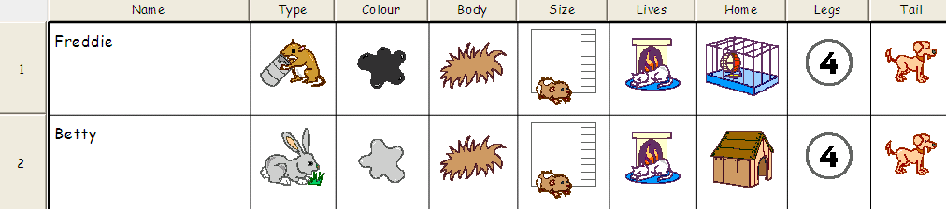
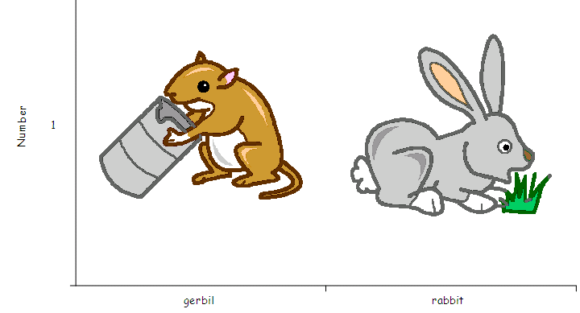

Select this button and then a category.
A graph will be drawn.


This button will enable children to sort information.


This button allows children to change how the graph is drawn. The data can be shown as a horizontal or vertical graph.


First Level – Move Screen
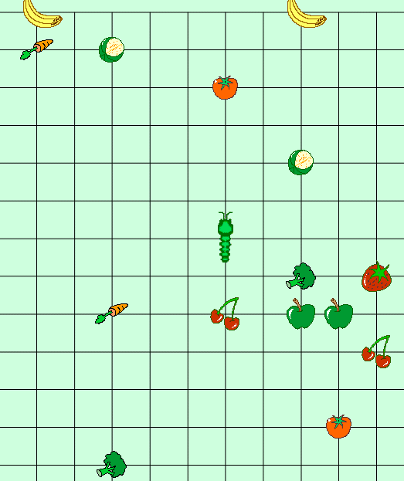

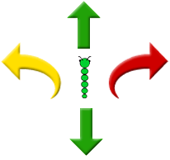
This screen enables children to move a worm around a screen from a central position using the keypad on the right. Children can turn the worm so that it moves forward, backward and turns left and right.

Third Level – Move Screen

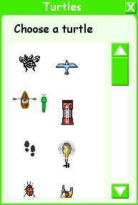
Children can select a range of backgrounds to move the turtle over.

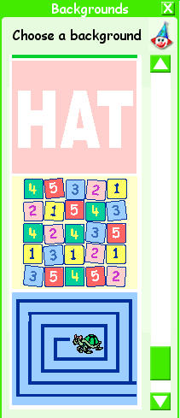

Use the turtle button to change the shape of the turtle.

Use the keypad to control the turtle movements around the screen.
Press the direction arrow, followed by an amount of movement, e.g. forward 30. Then select a turning arrow followed by a turning amount, e.g. right 90.

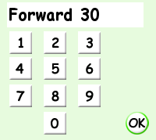
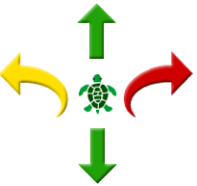

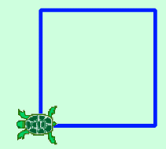

Select OK and the turtle will carry out the command.

First Level – Publishing Activities
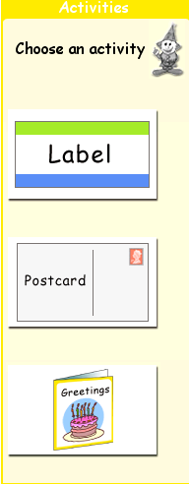
Children select an activity


In the label activity, children can cycle through a range of colours by clicking on the colour bands on the label.

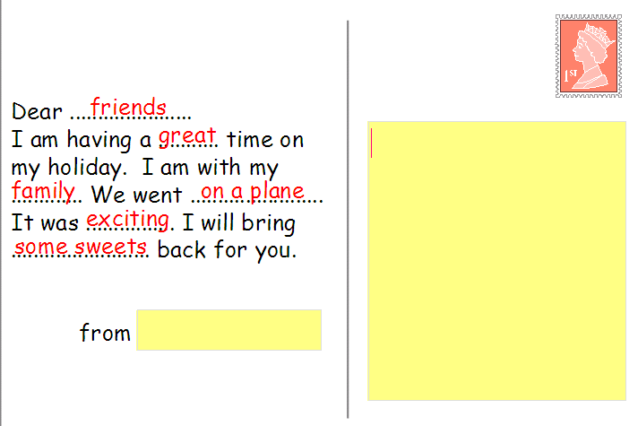

In the postcard activity children can cycle through a range of appropriate words (in red) a change the emphasis of the greeting

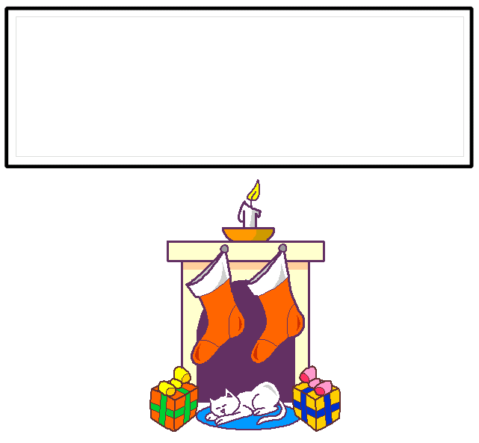
The third activity enables a range of different festivals and celebrations to be shown.
A different image/picture can be shown when selected.

Third level - Publishing

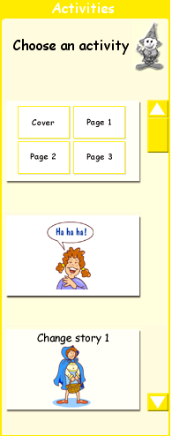

A greater range of activities are offered at level three. These include developing a pictorial story, telling jokes and changing well known stories.
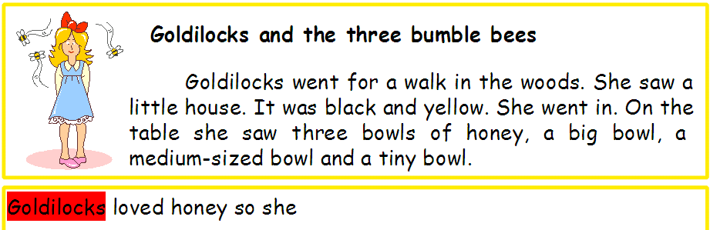

The full tool bar is available.

First level – Presentation screen

Children create a series of screens (slides). They can use the clip art which includes ORT characters. Children can write in the box.
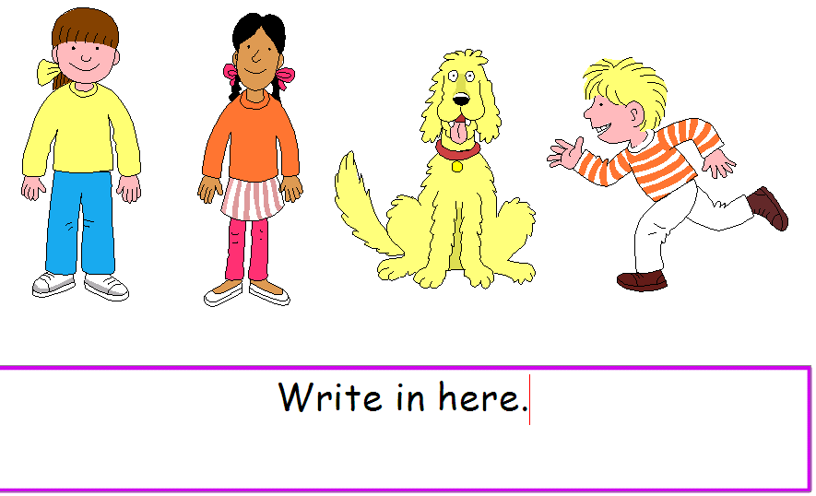


Use the forward button to add more slides. The presentation can be be viewed at any time by selecting the view button.

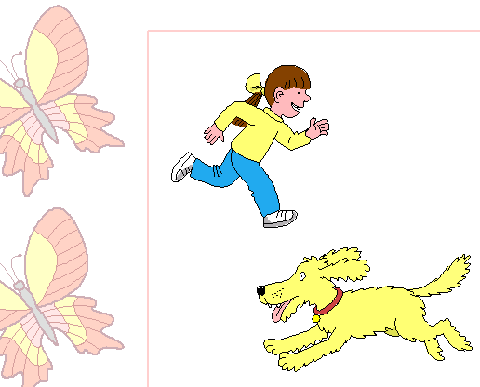
Third level – Presentation screen

This application enables children to make a series of ‘slides’ which can be viewed in sequence as a presentation.


Children select a background to their slides through the ‘slide button’.

Children can tell the story by writing on the slides near the images/clip art.


Clip art can be selected through the picture button.


Add sounds/speech to the slides.


Use the slide sorter to ensure that slides are in the correct order.

Add more slides by selecting the forward button. Use the view button to see your slide show.

First level – Decision Trees

This program enables children to make simply tree branching databases. Select one of the four topics, transport, coins, fruit and pets.
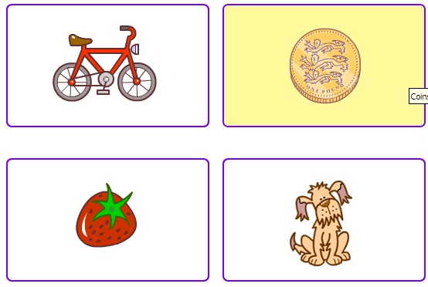

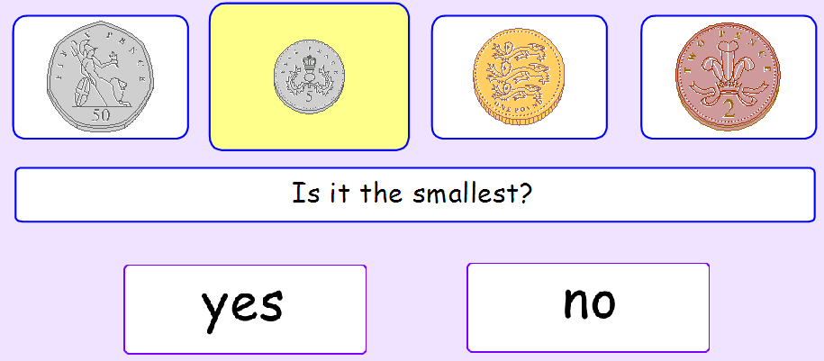

Children click yes or no in answer to the question. The speech button can be used to read the question. Once the question is answered the item will appear at the bottom of the screen in its appropriate position.
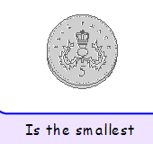
More questions are asked until all the objects have been dealt with.

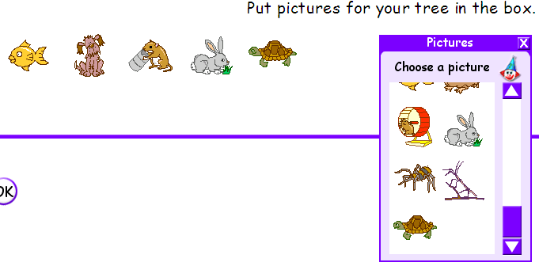

Third level – Decisions

At this level, children can make simple tree branching databases using the programs clip art. A spoken commentary accompanies the activity.

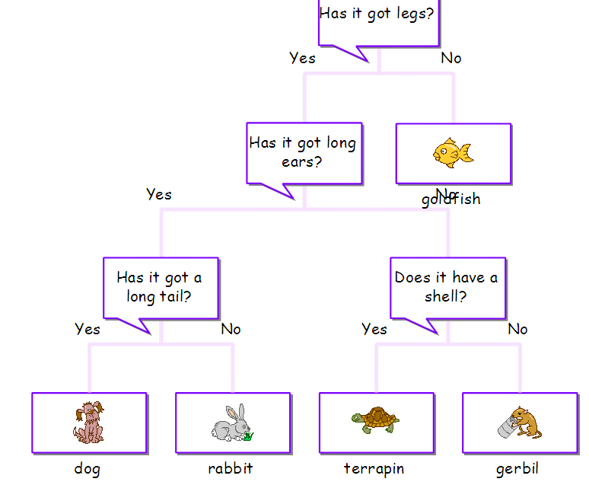
After following the prompts the child will be presented with a tree branching database as shown below.


Use the in an out zoom buttons to completely see the tree.

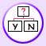
This button allows children to play the tree and so interrogate the information.

This aspect of Tizzy’s First Tools is very similar to the Branching section of Textease Studio Plus.

Tizzy’s First Tools offers an excellent introduction to Textease Studio Plus. Skills learnt here dove-tail nicely into all aspects of the applications.

