`1





Contents

Page

Overview 3

Internet Users 4

Mail Users 6

Home Access to files and e-mails 7

Password control 9

Print Queue Control 9

Drag and Drop Users 10

No Lock Workstation 10

Managed Service System – Secondary Schools

Overview
Background

The Baglan IT Managed Service System has been designed to meet the needs of the secondary schools creating a flexible, reliable and powerful system for the school.

School Ownership

It is important to read these notes carefully and discuss their contents with the school’s Senior Management Team (SMT) as the actions taken by the IT co-ordinator will have implications for the users. For example, whole school discussions may be required around Internet filtering levels and access to file and e-mails away from the school.

Assigning Permissions

When the IT co-ordinator uses the Baglan Management Tool care needs to be taken when reading the attribute you are assigning permissions to before the choice to Join, Leave alone or Unjoin is made.

Passwords

A culture will need to be developed in schools where all computer users realise the importance of passwords. Passwords for use outside school should only be known by the assigned users. There needs to be a mechanism within the school whereby the IT Co-ordinator is informed if passwords need to be changed in order that this can be done as quickly as possible.

User Log on
There are different log on identities for different types of user. The log on informs the system who you are and what software and services are available for you. Different desktop background colours have been used for the different types of user.
A Blue background for pupils
A Green background staff
A Brown background for IT co-ordinators

Future Developments

The Managed Service System will continue to be developed. The Standards Forum, in consultation with NAASH, will discuss future developments and priorities. If you have any issues that you wish to be considered please contact the ICT Curriculum Manager a.stoker@npt.gov.uk .

Internet Permissions

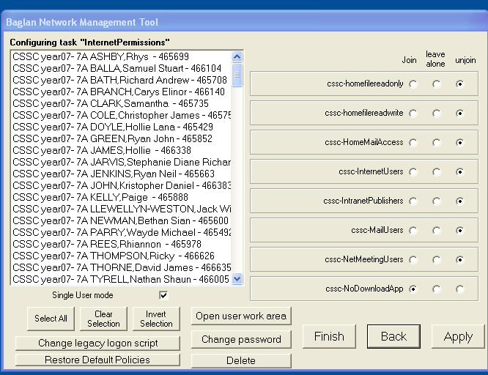

Internet Users

Note: It is advisable for the IT co-ordinator to discuss the procedure for log on to the Internet with other members of staff and in particular SMT.

Using the Baglan Management tool (see also page IT Co-ordinator Log on manual page 7) the school needs to decide whether or not the user is to be assigned to the Internet Users group. For example, schools may decide to assign staff to this group.

If you join a user to the Internet Users group it means that every time the user logs onto the computer system using their user name and password they will have access to the Internet without being prompted by a secondary log on.

The user will need to be assigned an Internet Filter group, which will determine their level of access. (See screen shot and notes- page 9 of the IT Co-ordinator Log on manual)

If an Internet user accesses unsuitable material on the Internet they need to be aware of the following guidelines:
- Switch the screen off
- Report the incident to a member of staff
- Incident reported to the IT co-ordinator
- IT co-ordinator to ring Baglan helpdesk

If there is an issue over appropriate use of the Internet and you have joined a user as an Internet user it is possible to track exactly who has misused the Internet as sites visited (with dates, time and length of visit) will be logged against the user name and password. This is another example of why it is important for users to keep passwords private.

It should also be remembered that all users should be aware of safe and appropriate use of the Internet. Each school should have a safe and acceptable use of the Internet policy.

If you unjoin a user to the Internet Users group it means that every time they try to log onto the Internet a secondary log on window will open. The user will need another user name and password to gain access to the Internet.

If a secondary log on to the Internet is required that user name will need to be joined to one of the four levels of Internet filter. It is important that this is the appropriate filter level for the particular group of users. Different groups of users will probably require different levels of Internet filtering.

Some schools may decide that the secondary log on may be more appropriate for their pupils. There are several issues to be considered. If for example a tutor or year group were given the same user name and password as the secondary log on to gain Internet access and there was misuse of the Internet it would be very difficult for the individual to be traced. Also these passwords would need to be changed regularly, sometimes several times a day.

Mail Users

Before setting individuals as E-mail users they will need to be reminded that use of the school's e-mail system is for curriculum use only and that their use of the e-mail system should fall within the guidelines set out in the Safe and Acceptable use of the Internet policy. E-mail users also need to be aware that the IT co-ordinator and Baglan IT Centre has the ability to see and monitor all e-mail accounts and their contents.
If you join a user to the Mail Users group it means every time the user tries to access their e-mail account they will be prompted by a secondary log on. The user enters their usual user name and password.

It is important that e-mail addresses are only given to trusted sources. Pupils should never enter their e-mail address into a website. It is also advisable that staff should not enter their e-mail address into a website.

Baglan IT Centre reserves the right to disable any mailbox which is receiving excessive spam.

Home Access to files and e-mails

The Managed Service System offers the facility for assigned users to have access to files and e-mails away from the school, this means anywhere in the world not just at home as the sub heading implies.
This is a very exciting facility and the potential for anytime anywhere learning is great if certain issues are considered.
Users need to be aware of the following:

- File and e-mail access away from the school is for curriculum use only.
- Passwords and user names must be secure.
- If logged on as IT co-ordinator the user has the same access away from the school as on the premises.

It is recommended that the IT co-ordinator only join this group when they feel they have a full understanding of the system. Remember they still have their staff identity.

A policy for the school may need to be drawn up by the school's SMT covering the issues surrounding such use.
Home file read only
Read Access
Files can only be read from the drive; in other words you can open files but you cannot save any work to the drive.
If you join a user to this group you will need to be give them a secure URL address. Using this address and their user name and password they can have read only access to their files. Users would need to save their work either to the computer's hard drive can then be e-mail into the school.
Home file read write

Write Access
Files can be written to the drive; in other words it is possible to save work to the drive. This also implies that work can also be opened from the drive.
If you join a user to this group you will need to be give them a secure URL address. Using this address and their user name and password they can have both read and write access to their files.

Home mail access

If you join a user to this group they will need to be given a secure URL address. Using this address and their user name and password they can have access to their e-mails.

It is important that e-mail addresses are only given to trusted sources. Pupils should never enter their e-mail address into a website. It is also advisable that staff should not enter their e-mail address into a website.

Baglan IT Centre reserves the right to disable any mailbox which is receiving excessive spam.

Administrative Control

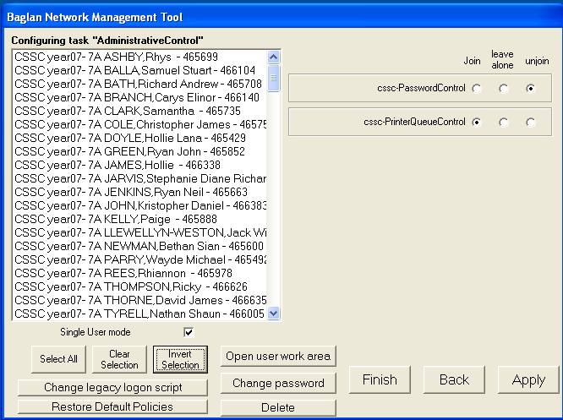
Password Control

If you join a user to this group they have the ability to change the password of other users. This is useful for staff because there may be a problem during lessons where a pupil forgets their password. This gives them the ability to change the individual’s password. The next time the individual logs on they will be prompted to change their password.

It is important to remember that there may be some pupils who are unable to take control of their own passwords.

The desire is that every one who is able to cope with their own strong password is encouraged to do so.

Print Queue Control

If you join a user to the Print Queue control it allows them to promote or delete jobs sent to the local printer. It is very useful to staff if all users have print queue control as it will enable them to make the appropriate changes at any machine. However, pupils may make inappropriate changes e.g. delete another user’s print job. If pupils misuse this facility they can be unjoined from the group.

Desktop Access

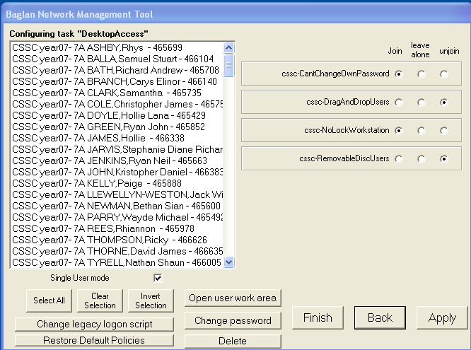

Drag and Drop Users

If you unjoin a user to this group (default setting) it gives a locked down system i.e. no access to explorer windows and no right mouse button functionality. The only way to access files is through open and saves as commands within applications. The locked down desktop is designed to stop users getting access to the command line. This is very restrictive but may be necessary if a user abuses the drag and drop facility.

If you join a user to this group they have access to explorer windows, right mouse functionality and the command line. If users are found to be using the command line in an unauthorised manner they should be unjoined from this group immediately.

No Lock Workstation

If you join a user to this group it will disable the CTRL-ALT-DEL lock facility. This means that the user will not be able to lock a machine. It is recommended that you join all pupils to this group otherwise at the end of the lesson they may decide to lock the machine which will stop others from using the machine.

