All existing pupils will use their current user name with a 2-character school prefix e.g. cs-JohnSmith

When the computer is switched on, you will see the Welcome to Windows dialogue box. Press CTRL-ALT-DEL

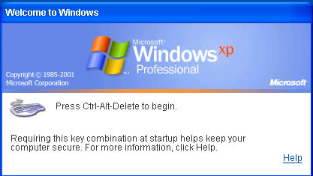

The following dialogue box will appear

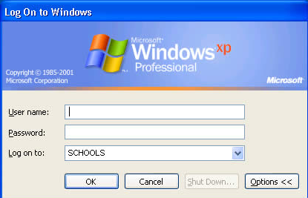

Type in your User name and password and click OK

Login name 2 character school code-pupilname
Password As Usual
Domain School

The desktop background will be blue

Each user has an area in which they can store their own work on the system. Double click the My Computer icon on the desktop to view the areas which are available to you.

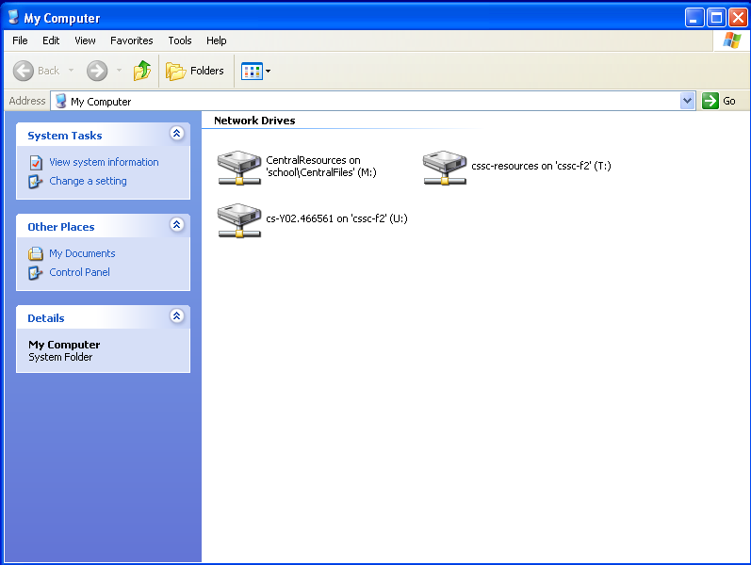

Pupils have the following drives available to them. Each one has a different purpose.

U: Drive
Personal work space for users. All users can read and write to this area.

T: Drive
Resources area for individual schools. Pupils can only read files from this area. If they work on a file and wish to keep it they need to save it to the U: Drive.

M: Drive
Central Resources area containing files and documents licensed for use by all schools. No-one has write access to this area, i.e. it is not possible to save work to this drive.

You may also be able to view drives A:, B:, D: and E: if permission has been granted.

Read Access
Files can only be read from the drive; in other words you can open files but you cannot save any work to the drive.
Write Access
Files can be written to the drive; in other words it is possible to save work to the drive. This also implies that work can also be opened from the drive.

