When the computer is switched on, you will see the Welcome to Windows dialogue box. Press CTRL-ALT-DEL

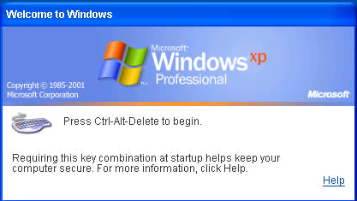

The following dialogue box will appear

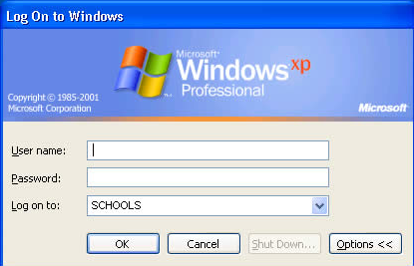

Type in your User name and password and click OK
Username 4-character asset tag code-initials
Password same as before
Domain SCHOOLS NOT School name as before

The desktop background will be green

Each user has an area in which they can store their own work on the system. Double click the My Computer icon on the desktop to view the areas which are available to you.

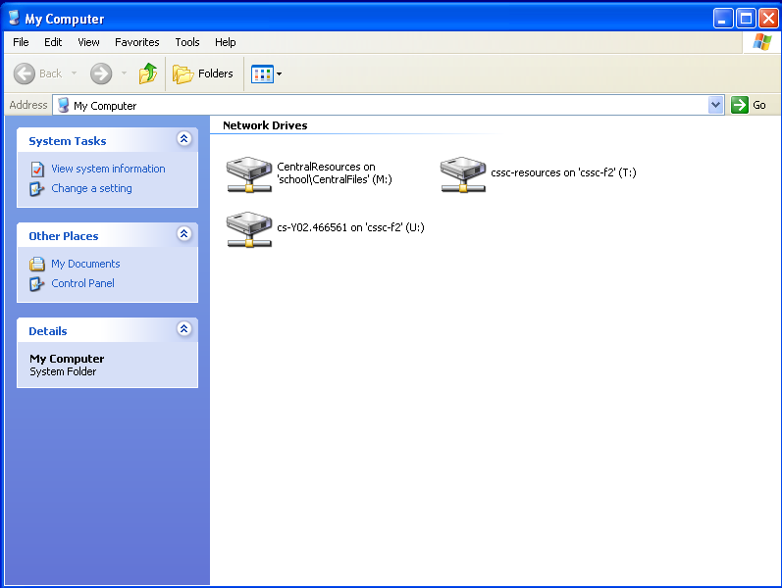

Staff have the following drives available to them. Each one has a different purpose.

U: Drive
Personal work space for users. All users can read and write to this area.

T: Drive
Resources area for individual schools. The T: Drive is available to all users on a Managed Service System and has a few specific functions. Its primary use is for staff to place files which they would like pupils to access. However, pupils can only read files which are in the T: Drive, they can neither replace them nor delete them. This is called having Read Access to the files. Staff have Read and Write Access to files on the T: Drive so they can freely open, edit and re-save work which is stored there.

M: Drive
Central Resources area containing files and documents licensed for use by all schools. No-one has write access to this area, i.e. it is not possible to save work to this drive.

You may also be able to view drives A:, B:, D: and E: if permission has been granted.

Read Access
Files can only be read from the drive; in other words you can open files but you cannot save any work to the drive.

Write Access
Files can be written to the drive; in other words it is possible to save work to the drive. This also implies that work can also be opened from the drive.

Your personal work area is designated as the U: Drive (think of U: for User) and will already contain a few folders by default.

These include:
Favourites: A special folder that contains a collection of web site addresses which you may have added from the web browser Microsoft Internet Explorer.
Staff-*** Music: A folder that contains a collection of music files in a variety of formats (MP3, MIDI, WAV etc.)
Staff-*** Pictures: A folder that contains a collection of image files in a variety of formats (BMP, JPG, GIF etc.)
You do not have to keep your music and image files in these folders, but it makes sense to do so as it would make them easier to find. Also, any images saved in the Staff-*** Pictures folder can be displayed as a slide show by using the View as a slide show icon which appears when the folder is opened by double-clicking.

