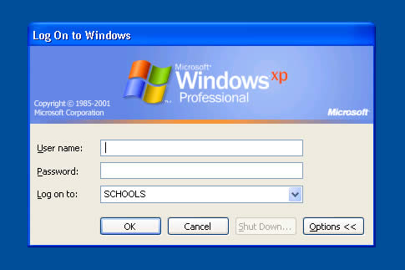

Login

Year 7 pupils September 2004 - on

name pupilnumber
Password As Usual
Domain School

Existing pupils (migrated users)

name 2-character school code-pupilname
Password As Usual
Domain School

School generated users (staff and student teachers)

name 4-character asset tag code-initials
Password As Usual
Domain School

