`1

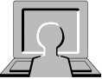

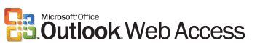

Contents

Page

Introduction 3

Getting started 4

Inbox 5

Replying 6

Attachments 7

Calendar 8

Appointments 9

Rules 11

Options 12

Microsoft Outlook Web Access

Introduction

Schools that have BITC Managed Service 2 now use Microsoft Outlook Web Access (OWA) for e-mail. Users can access their e-mail within the school from any computer with a web browser and an Internet connection. Users who have been given the appropriate permissions can also access their e-mail account from any computer in the world that has a web browser and an Internet connection.

When using your e-mail account you should take a few simple precautions to help protect your data and ensure your privacy:

- Keep your password secure, if you suspect that someone has found out your password change it as soon as possible.

- Do not select an option that remembers your password for later use – always type your password.

- Only open e-mails from people you trust

- Save and open attachments only from people you know and trust.

- Log off from Outlook Web Access when you’re finished. Logging off helps prevent someone else from using the computer to access your mailbox.

Getting Started

Log on to the computer in the usual way

- Click the Select (Left) mouse button on Start
- Move up to programs and follow the arrow across
- Move up to email 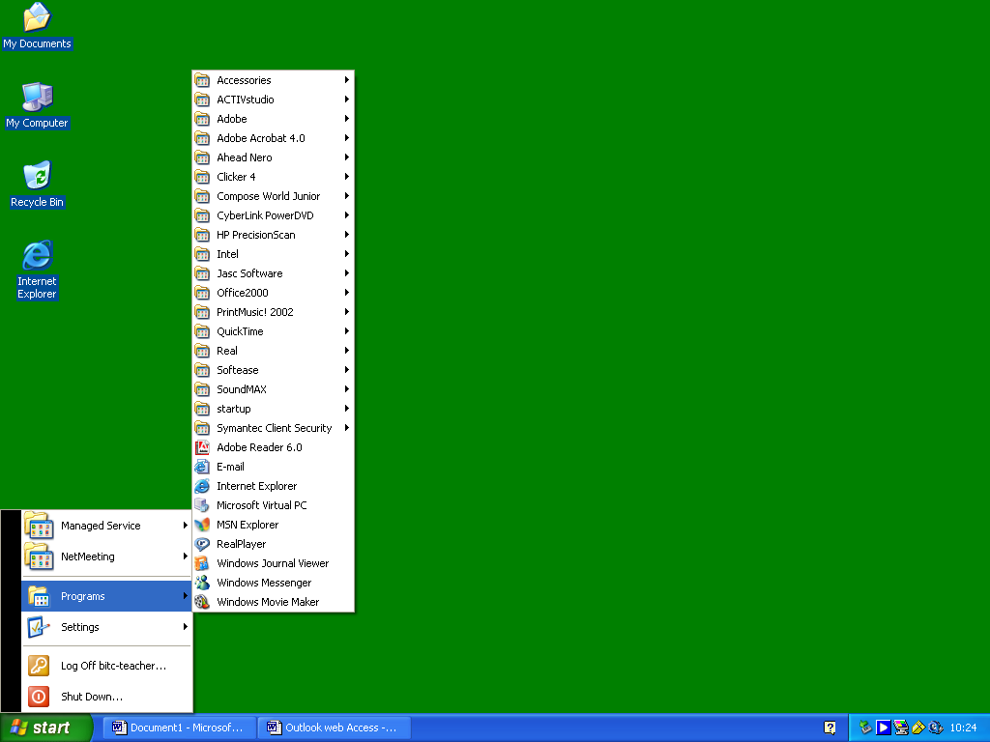and click the Select mouse button

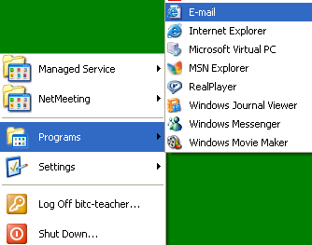

- An Internet explorer window will open with a pop up window asking for a user name and password

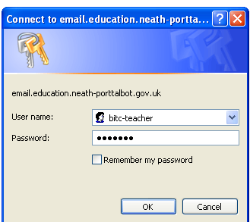

- Click in the white dialogue box next to User name: and type in your user name
- Click in the white dialogue box next to Password: and type in your password

Note: Do not put a tick in the box to the left of Remember my Password. Please ensure that you keep your password secure i.e. do not let anyone else have it or see you type it in.

- Click OK
- Your e-mail account will open in the web browser

Your e-mail address using this system will be:
school-username@npt.baglanit.org.uk e.g. bitc-teacher@npt.baglanit.org.uk

If you are e-mailing another user on the managed service 2 system you just need to type their user name e.g. bitc-teacher

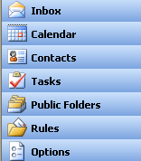

Inbox

- Select Inbox from the menu

Composing and sending an e-mail message

- Move the mouse pointer to New 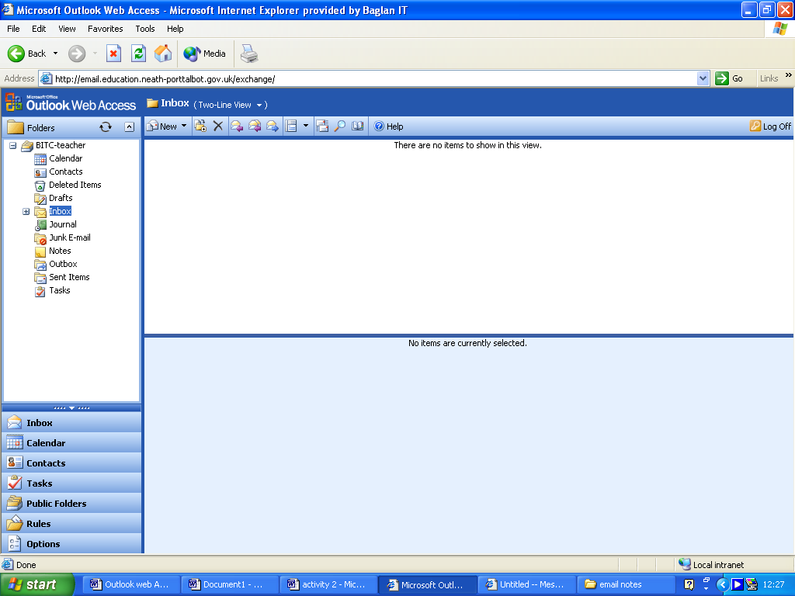 on the toolbar of Outlook Web Access and click the Select mouse button once.

- A Message window will appear into which you have to enter a few details.
- Move the mouse pointer to the white dialogue box next to To: and click the Select mouse button once.

- Type in the e-mail of the person you are sending the message to. This is always in the form someone@somewhere.someplace, e.g. a.stoker@npt.gov.uk will send a message to the IT Curriculum Development Officer. Please check that the address is accurate otherwise it will not reach its destination.

- Click the Select mouse button in the white dialogue box next to Subject: Whatever you enter in here is what the recipient will see in their Inbox. The subject should tell the recipient what to expect in the contents of the message.
- When these details have been entered click in the large white area underneath, this acts as a mini word processor and is where you type in your message.

- Remember to end your message with your name.

- Finally, send the message by selecting the Send icon. If all has gone well, the Composition window will close and the message sent.
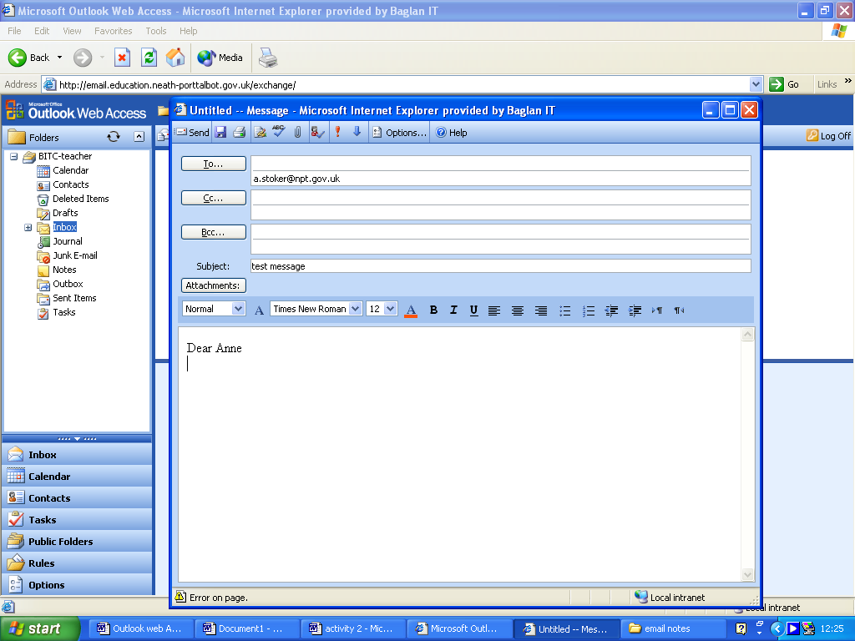

Reading your e-mails
- Move the mouse pointer up to the check for new messages icon and click the Select mouse button once.

- If there are any new messages, they will appear in bold text in the subject area of the Inbox.

- Double click the Select mouse button to read its contents.

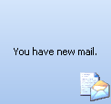
- If you are still connected to Outlook Web Access and new messages arrive an icon will appear on your screen

Replying to messages

This is similar to composing an e-mail message with the added bonus of the automatic filling in of the e-mail address and subject line being carried out by the program.

- Click on the message you wish to reply to, it will become highlighted. You have three options:

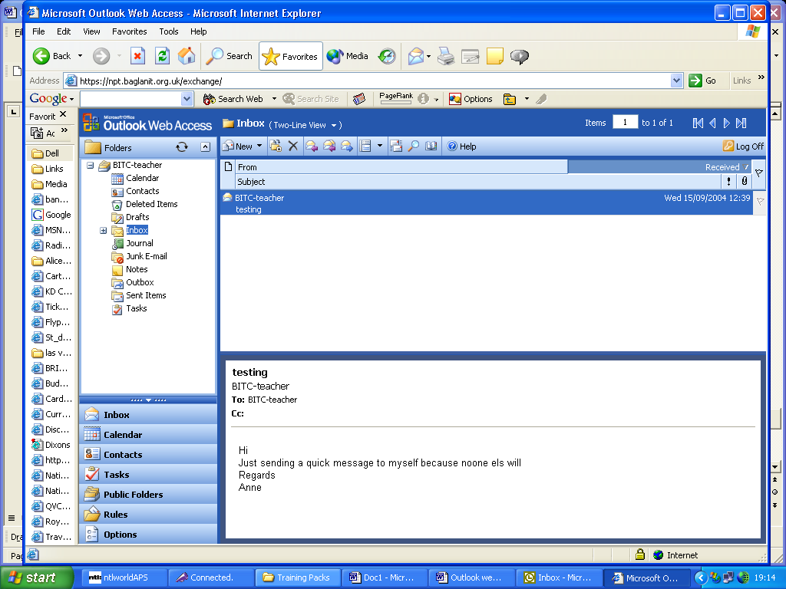
Reply to Sender - To send a reply to the sender click the Select mouse button once on the Reply icon.

Reply to all - To send a reply to the sender and all other recipients click the Select mouse button once on the Reply to all icon.
Forward - To forward the message to someone else click the Select mouse button once on the Forward icon.
- Select the appropriate icon from the three above.

- The Composition window will open with the e-mail address and subject lines already filled.

- The mini word processor will contain the original message to which you are replying. Type where the cursor is flashing.

- When you have completed your reply, Select the Send icon from the toolbar.

Deleting messages

- Select the message to be deleted (it will become highlighted).
- Select the Delete icon on the toolbar.

- The message will be deleted from the inbox and go into the recycle bin.

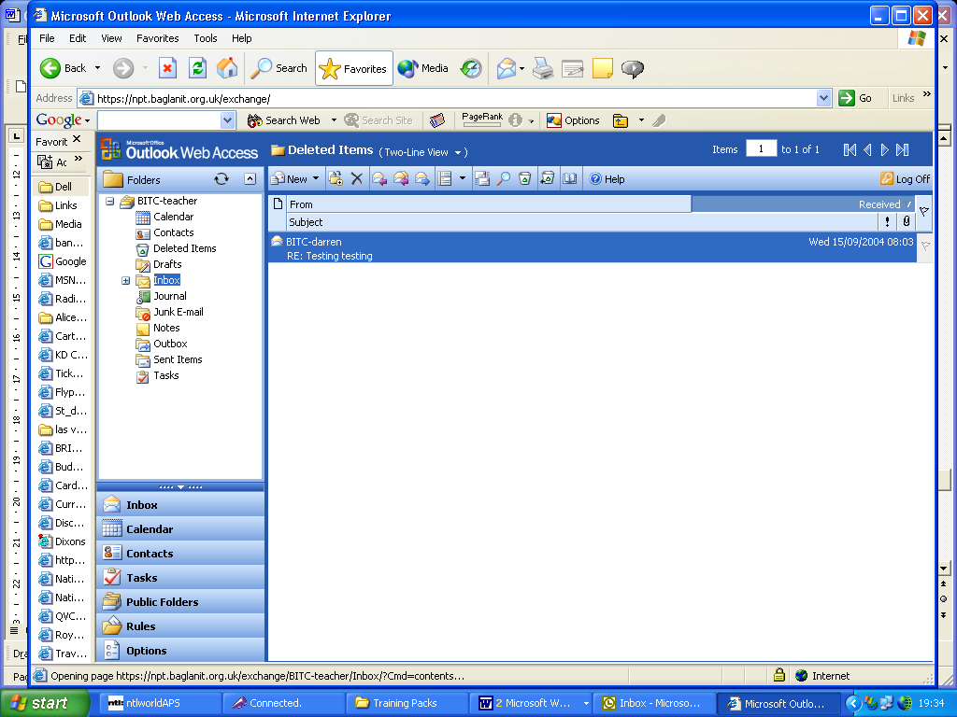
To Empty the Recycle bin
- Move the mouse pointer to the Deleted Items icon

- Click the right mouse (menu) button.

- Move down to Empty Deleted Items and Click the Select mouse button once.

Sending Attachments

This facility enables you to send a file along with your e-mail message, e.g. a piece of work, a photograph etc. When sending a document it is important to know that the recipient has got that piece of software on their computer, in order for them to see it as it was created. If you send a Word/Textease document do they have Word/Textease? If you send images check that they are JPEG format as this is generally a condensed file type. Attachments may take a while to send depending on the file size.

Select the New icon and fill in the relevant details (e-mail address, subject and message).

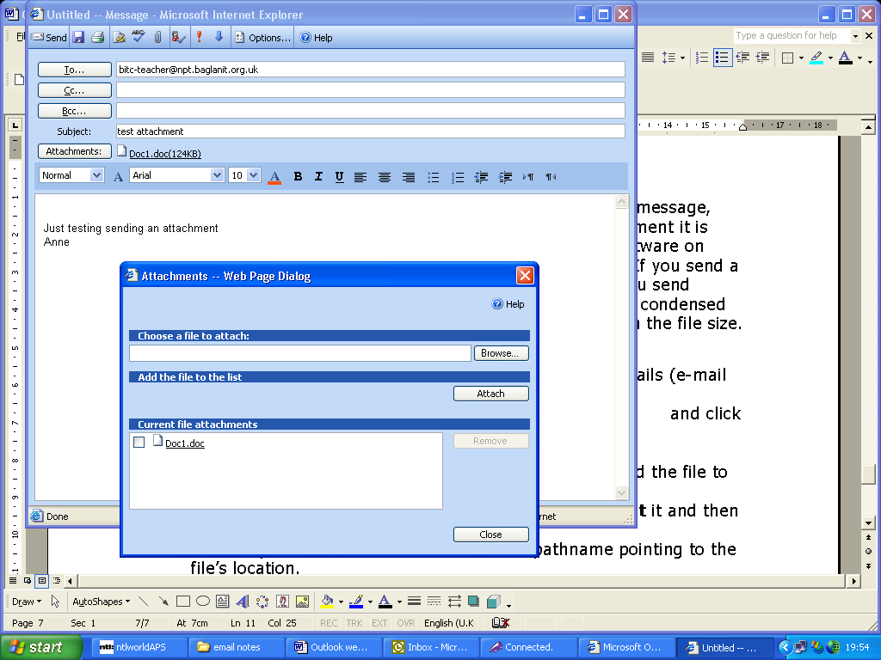
Move the mouse pointer to the attach icon and a new Attachments window will open.

- Select Browse.. and locate the file you wish to attach.

- Select Attach.

It does take some time for the file to appear in the Current file attachments box.

- Select Close.

- The attached file name will appear next to attachment on the new message window.

- Select Send when you are ready to send the message and its attachment.

When you receive messages with attachments you get a warning that attachments may contain viruses. Ensure that you have update virus protection before opening an attachment.

Calendar

Outlook Web Access provides access to create, view and edit your calendar appointments.

- Select Calendar from the menu
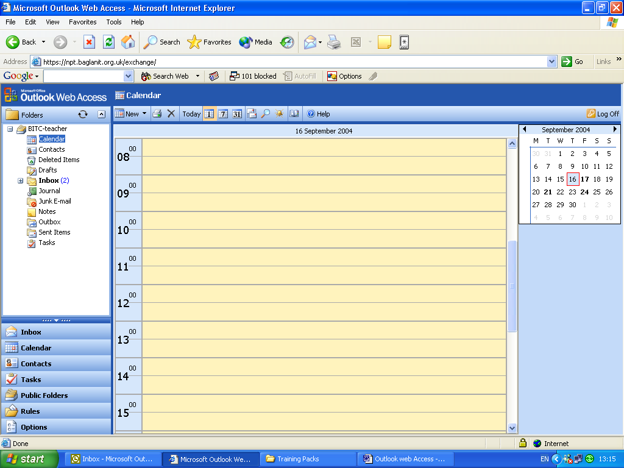

To change calendar views (daily, weekly, monthly) select the appropriate icon on the menu bar above the calendar. Any appointments you have can be quickly identified in the month view on the right hand side of the screen, as the numbered day will be shown as bold for any day that has appointments in it e.g. September 17th 2004.

To create a new appointment

Select the New icon on the menu bar and the blank appoint window will open

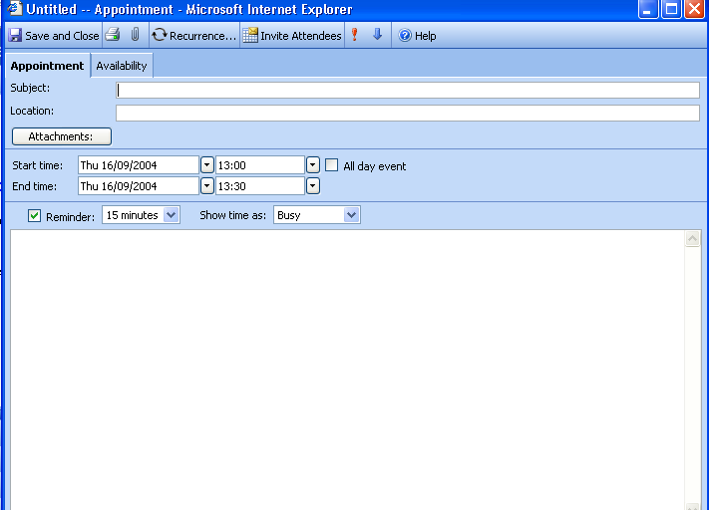

    - Type in a title for the appointment in the subject white dialogue box.

    - Type in the location in the Location dialogue box.

    - Select a start date and time and end date and time by selecting the individual pull down arrows.

    - Move the mouse pointer to the appropriate date/time and click the Select mouse button.

    - You can select All day event and it will automatically fill in the entire day in the calendar.

    - You can also set a reminder for the appointment.

When the reminder box appears you may open the appointment to view any notes you have made, or you can set the reminder to snooze and remind you again later. To close the reminder window and acknowledge the reminder, select Dismiss or Close and the reminder will close and will not re-appear.

    - Any notes about the appointment can be typed into the large white area.

    - When all the information is entered Select Save and Close

To delete an appointment

- Using the calendar tabs on the right hand side of the window locate the date of the appointment you wish to cancel.

- Click the Select mouse button on the date.

- The page for that day will open.

- Click the Select mouse button once on the appointment.
- Select the Delete icon from the menu bar.

Create a rule
You can manage your e-mail messages by using rules to automatically perform actions on incoming messages. After you create a rule, Microsoft Office Outlook Web Access applies the rule to messages that arrive in your Inbox. For example, you can automatically forward all messages sent by Baglan IT Helpdesk to your Baglan folder when they arrive in your Inbox. They are still marked as unread until you read them but are ‘filed’ as they come in – keeping your inbox down to a minimum.
From the main screen click Rules on the bottom left hand corner.
In the Rules screen, click New.
In the Rule Name box, type a name for the rule to give the rule a specific name (it helps later when you’d like to edit or delete the rule).
1. In the Edit Rule dialog box, specify any or all of the following conditions-
- To base the rule on who sent the message, type the alias (the name you have stored your contact as) or e-mail address of the user name or distribution list in the From field contains box. To find the person or distribution list in your organization's address book or your contacts, click Address Book .
  - To base the rule on words in the subject of the message, type the words in the Subject contains box.
- To base the rule on the importance setting of the message, select the importance in the Importance is menu.
  - To base the rule on who the message was sent to, type the alias or e-mail address of the user name or distribution list in the People or Distribution List box. Separate two or more entries with a semicolon (;). To find the person or distribution list in your organization's address book or your contacts, click Address Book .
- To base the rule on messages that are sent only to you, select the Sent only to me check box.
2. If the message meets the conditions you set in step 1-
  - To move the message to a folder, select Move it to the specified folder, click specified, and then select the appropriate folder in the Move/Copy Item dialog box.
- To copy the message to a folder, select Copy it to the specified folder, click specified, and then select the appropriate folder in the Move/Copy Item dialog box.
  - To delete the message, select Delete it.
- To forward the message to someone, select Forward it to, and then type the alias or e-mail address of the person or distribution list in the adjacent box. Separate two or more entries with a semicolon (;). To find the person or distribution list in your organization's address book or your contacts, click Address Book . By default, a copy of the forwarded message is kept in your Inbox.
Click Save and Close.

Options
Important - When you change any settings for the following options, you must click Save and Close for your changes to take effect.

From the main screen click Options on the bottom left hand corner.

Out of Office Assistant
The Out of Office Assistant generates automatic replies to e-mail messages that you receive while you're away. Each time you activate the assistant, Outlook Web Access sends an automatic reply to someone the first time he or she sends you a message.
- To enable the Out of Office Assistant, click I'm currently out of the office.
- In the text box, type the message you want people to receive when they send you e-mail messages while you're away.
- To disable the Out of Office Assistant, click I'm currently in the office.


Messaging Options
To change the number of items displayed per page in your Inbox or other folders-
- In the list next to Number of items to display per page, select a number. The higher the number, the longer each page takes to refresh.
To indicate what to display after you move or delete an item-
- In the list next to After moving or deleting an item, select an action. Outlook Web Access can open the next item in the list (the default), open the previous item, or return to the window you moved or deleted the item from and select—but not open—the next item in the list.
To enable pop-up message notifications on your computer when you receive new e-mail messages
- Select the Display a notification message when new mail arrives check box.
To be notified with a sound when new messages arrive
- Select the Play a sound when new mail arrives check box.
To append a custom signature to each message you send
- Click Edit Signature.
- In the Signature dialog box, type and format the signature you want to use, and then click Save and Close.
- Select the Automatically include my signature on outgoing messages check box.
To set the font you use for new, replied to, and forwarded messages
- Click Choose Font.
- In the Font dialog box, select a font, style and size, and then click OK.

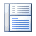
Reading Pane Options
Use the following options to determine whether items displayed in the Reading Pane will be marked as read or left as unread. Even if you view an item in the Reading Pane, you may want to leave the item marked as unread as a reminder to return to it later.
To mark items you view in the Reading Pane as read
- Select the Mark item displayed in Reading Pane as read check box.
- To set a delay for when the item is marked as read, type a number in the Wait [n] seconds before marking item as read text box. The default is five seconds.
To mark items you view in the Reading Pane as read after you select another item in the list
- Select the Mark item as read when selection changes check box. This is the default setting.
To leave items you view in the Reading Pane marked as unread
- Select Do not automatically mark items as read.

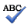
Spelling Options
Use the following procedures to customize your spelling options.
To prevent the spelling checker from checking words in UPPERCASE letters
- Select the Ignore words in UPPERCASE check box.
To prevent the spelling checker from checking words that contain numbers
- Select the Ignore words with numbers check box.
To automatically check spelling before a message is sent
- Select the Always check spelling before sending check box.
Outlook Web Access also allows you to spell-check messages in several languages using language-specific dictionaries.
To select a dictionary
- Select a language from the drop-down list.


E-mail security
You can help make your e-mail messages more secure by using a message encryption protocol called Secure/Multipurpose Internet Mail Extension (S/MIME). With S/MIME you can digitally sign your messages to help protect them from tampering while in transit. The digital signature also certifies to the recipient that the message is from you. You can also encrypt the message contents to help prevent unauthorized recipients from reading the message.
To use S/MIME with Outlook Web Access, you must have the following:
- Microsoft Windows XP or Windows 2000.
- Microsoft Internet Explorer 6 or later.
- A computer that allows you to download and install the S/MIME Control.
- Valid digital certificates for sending digitally signed e-mail messages or receiving encrypted e-mail messages.
To download and install the newest version of the S/MIME Control on your computer, under E-mail Security, click Download. If an older version of the control is already installed on the computer, under E-mail Security, you may need to click Re-install to update it.
When the control is installed on your computer, the toolbar on the new message form will contain the following buttons:
- Allows you to digitally sign the message.
- Allows you to encrypt the contents of the message, including attachments.
To remove the S/MIME Control
- In Control Panel, select Add or Remove Programs.
- In the list of installed programs, select Microsoft Exchange Outlook Web Access S/MIME, and then click Change/Remove.
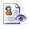

Privacy and Junk E-mail Prevention
Outlook Web Access helps you control unwanted and unsolicited messages ("junk e-mail") and block links to external content that can make you the target of junk e-mail messages.

Turn on the junk e-mail filter - Under Privacy and Junk E-mail Prevention, select the Filter Junk E-mail check box.

To add or modify e-mail addresses or domains in your junk e-mail folder see section Manage Junk E-mail.

Block external content in HTML e-mail messages
HTML messages you receive can include links to external content, such as pictures or sounds. These links aren't the kind that are underlined (hot) and that you click on. They are references in the HTML source code to an external location on the Internet, such as a Web site. When you open or preview the message, your computer downloads the external content so that the picture can be displayed or the sound played. This is typically done by legitimate senders to avoid sending large messages.
However, junk e-mail senders use the downloading of external content by your computer to verify your e-mail address as "live." Once they know there is a real person associated with your address, you can then become the target of more junk e-mail. External content used to identify you in this way is called a Web beacon.
To prevent Outlook Web Access from downloading Web beacons, under Privacy and Junk E-mail Prevention, select the Block external content in HTML e-mail messages check box.

Choose how to reply to read receipt requests
In addition to requesting a read receipt for e-mail messages you send, you can, as a recipient, choose whether to send a read receipt whenever one is requested of you.
To send a read receipt automatically whenever one is requested, select Always send a response.
To never send a read receipt, select Do not automatically send a response.

Manage Junk E-Mail
Use the procedures in this section to specify e-mail addresses and domains you want—or don't want—to receive messages from.
Note - When checking incoming messages, your junk e-mail filter gives precedence to e-mail addresses over domains. For example, suppose the example.com domain is on your Blocked Senders List and the address somebody@example.com is on your Safe Senders List. The address somebody@example.com will be allowed into your Inbox, but all other e-mail addresses with the domain example.com will be sent to your Junk E-mail folder.
When entering domains, you don't need to include the "at" (@) sign. Outlook Web Access automatically adds it.
From the main screen click Options on the bottom left hand corner.
(a) Modify your safe senders list
Safe senders are people and domains you want to receive e-mail messages from.
- Under Privacy and Junk E-mail Prevention, select the Filter Junk E-mail check box.
- Click Manage Junk E-mail Lists. The Safe Senders List is displayed by default.
- To add a sender to the list, click Add, type an e-mail address or domain in the text box, and then click OK.
- To modify a sender in the list, select the sender, and then click Edit. Change the entry, and then click OK.
- To include your contacts as safe senders, select the Also trust e-mail from my Contacts check box.
- Click OK to close the Manage Junk E-mail Lists dialog box, and then click Save and Close.

(b) Modify your Safe Recipients List
Safe recipients are distribution lists that you are a member of and want to receive e-mail messages for. You can also add individual e-mail addresses to your Safe Recipients List. For example, you might want to allow messages that are not only sent to you but also to a particular person.
- In the drop-down menu, select Safe Recipients.
- To add a recipient to the list, click Add, type an e-mail address or domain in the text box, and then click OK.
- To modify a recipient in the list, select the recipient, and then click Edit. Change the entry, and then click OK.
- Click OK to close the Manage Junk E-mail Lists dialog box, and then click Save and Close.

(c) Modify your Blocked Senders List
Blocked senders are people and domains you don't want to receive e-mail messages from. Messages received from any e-mail address or domain on your Blocked Senders List are sent directly to your Junk E-mail folder.
- Click Manage Junk E-mail Lists.
- In the drop-down menu, select Blocked Senders.
- To add a sender to the list, click Add, type an e-mail address or domain in the text box, and then click OK.
- To modify a sender in the list, select the recipient, and then click Edit. Change the entry, and then click OK.
- Click OK to close the Manage Junk E-mail Lists dialog box, and then click Save and Close.

(d) Block links to external content in HTML e-mail messages
With Outlook Web Access, you can block a mechanism called a Web beacon that can make you the target of unsolicited e-mail messages.
- Select the Block external content in HTML e-mail messages check box.
Note - Setting this option also removes Web beacons from your replies and forwarded messages.


Appearance
You can customize the appearance of Outlook Web Access by selecting a color scheme that matches your current Windows theme or color scheme.
To change the color scheme
- Under Appearance, in the drop-down menu, select a colour.
- Click Save and Close.

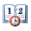
Date and time formats
To set the date and time formats used in your message folders and calendar items, use the drop-down lists to select your preferred format for the different styles.
Note - The date and time formatting options may vary, depending on the language configured for Internet Explorer. Outlook Web Access uses the browser language setting to provide region-specific options.

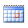
Calendar Options
You can customize your calendar using Calendar options.
To set the day your calendar displays as the beginning of the week, select the appropriate day from the Week begins on list.
To set the times Outlook Web Access will display for each business day, select the appropriate times from the Day start time and Day end time lists.
To select when Outlook Web Access will begin numbering weeks for the current year, select the appropriate option from the First week of year list. The week numbers are displayed in the date picker window in Calendar. If you don't want weeks to be numbered, select Do not display week numbers.



Reminder Options
To receive reminder messages before your appointments and meetings, select the Enable reminders for Calendar items check box.
To receive reminder messages for tasks that are coming due, select the Enable reminders for Task items check box.
To also be reminded with a sound, select the Play a sound when a reminder is due check box.
In the Default reminder list, select the amount of time before the item occurs that you would like to receive a reminder.

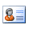
Contact Options
You can select which address book to search first when resolving the name of a contact.
- To set your organization's address book as the first place to search, select Global Address List.
- To set your personal contacts as the first place to search, select Contacts.


Deleted items
After you delete an item from your Deleted Items folder it is permanently deleted. However, you can recover a deleted item if you change your mind about deleting it.
Important - Deleted items are recoverable only for a limited time. The amount of time you have to recover an item is configured on the computer running Exchange Server. For more information, contact a system administrator in your organization.
- On the toolbar, click View Items.
Tip - Another way to open this window is to select your Deleted Items folder from the Navigation Pane, and then click Recover Deleted Items on the toolbar.
- In the Recover Deleted Items dialog box, select the item you want to recover. Hold down CTRL or SHIFT to select multiple items.
Note - If the item you want to recover isn't there, it's likely that the recovery time has expired for that item.
- To return the selected items to your Deleted Items folder, click Recover on the toolbar, or click Permanently Delete to permanently destroy the items.

