
Main Toolbar

New message Reply Show/Hide reading pane Check for New Help

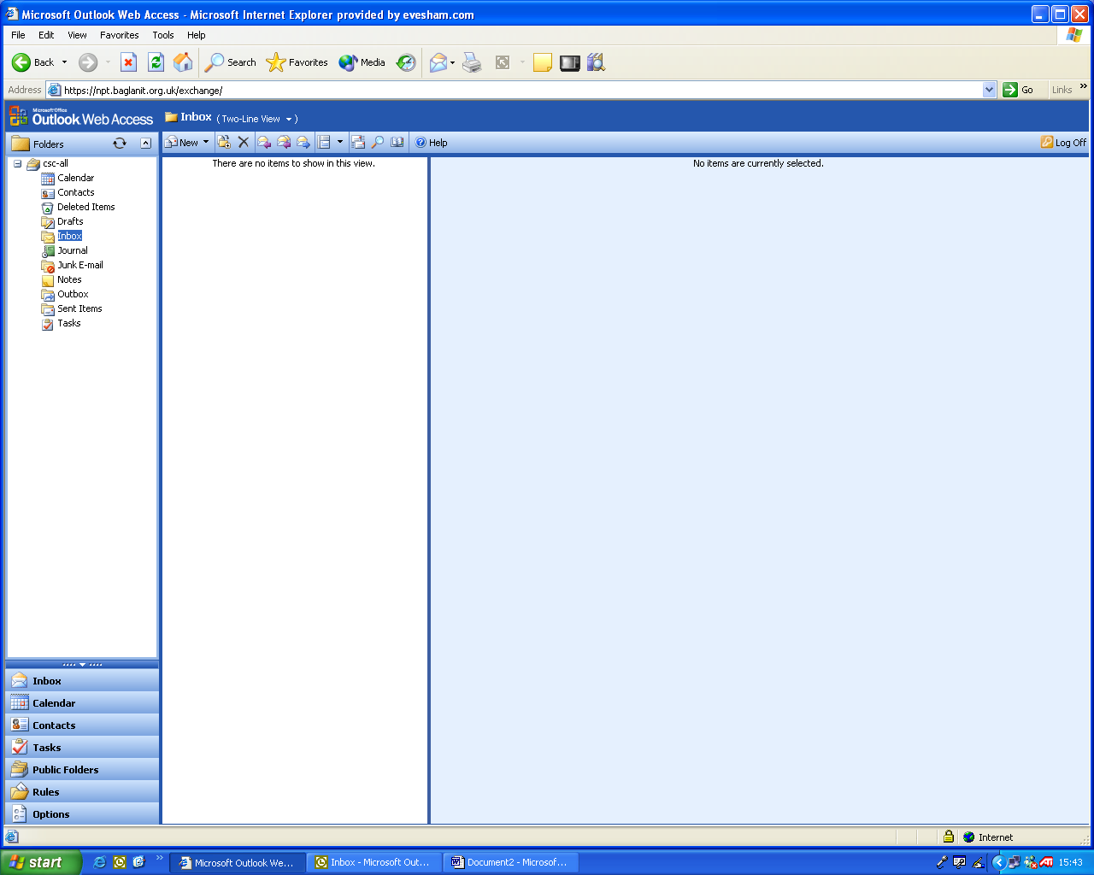

Move/Copy Reply to All Search

Delete Forward Address Book

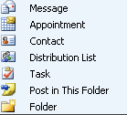
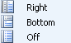

New Item Reading Pane Position

