Interactive White
Board Training
Guide – Level 1

Designed by
space
L. Shaw
C. A. Gerrard
S. Williams
Promethean Interactive White Board Training Guide.

Level 1

Contents

- Whiteboard setup.

- Calibration.

- Logging on.

- Floating tools.

- Flipchart tools.

- Flipchart resources menu.
Promethean Whiteboard Setup
1. The laptop is connected to
the projector via a blue serial cable.
por connecor.
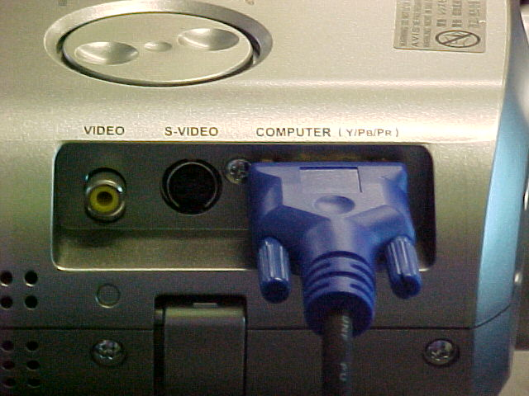
2. The other end of the blue
serial cable is connected
to the projector.
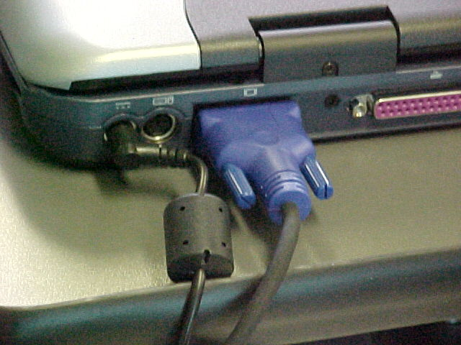
3. The laptop is connected to the whiteboard cable via a small adapter.
4. There are two leads that join onto this adapter, the whiteboard lead (white) and the whiteboard power lead (black).
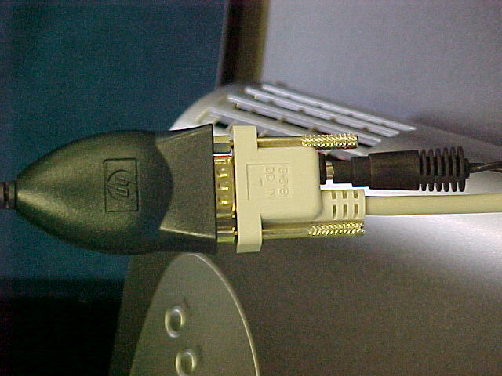
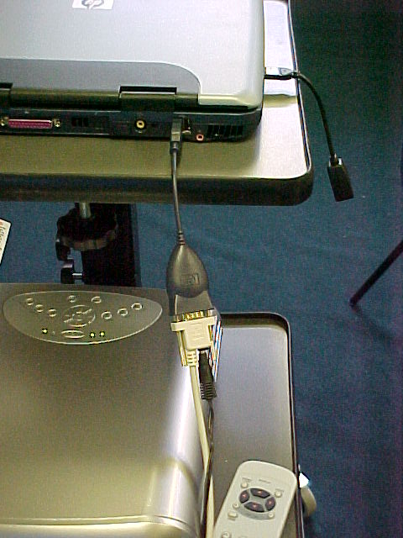

5. The network connection adapter plugs into the side of the laptop.
6. This is what the laptop and projector should look like when all of the cables are connected.

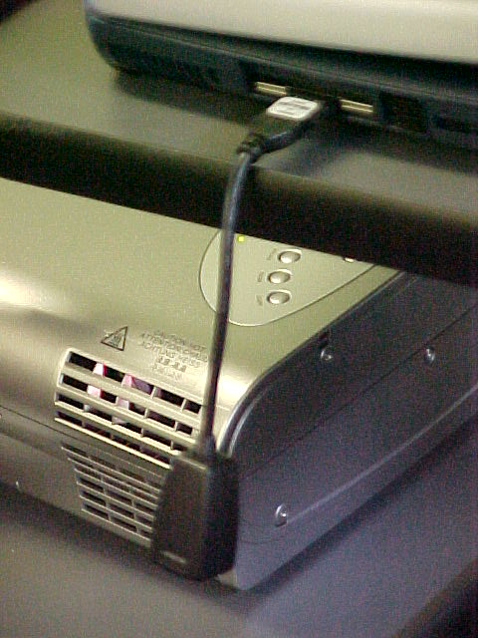
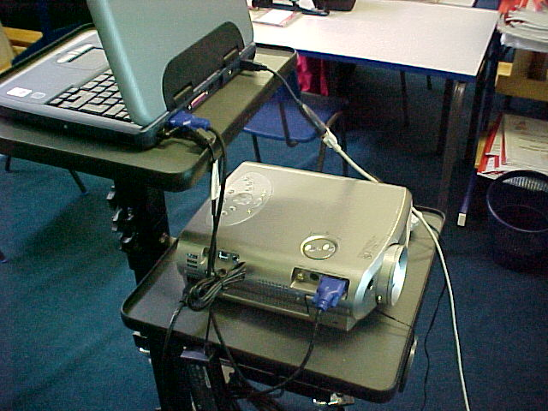

*Tip – Switch on the whiteboard and projector before the

laptop.

The projected image needs to be within the interactive area i.e. the four grey corners marked on the board.

To shut down the projector press the on/standby button. A message will appear on the board instructing you to press the button again. Do not disconnect from the mains power until the fan has cooled down the projector lamp.

Calibration

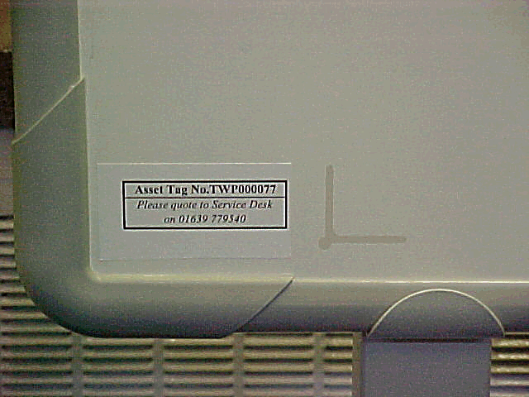
Before the whiteboard can be used it must be calibrated so that the on screen cursor corresponds to the pen pointer.
To calibrate the whiteboard click on the grey dot on the bottom left hand corner of the board with the pen.

When this is selected a message will appear to click on the screen. Click anywhere on the screen and follow the instructions.
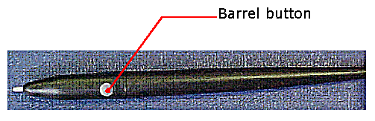
Click on the four crosses (five on the latest version of the software). When this is done the whiteboard will be calibrated. If any mistakes are made the calibration procedure can be cancelled by clicking the barrel button on the pen.

The whiteboard may be re-calibrated at any time by clicking on the grey dot on the bottom left hand side of the board.

Logging on
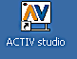
Double click on Activ Studio to load the software.

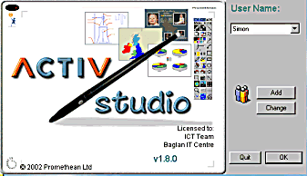
Use this screen to log-on to Activ Studio. The name of a different user may be selected or a new user may be created by using the Add button.
Click here to view the list of users.

If the Add option is being used this window will appear.
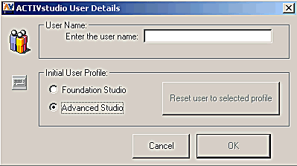

The new user name can now be entered.

All new users should select the Advanced Studio Profile.

When a new user has logged on they should customise their floating toolbox.

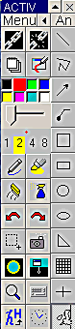

Select menu on the floating toolbar. When the menu appears select Customise…
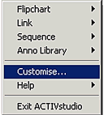

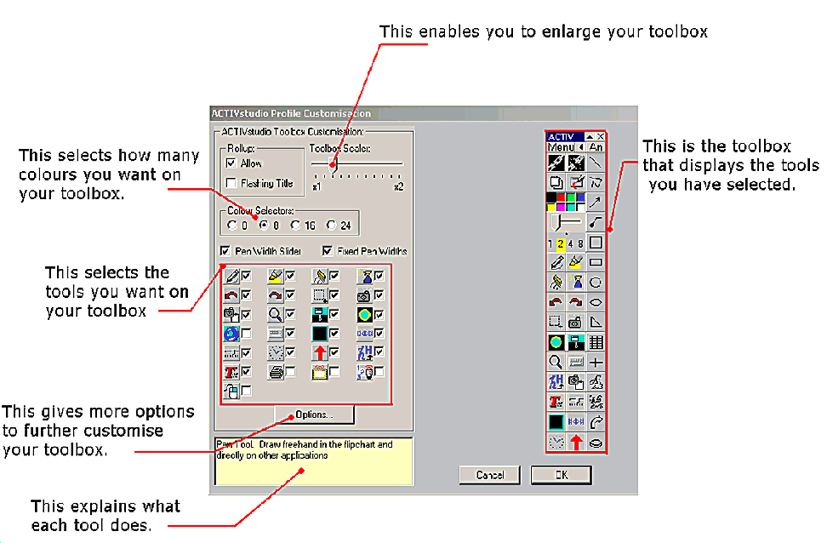
This is the Customise menu. This menu is used to individualise a user’s toolbox.

Floating Tools
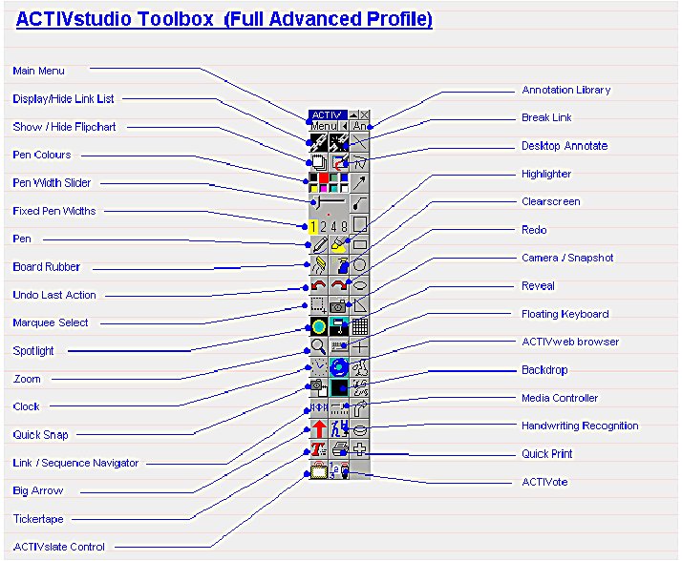

Recommended set of tools
*Extra tools can be added as required

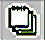 | Click to open a flipchart.  Click again to hide it. | 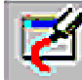 | Annotate (draw and write) over Windows applications.  (Yellow when in use)
 | Click to select colour. Right click (barrel button on pen) for more colours. | 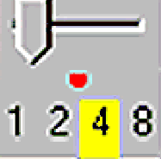 | Pen width – select number or use slider to increase/decrease size.
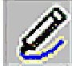 | Pen – writes with selected colour and width. | 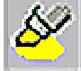 | Highlighter – two preset sizes. All colours available but light colours work best.
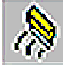 | Eraser – rubs out by covering previous images. | 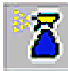 | Clears whole screen of annotations (not text).
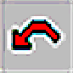 | Multiple undo. | 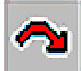 | Multiple redo.
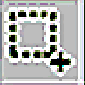 | Marquee select – resize, rotate, flip and move. | 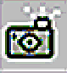 | Camera – select and capture an area or full screen.
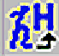 | Handwriting recognition – changes handwriting into text. | 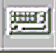 | Onscreen keyboard.
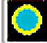 | Spotlight – Focus attention on an area of the screen. (Size and shape can be adjusted.) | 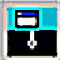 | Reveal – gradually reveal page from top to bottom, bottom to top or side to side.
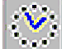 | Clock – analogue, digital and count up/down clocks. | 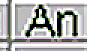 | Annotations – click to see full menu.

* Tip – When creating Annotations always drag from top left of the flipchart to bottom right.

Flipchart Tools
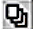 | Page selector – thumbnail view of all flipchart pages. Click on required page to view.
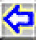 | Previous page.
 | Next page.
 | Resources – view all available resources.
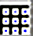 | Tile library – view available backgrounds or select background colour.
 | Access images from library or disk.
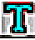 | Text – use to create simple labels or full paragraphs. It is possible to change font, size, style and colour.
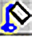 | 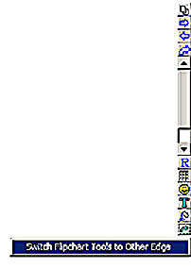  Fill annotation with selected colour.

The Flipchart Tools can be switched to the
left side of the board. Click the barrel button
whilst holding the pen near the bottom edge
of the Flipchart Tools and this instruction
will appear.

The flipchart will always appear on the selected side.

Flipchart Resources Menu

When you click the Resource button on the flipchart, the following menu appears.
The resources are found in the shared area, with the 3 blue people.

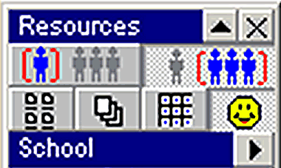

All personal images and resources can be found in (or saved to) the single blue person icon.

Flip-chart Page Tile Image
Library Library Library Library

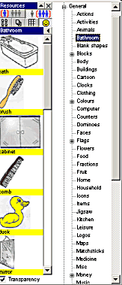
You can access images by clicking on the Smiley face icon, here.

More images are available by
clicking the arrow key here.

A large window will open showing the categories of images available.
Select a category or topic and the images will appear here.

Scroll down until you find the picture that you require and drag and drop it onto the flip chart page.

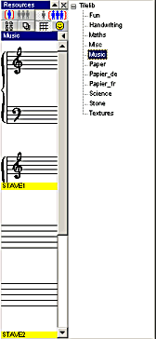
The Tile Library provides a wide range of backgrounds, e.g. graph paper, clocks, music staves, etc.
Click the arrow to view the categories.

The choice of tiles within each selected library will appear. Scroll down and drag and drop the required tile page onto the flipchart page.

