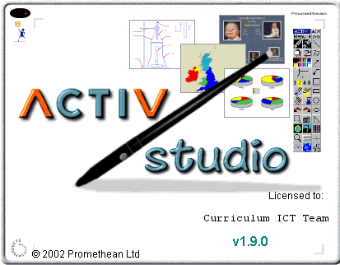
Interactive White
Board Training
Guide – Level 2

Designed by
space
L. Shaw
C.A.Gerrard
S. Williams
Promethean Interactive White Board
Training Guide.
Level 2

Contents

- On screen keyboard

- Camera

- Page selector

- Flood Fill

- Text

- Handwriting recognition

- Marquee select

- Images

- Annotations

- Printing flipcharts

- Saving flipcharts

- Loading new flipcharts

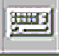
On Screen Keyboard

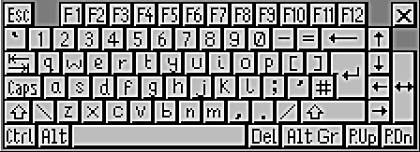

Click here to re-size

The on screen keyboard can be selected at any time and can be used to enter text in any application e.g. Textease.

The keyboard may be enlarged or reduced by clicking the grey button on the pen barrel over one of the three blank squares.

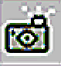
Camera (Snapshot)

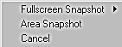
When the snapshot icon is selected a menu will appear.

The full screen snapshot will take an image of the whole screen. The area snapshot enables the user to select an area of the screen to capture.

The Snapshot Menu
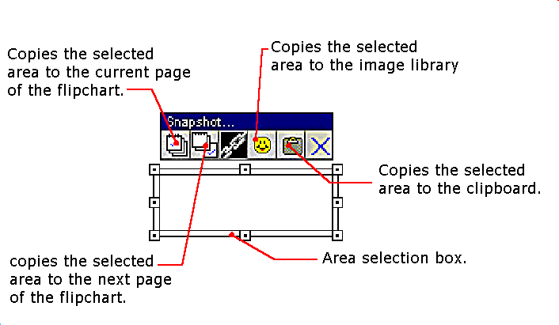
Re-size area
When the hand appears drag

the window to the required

area.
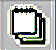

Page Selector

The page selector enables the user to view all of the current flipchart pages.

When the page selector has been activated, individual pages can be selected by simply clicking on them.

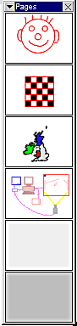
The page selector may be kept open by selecting the pull down menu

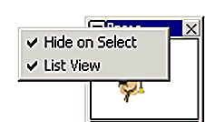

Click here to remove tick and the page selector will remain open when pages are selected.

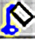
Flood Fill Tool

The flood fill tool on the flipchart menu can be used to fill any enclosed shape with a selected colour. Care must be taken to only fill the desired area and special attention should be paid to the cursor as it will display the flood fill colour and the border colour.

This shows that the shape will be flood filled with blue up to the black border.

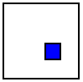
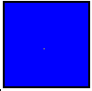

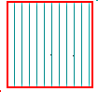
If the right mouse button or the barrel button is used on the flood fill icon a number of different effects can be used to fill an enclosed shape.
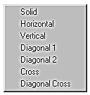

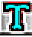
Text

The text tool may be used to create labels on the flipchart.
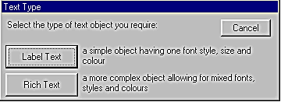
Start by selecting Label Text on the Text Type window.

When Label Text is selected a label may be made using the following tools. The chosen styles apply to all the text.
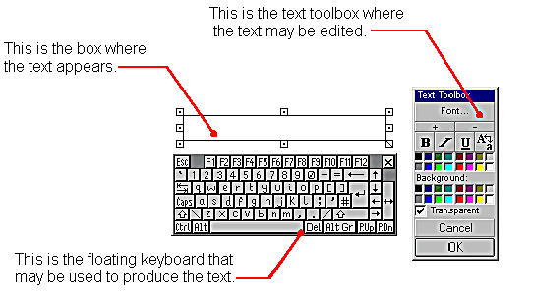
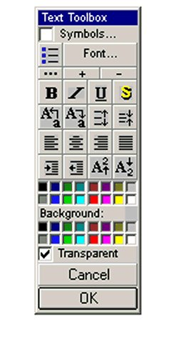
If Rich Text is selected individual
words can be changed e.g. bold,
italic, font colour, size etc.

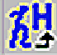
Handwriting Recognition

When handwriting recognition is activated the following menu will appear.

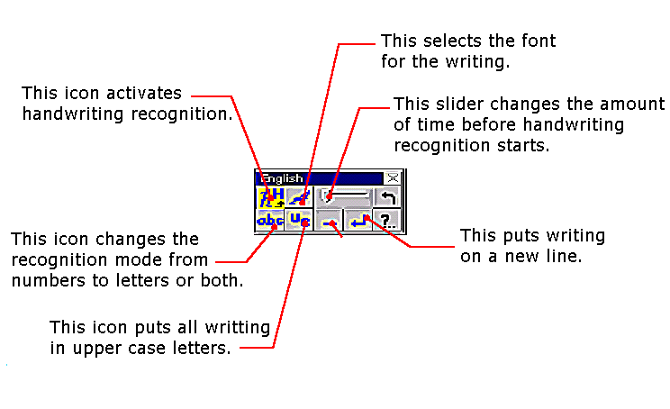
This adds a space
to the writing.
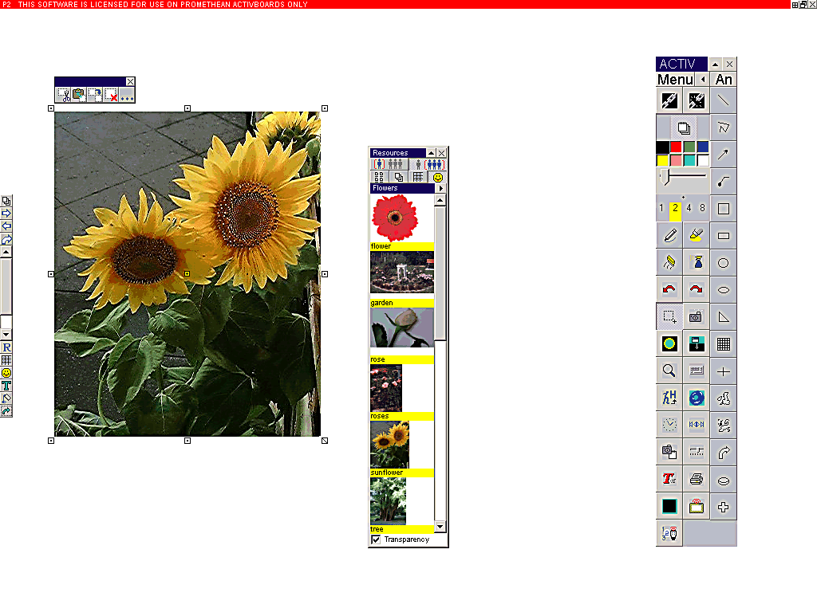
Marquee Select 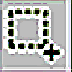

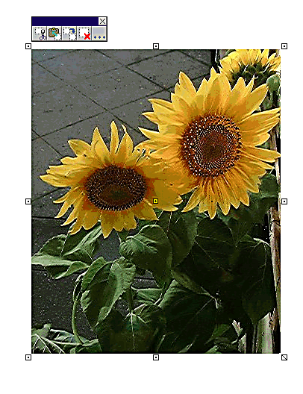
Marquee Select allows objects to be re-sized or moved.

Having selected the image a menu box will appear on the top, with cut, copy, duplicate, delete and more options.
*If the blue, menu box is not there – use the grey barrel button over the image to open the menu. Click on Selection Toolbox
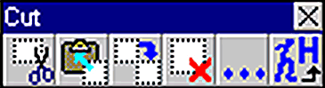
The icons from left to right are: Cut – this cuts the image and removes it to the clipboard to be pasted into other software e.g. Textease or Splosh.

Copy – this does the same job as Cut but leaves the object on the flipchart page. Again the image is transferred to the clipboard ready to be pasted elsewhere.

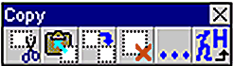

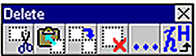
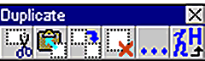
Duplicate – this creates a duplicate image on the flipchart. Drag it into position off the first image.

Delete – this deletes an image from the flipchart page.



Using images

To add an image from disk to a flipchart page
click on image tool.

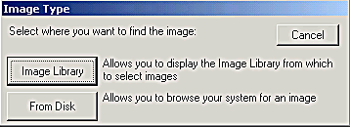

When this window appears, select From Disk.
Use the dialog box to browse your computer system for an image or clip art. As you click on images you will see a preview of the image in the dialog box.

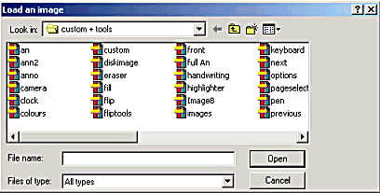

Click to select the required image and then click Open.


Using annotations

Click here to access the full
Annotation menu.

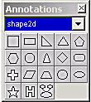
This menu contains groups
of annotations.

Click here to choose a group.
Click to select annotation, move
pen to starting position on the
board and drag out to required
size.

*Tip – Drag out from top left to bottom right.

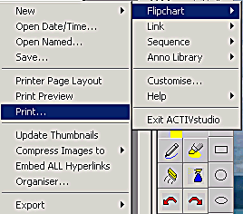
Printing flipcharts

Click on menu to display this window. Click on flipchart and then print.

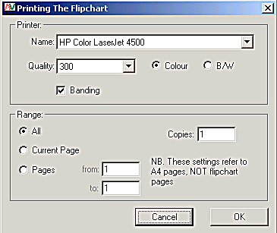

The Printing The Flipchart box will appear. Select the required settings and click OK.

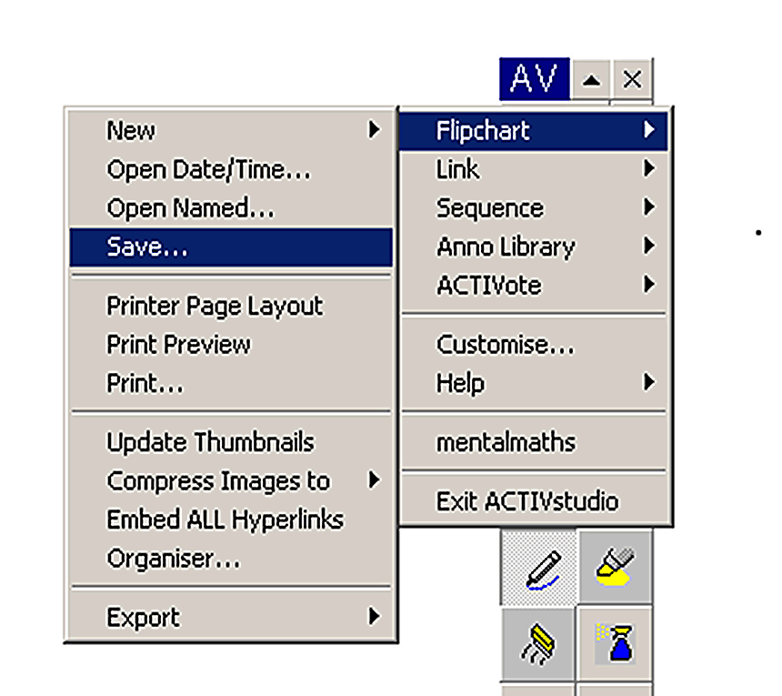
Saving Work

In order to save work, select Menu on the floating tool bar and then select flipchart in the sub menu.
Click on Save…, and the Save Flipchart File dialogue will appear.

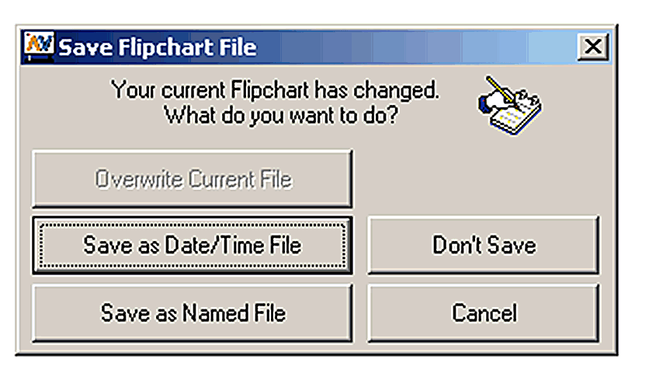
Select Save as Named File
Name the file and Save. The file will automatically be put into the file folder that was created or opened when the user Logged on.

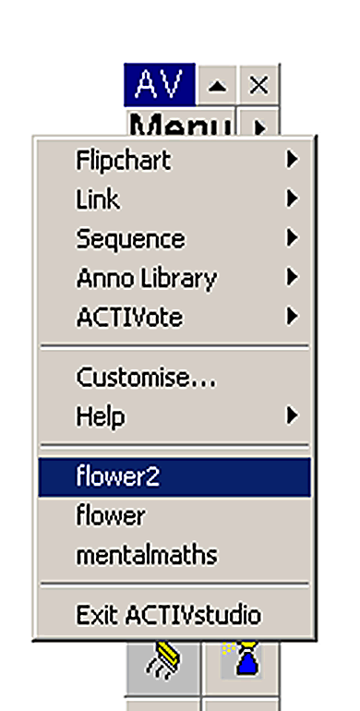
Opening a Saved Flipchart

To open a Flipchart file you have made, select Menu and scroll down the first window. Recent files will appear near the bottom of the window.

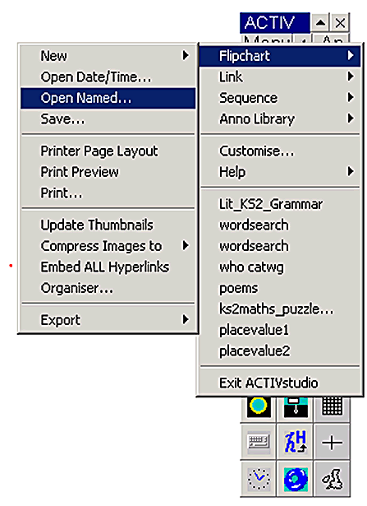

Slide through Flipchart, select Open Named…. In the new window click to select the required flipchart and Open.

To open files from elsewhere, e.g. a floppy disc, select Menu, Flipchart and Opened named. Open as other Windows programs e.g. the A drive.

Creating a New Flipchart

When creating a new flipchart, the screen definition of the laptop is normally set to 1024 X 768. If the whiteboard is being run through a desktop P.C. the definition is usually set to 800 X 600.

Select menu on the floating toolbar then select New – Flipchart – 1024 x 768 or 800 x 600 as appropriate.
