Smartboard Training Guide

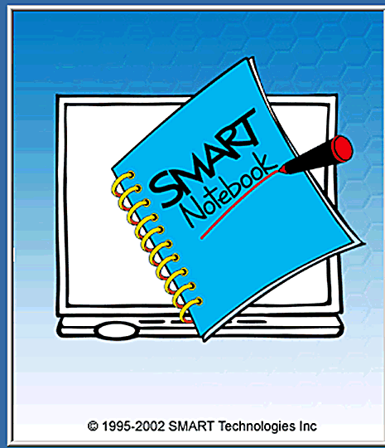

Designed by
space
L. Shaw,
C.A. Gerrard
S. Williams

Orientation

Before the Smartboard can be used it must be orientated so that the on-screen cursor corresponds to the pen or your finger. To orientate the board, double click on the Smartboard icon on the desktop. This menu will appear:

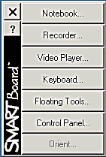

Click here to Orientate the board

This image will appear on the screen.
It is recommended that you use 80 points.
Click on Next to continue.

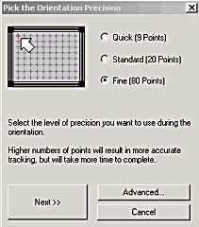

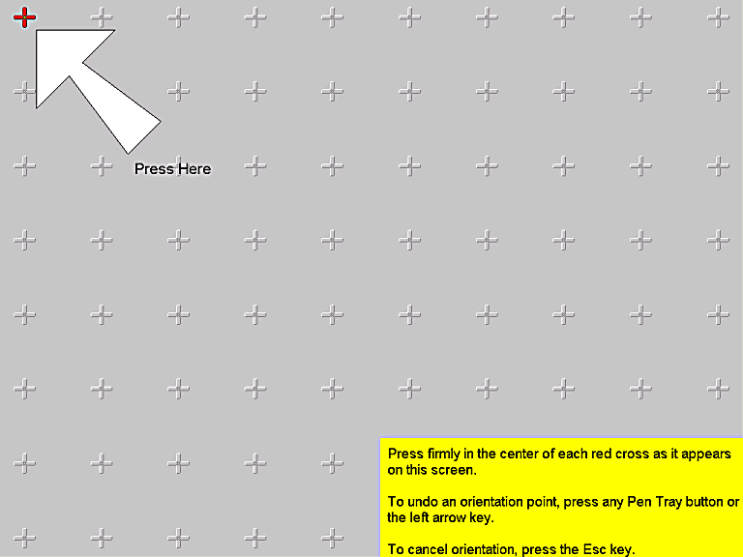

When this image appears
follow the on-screen
instructions to complete
the orientation.

Getting Started
After completing the orientation process select Control Panel from the menu.

This new window will appear.

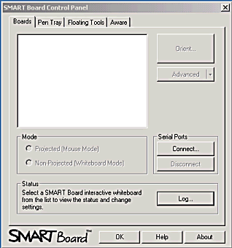
Click on Floating Tools tab.

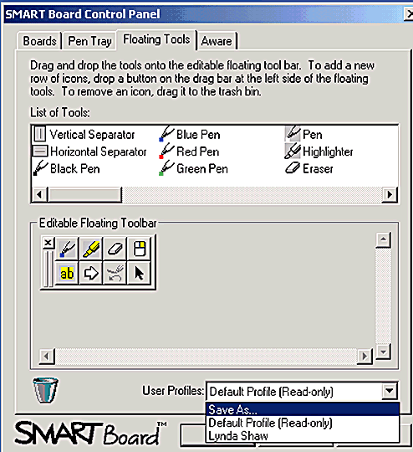

It is possible to customise the
floating toolbar by dragging tools
to it.

To save your toolbar settings
select Save As, then type your
name in the New Profile window.

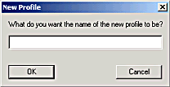

Using the Notebook

Click here to display the floating tools.

Then select Notebook.

This is the Notebook screen.
Click insert to access pictures or clip art
Click help to access tutorials
Click format for option to change background colour

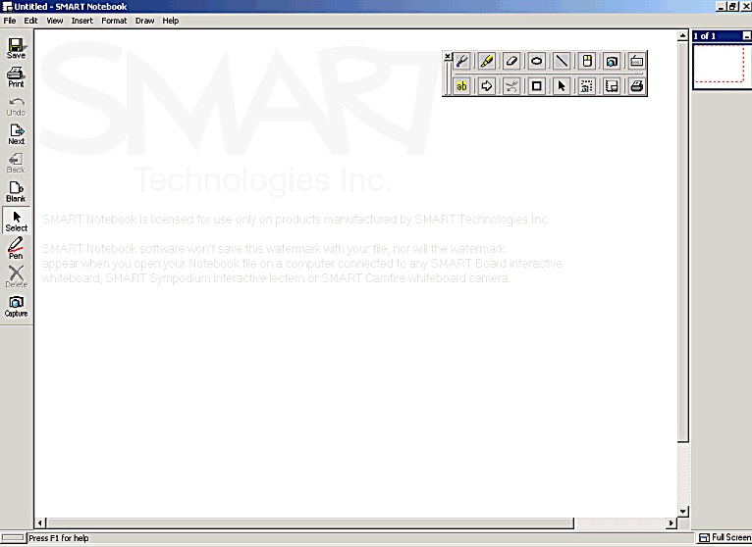

This toolbar has a pen, select and delete option. Also use it to turn pages and create new pages.
The side sorter enables you to view all notebook pages

Page Sorter

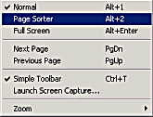

Select view to display this menu.
Select Page Sorter to open
this window.

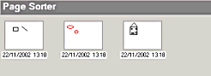

Rearrange pages by dragging to the required position then click on View – Normal to return to the notebook. It is also possible to insert or delete pages.

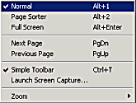

Screen Capture

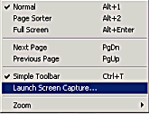

Select View to display this menu and click on Launch Screen Capture.

It is also possible to launch Screen Capture by selecting this tool on the Floating Tools.

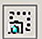

Select an area, window or whole screen.
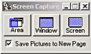

If this box is ticked the capture is automatically sent to
a new notebook page.

Smartboard Setup

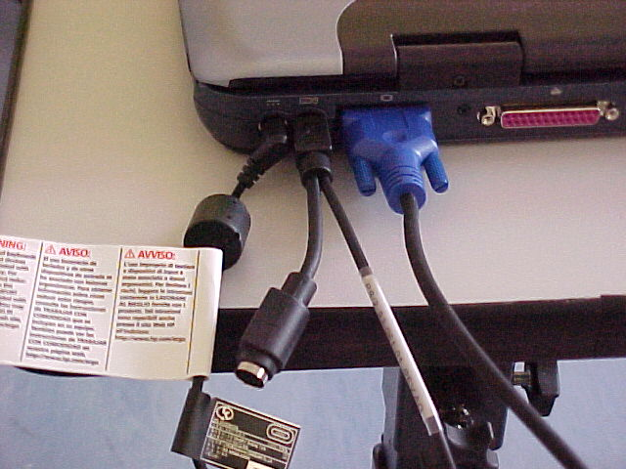
The laptop is connected to the projector via a blue serial port lead.

A mouse may be attached to the Smartboard connection cable at this mouse port.

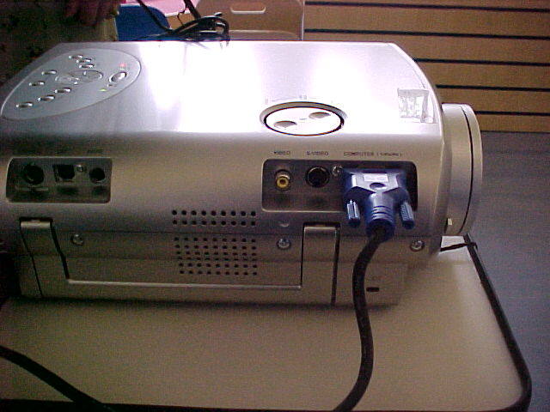

This is where the blue serial lead connects to the projector.

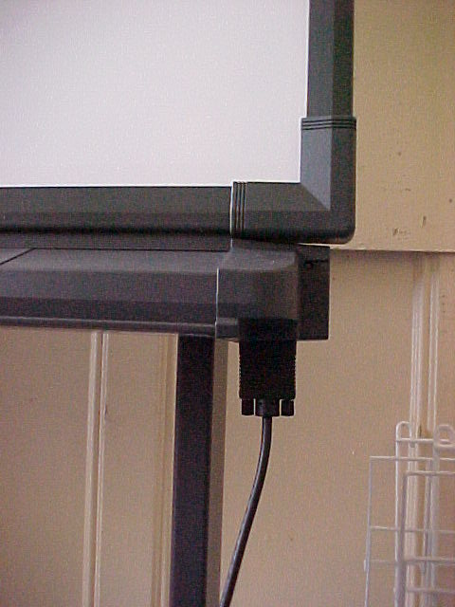
The Smartboard connects to the laptop via a black serial lead.

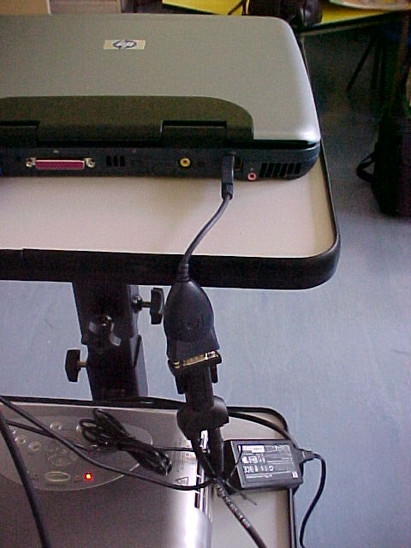
The other end of this lead connects to the lap-top via an adapter that plugs into the USB port on the laptop.
This is the adapter that connects the lead from the Smart board to the laptop.

There is another lead that plugs into this connection. This lead plugs into the mouse port on the laptop.

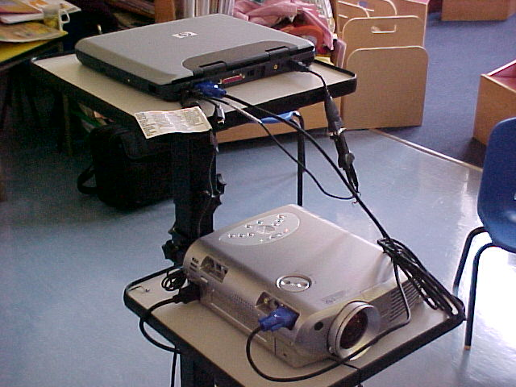
This is what the connections on the laptop and the projector should look like.

When the smart board is wired correctly and is receiving a signal from the laptop a green light will show. Otherwise a red light will show.
Position of signal light.

