Internet Access for Whiteboard Portables

The portables issued as part of the whiteboard project are not by default part of the school network (Domain) or have Internet access. These instructions enable users to connect to the internet temporarily prior to the full integration of the portable into the school’s network (Domain).

To set up a connection to the internet please follow the procedures listed below.

- Allow the machine to start as normal and log on as the schools Administrator (detailed in previously issued instructions).

- On portables where no previous internet setups have been attempted the Internet Connections Wizard will launch, as shown below.

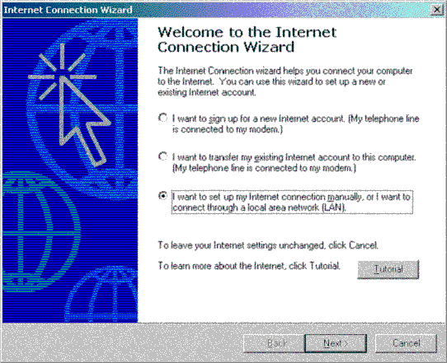

- Select the “I want to set up my Internet connection manually …” radio button, and then click [ Next > ].

- The next page of the wizard will be displayed.

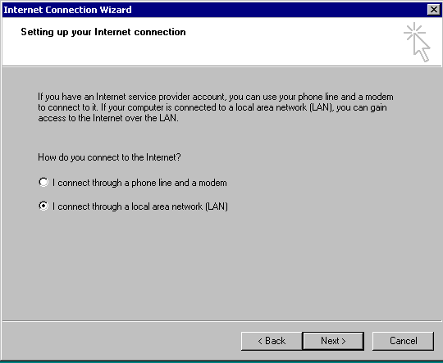

- Select the “I connect through a local area network (LAN)” radio button, and then click [ Next > ].
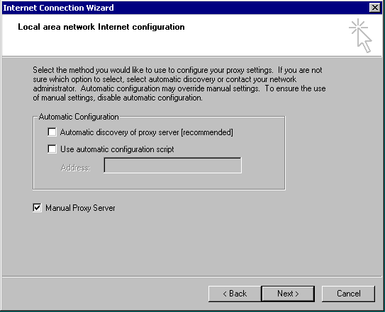

- Place a tick in the “Manual Proxy Server” box and then click [ Next > ].

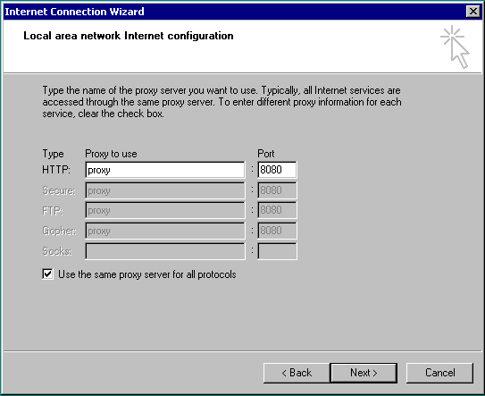

- Place a tick in the “Use the same proxy server for all protocols” box and then click [ Next > ].

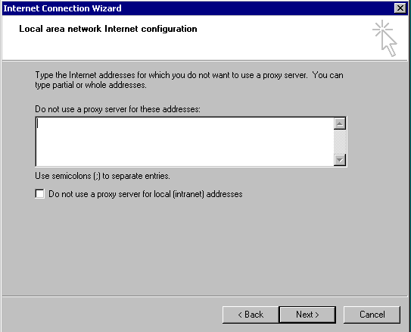

- Ensure that all entries on this page of the wizard are blank and then click [ Next > ].

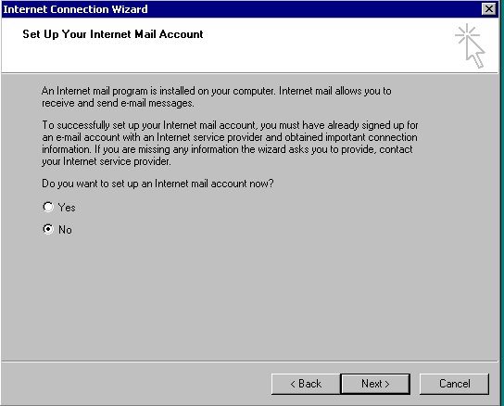

- Ensure that you select the “No” radio button on this page of the wizard and then click [ Next > ].

- Mail accounts will be set once the machine is part of the school Domain.

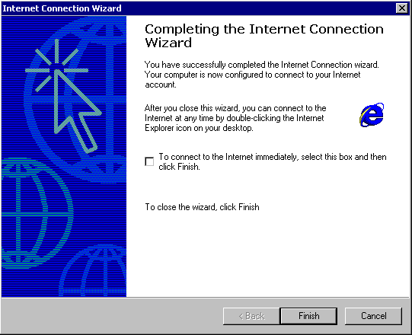

- Ensure that you un-select the “To connect to the internet immediately” box and then click [ Finish ]. This will close the wizard.


- With the mouse click the I.E. icon on the toolbar.

- Internet Explorer will load and try to access it’s default “Home” web page.

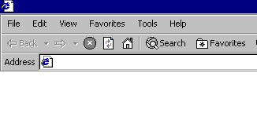
- Click on the Stop button

- Select Tools
Internet Options

The following Internet Options dialogue box will appear.

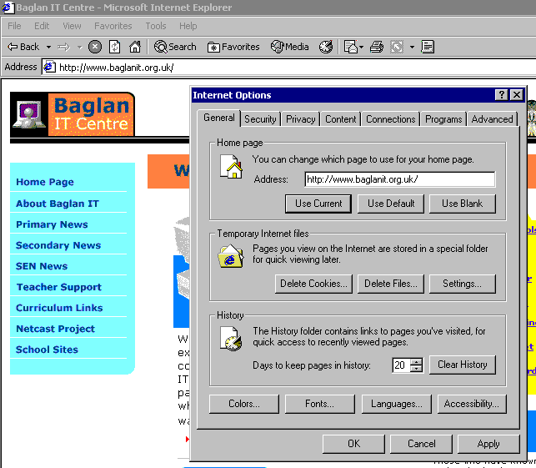

- Use this “Address” setting to set the default “Home Page” for the portable. The entry shown above makes the Baglan web site the default “Home Page”.

- To change this entry simply overtype it and then click on Apply and OK to close the box.

- Clicking on the I.E. icon on the toolbar should now bring up the normal proxy access dialogue box for the school

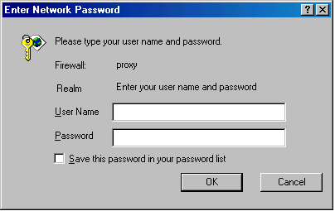

allowing you to enter the group and password as normal.

