Password Access for Whiteboard Portables

The portables issued as part of the whiteboard project have a number of security settings enabled which users need to be aware of, namely:

- The requirement to prompt for a password when the portable resumes operation after a period of hibernation or standby.

- Three pre-set user accounts Administrator Password Protected with full administrative rights.
Guest Default user account with restricted rights.
School Password Protected with full administrative rights.

- The “School” account password is blank.

Initial boot up of the portable will see the machine run directly in to the desktop in the Administrators account. Whilst this account gives full administrative rights after approximately 8 minutes of inactivity the machine will close down into standby. When reactivated from standby the security setting (1) above is activated and the machine requires the insertion of the administrative password to continue. If this is not known the portable will need to be restarted in order to continue operation.

To avoid this situation the following procedures should be followed.

- Allow the machine to start as normal and run in to the Administrators desktop.

- With the mouse select Start
Settings
Control Panel
Users and Passwords

The following dialogue box and screen will appear.
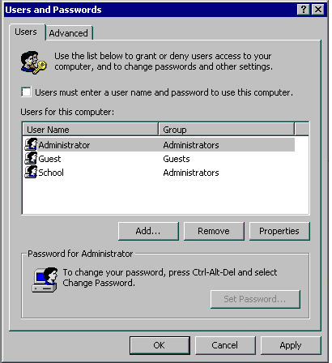

- Place a tick in the empty box entitled “Users must enter a user name and password to use this computer.
- Click on the Advanced tab to display the following dialogue box screen.

- Click on the box within the Secure Boot Settings section. Which will allow users to select which user they log on as. Then click on Apply.

It is recommended that schools also perform the following steps to add a second “Administrative” account and change the type of the existing “School” account.

- Click on the Users tab to redisplay the first Users and Passwords dialogue box.

- Click on the Add button. The following dialogue box will be displayed.
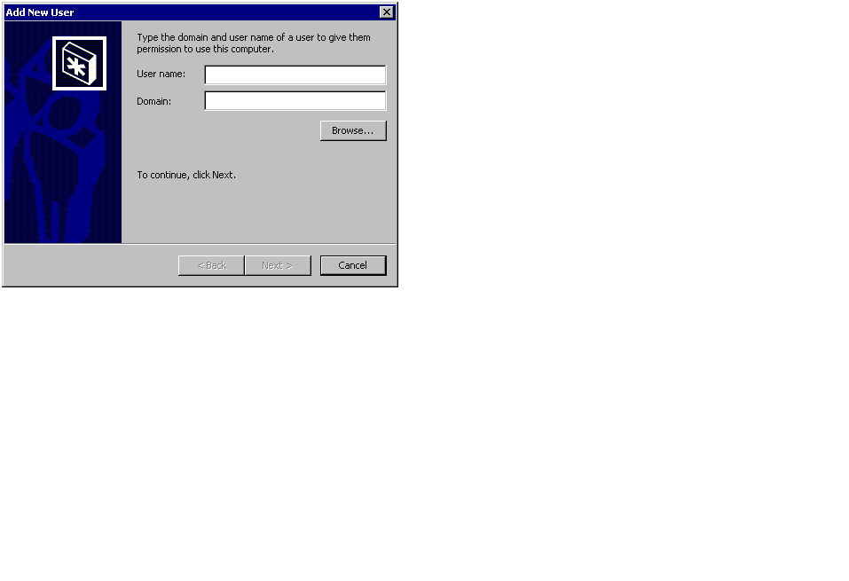

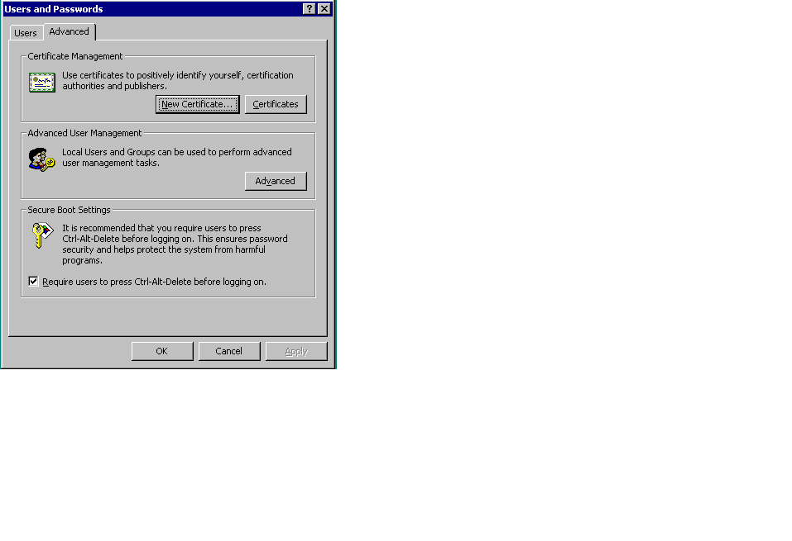
- Now enter a new User Name of your own choice e.g. ABC123 and click Next.

The following dialogue box will be displayed.

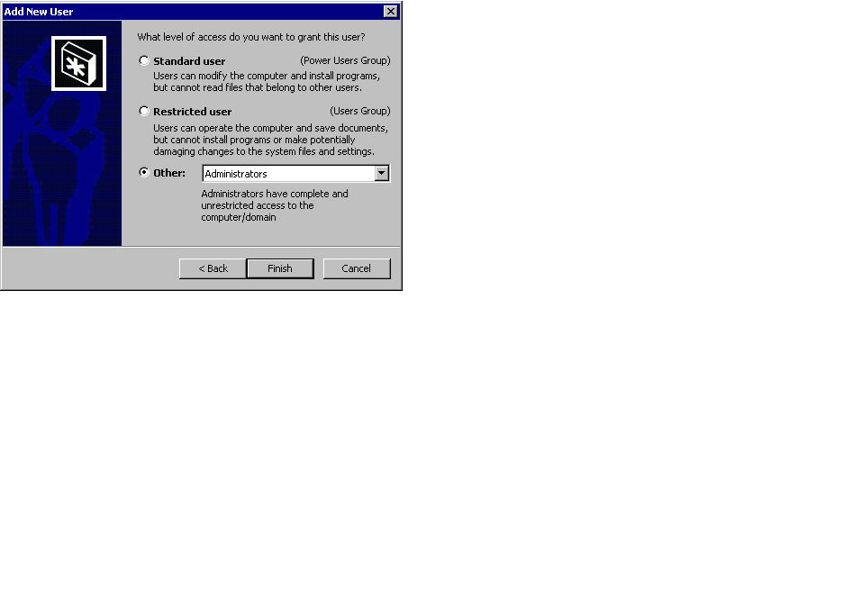
- Ensure that the type of account is set to Administrators, and click Finish.

- From the main Users and Passwords dialogue box click once on the newly created account name and then click on Set Password. The following dialogue box will be displayed.
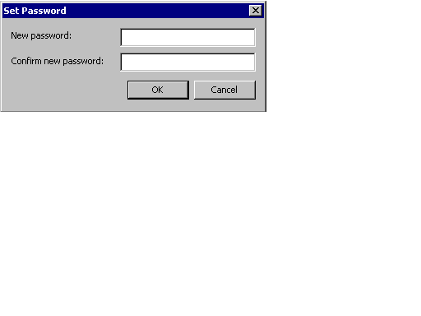

You will be prompted to enter a password and then re-enter the password. Please ensure that this password is at least 8 characters long and can be remembered. It must not be written down.
The 8 characters can be a mixture of upper and lower case and can include numbers. It should not be something that other users can easily associate with the user name.

- Then click OK to set the new password.

- From the main Users and Passwords dialogue box click once on the “School” account name and then click the Properties button. The following dialogue box will be displayed.
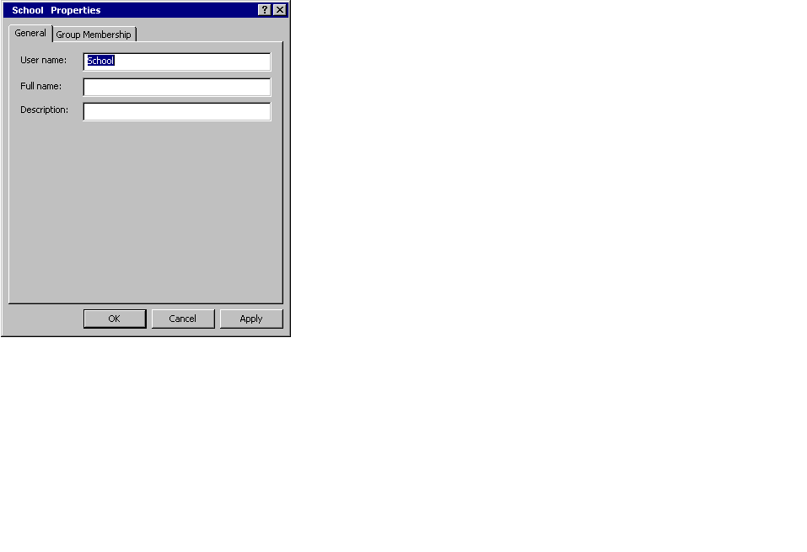

- 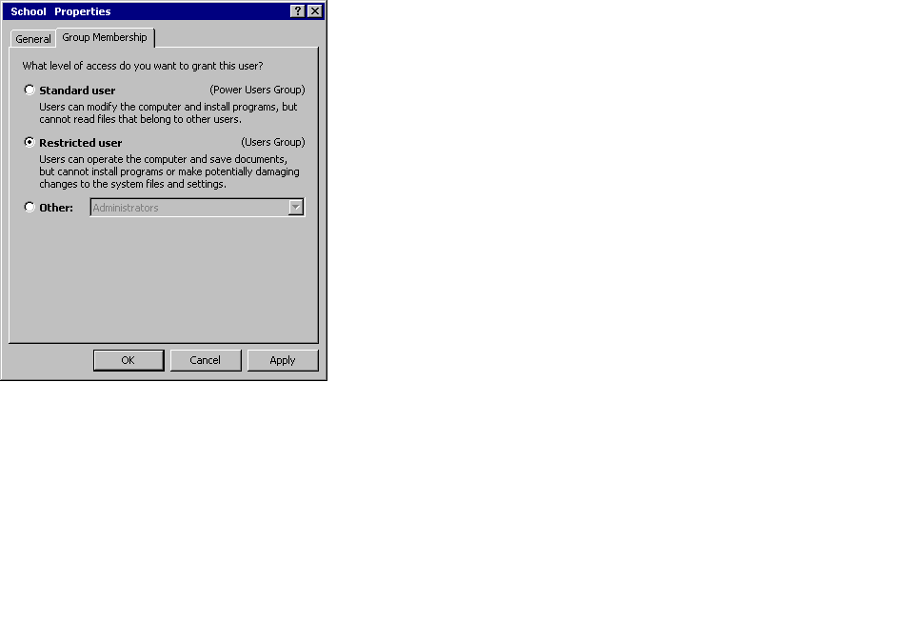Click on the Group Membership tag and then select Restricted User as the type of access to grant to this user.

- Then click on OK to complete the change.

- Now close down all open dialogue boxes and restart Windows 2000.

- When the machine completes the boot process you should see a log on dialogue box with a default user of Administrator shown as being the last successful logged on user.

- Simply overtype the displayed “Administrator” account name with “School” or the newly created local Administrators account name [created in (7) above]. Enter the password and click on OK.

If you have chosen to follow all of the recommendations above the portable will now have the following accounts enabled:

Administrator Password Protected BITC account with full administrative rights.
ABC123 Newly created school admin user account with full administrative rights.
School Null Protected main school user account with restricted rights.

Use of the two local accounts will enable normal use (using School) and the ability to install new software, printers etc (using the newly created local admin account e.g. ABC123).

The original Administrative account needs to remain so that Baglan IT Centre support staff can gain access to the machine in the event of failure or if the local accounts become deleted or corrupt in some way.

